Genetische Risikofaktoren und deren molekulare Mechanismen der generalisierte pustulöse Psoriasis

Der Naturwissenschaftlichen Fakultät
der Friedrich-Alexander-Universität Erlangen-Nürnberg
zur
Erlangung des Doktorgrades Dr. rer. nat.

vorgelegt von
Stefan Haskamp
aus Lohne (Oldenburg)

Als Dissertation genehmigt
von der Naturwissenschaftlichen Fakultät
der Friedrich-Alexander-Universität Erlangen-Nürnberg

Tag der mündlichen Prüfung:
Vorsitzender des Promotionsorgans:
Gutachter: Prof. Dr. André Reis
Gutachter:

1. Zusammenfassung 7
2. Abstract 9
3. Introduction 12
3.1. The burden of psoriasis 12
3.1.1. Types of psoriasis 12
3.2. Generalized pustular psoriasis (GPP) and further rare pustular skin diseases 13
3.2.1. Clinical characteristics of GPP 13
3.2.2. Genetic basis of GPP 14
3.2.3. Further cellular and molecular players in GPP 18
3.3. Research aims 18
4. Results 20
4.1. Identification of genetic factors and heritability models in generalized pustular psoriasis 20
4.1.1. Identification of MPO variants in GPP patients 20
4.1.2. Functional characterization of MPO variants 20
4.1.3. IL36RN and MPO - an oligogenic model 26
4.2. Pathomechanisms in GPP triggered by MPO-deficiency 32
4.2.1. Enzyme activity of serine proteases inversely correlated with MPO activity 32
4.2.2. MPO-deficiency impaired the formation of neutrophil extracellular traps 33
4.2.3. MPO-deficiency reduced phagocytosis of neutrophils by monocytes 34
4.3. The role of MPO in other psoriatic diseases 36
4.3.1. Segregation analysis in seven families of MPO-deficient patients 36
4.3.2. Genetic analysis of MPO variants in four psoriatic subtypes 37
4.4. Cellular and molecular features in GPP patients 46
4.4.1. Cellular composition of PBMCs in GPP patients 46
4.4.2. Pathway analysis of PBMCs 55
4.4.3. Transcriptome analysis of neutrophils in GPP 57
4.5. Cellular and molecular features in GPP patients of acute state 58
4.5.1. Cellular characterization of PBMCs of one GPP patient during an acute episode 60
4.5.2. Pathway analysis and prediction of ligand-receptor interaction of peripheral mononuclear blood cells (PBMCs) in an acute episode of GPP 63
4.5.3. Transcriptome analysis of neutrophils in acute episode 68
5. Discussion 70
5.1. Pathogenic MPO variants in GPP 70
5.2. MPO-deficiency may contribute to GPP by multiple mechanisms 72
5.3. Variants in MPO in other psoriatic subtypes 75
5.4. Cellular and molecular players in GPP patients of stable and acute disease-state 76
5.5. Conclusions 83
6. Materials & Methods 85
6.1. Recruitment of patients 85
6.2. Polymerase chain reaction (PCR) 86
6.3. Agarose gel electrophoresis 88
6.4. Sanger sequencing 88
6.5. Synthesis of cDNA 89
6.6. Targeted gene expression analysis 89
6.7. Site-directed mutagenesis 89
6.8. Transformation of bacteria and plasmid preparation 90
6.9. Transfection of Human Embryonic Kidney (HEK)-293T cells 90
6.10. Isolation of RNA 91
6.11. Enzyme activity assays 92
6.11.1. Myeloperoxidase based on ELISA 93
6.11.2. Myeloperoxidase based on differential blood count 93
6.11.3. Cathepsin G 94
6.11.4. Proteinase 3 94
6.11.5. Neutrophil elastase 94
6.11.6. Cathepsin S 94
6.12. Isolation of immune cells from peripheral blood 95
6.12.1. Isolation peripheral blood mononuclear cells (PBMCs) and neutrophils based on Ficoll 95
6.12.2. Isolation of CD14⁺ monocytes from PBMCs 95
6.12.3. Isolation of neutrophils from whole blood 95
6.13. Methods based on next-generation sequencing 95
6.13.1. Whole-exome sequencing analysis 100
6.13.2. Number of variants in MPO or MPO and IL36RN in GPP patients and control individuals 100
6.13.3. Single-cell RNA sequencing (scRNAseq) analysis of PBMCs 100
6.13.4. RNA sequencing analysis 103
6.14. Genotyping of MPO variants 106
6.15. Analysis of individuals with two variants for compound heterozygosity 106
6.16. Analysis of neutrophil extracellular traps (NETs) 106
6.17. Efferocytosis assay 106
6.18. Flow cytometry analysis 106
6.18.1. CD47 on neutrophils 106
6.18.2. Immunophenotyping by multicolor ﬂow cytometry 106
6.18.3. Granzyme A, Granzyme K and KSP37 106
6.19. Statistical analysis 106
6.20. Reagents and materials 107
6.20.1. Consumable materials 107
6.20.2. Chemicals and enzymes 108
6.20.3. Buffers and solutions 109
6.20.4. Kits 110
6.20.5. Devices 111
6.20.6. Antibodies 112
6.20.7. Oligonucleotides 113
6.20.8. Plasmids 114
6.20.9. Software and databases 114
6.20.10. Mpo^{-/-} mice 115
7. References 116
8. Acknowledgements 117
9. Publications 118
10. Supplements 119
10.1. List of abbreviations 119
10.2. List of figures 121
10.3. List of tables 122
10.4. Supplemental data 125

Zusammenfassung
Psoriasis ist eine Erkrankung der Haut, die in der westlichen Welt mehr als 150 Millionen Menschen betrifft. Die genetische Ursachen von den häufigen Formen Psoriasis vulgaris und Psoriasisarthritis sind komplex und teilweise unbekannt, während die von dem seltenerem SAPHO-Syndrom (Akronym für synovitis-acne-pustulosis-hyperostosis-osteitis) und der palmoplantare pustulöse Psoriasis (PPP) ungeklärt sind. Die generalisierte pustulöse Psoriasis (GPP) ist potenziell lebensbedrohlich und die Prävalenz wird auf 1-9 Betroffene pro eine Million geschätzt (Japan 7,46 und Frankreich 1,7). Als genetische Ursache wurden bei einem Viertel der Patientinnen und Patienten biallelische Varianten im Gen IL36RN beschrieben, welches den Antagonisten des IL-36 Rezeptors kodiert. Obwohl weitere genetische Prädispositionsfaktoren entdeckt wurden, ist die genetische Ursache in der Mehrheit der Fälle unbekannt. Weiterhin sind die Pathomechanismen, die der GPP zugrunde liegen, unzureichend erforscht. Ob andere Zellen zur Erkrankung beitragen, ist unzureichend untersucht worden.
Im Rahmen dieser Arbeit wurde mittels Whole exome-Sequenzierung und Sanger-sequenzierung von 82 GPP-Patientinnen und Patienten acht seltene Veränderungen im Gene MPO identifiziert und nach mehrere Experimente als funktionell relevant eingestuft. MPO kodiert die Myeloperoxidase, welche in Neutrophilen und in geringerem Ausmaß in Monozyten exprimiert ist. Vier Patientinnen und Patienten waren Träger homozygoter Varianten und 13 trugen eine heterozygote Variante. Die Zahl der seltenen, funktional relevanten Varianten war signifikant erhöht bei Patientinnen und Patienten im Vergleich zu 4.937 Kontrollpersonen (p=1,1 E-8). Die Signifikanz nahm zu, wenn die Trägern von heterozygoten IL36RN Varianten zusätzlich berücksichtigt wurden (p=2.3 E-12).
Durch Untersuchungen von humanen Patientenproben und murinen Modellen wurden mehrere Mechanismen beleuchtet, die durch eine MPO-Defizienz ausgelöst zur GPP beitragen. Die Phagozytose von apoptotischen Neutrophilen durch Monozyten, auch Efferozytose genannt, wurde durch den Gendefekt verringert. Damit könnte ein längerer Verbleib von Neutrophilen im Entzündungsherd verbunden sein. Die Bildung von extrazellulären Fallen (NETs) ausgehend von Neutrophilen war nach der Stimulation mit PMA (Phorbol 12-Myristat 13-Acetat) reduziert. Die Bildung von NETs hat sowohl entzündungshemmende als auch -fördernde Auswirkungen. Die MPO-Aktivität von Patientinnen korrelierte negativ mit der enzymatischen Aktivität von IL-36 aktivierenden Serinproteasen in Neutrophilen und Monozyten. Es ist anzunehmen, dass dadurch mehr aktives pro-inflammatorisches IL-36 in der Haut der Patientinnen und Patienten vorliegt.
Phänotypische Analysen von Patientinnen und Patienten mit und ohne MPO Varianten zeigten, dass Anlageträger häufiger eine positive Familiengeschichte für Psoriasis haben, häufiger die Zunge beteiligt ist und häufiger an PPP leiden.
Sieben funktional relevante MPO Varianten wurden auch bei anderen psoriatischen Subtypen, und zwar insgesamt 2741 Personen mit Psoriasis vulgaris, Psoriasisarthritis, PPP oder SAPHO Syndrom, untersucht. Ausschließlich PPP-Patientinnen und -Patienten waren häufiger Anlageträger von krankheitsassoziierten Varianten verglichen mit Kontrollpersonen (p=0.015). Wenn alle Patientinnen und Patienten zusammen untersucht wurden, war der Anteil der Personen mit zwei Varianten um 50% erhöht im Vergleich zu den Kontrollpersonen (nicht signifikant).
Mittels Einzelzell-RNA-Sequenzierung (scRNAseq) und anschließender Clusterannotation durch multimodale Referenz-Kartierung wurden periphere mononukleäre Blutzellen von zwei MPO-defizienten Patientinnen untersucht. Die Analyse ergab eine Expansion von CD4⁺ zytotoxischen T-Lymphozyten (CTLs), welche auch durch durchflusszytometrische Analysen bestätigt werden konnte. Die Expression des Markergens für CD4⁺ CTLs FGFBP2 war höher bei Patientinnen mit Varianten in MPO und/ oder IL36RN im Vergleich zu Patientinnen und Kontrollen ohne Varianten in diesen Genen (n=20, p=0,0015). Eine Signalweg-Analyse von differentiell exprimierten Genen (DEGs) an RNA aus Neutrophilen rückte das Komplementsystem in den Fokus.
Bei der Untersuchung des Transkriptoms einer Patientin mittels scRNAseq waren die absoluten Zellzahlen von CD8⁺ TEMs während einer akuten Episode konstant hoch und die Proportionen von CD14⁺ Monozyten rückläufig. Signalweg-Analysen basierend auf den DEGs (Beginn und Ende der Episode) ergaben, dass der Signalweg “SRP-dependent cotranslational protein targeting to membrane” in mehreren T-Zellarten, NK-Zellen und Monozyten stark angereichert war. Dieser Signalweg hat die Aufgabe, Proteine in den Sekretionsweg zu leiten. In Neutrophilen änderte sich im Verlauf der Episode die Expression von Genen, die zum Interferon-I Signalweg gehören. Dieser Signalweg war auch angereichert bei DEGs aus CD16⁺ Monozyten und CD4⁺ TEMs im ersten Teil der Transkriptomstudie.
In dieser Arbeit wurde MPO als zweithäufigstes Suszeptibilitätsgen für GPP identifiziert, sodass die GPP als oligogene Erkrankung bezeichent werden kann. Der Mangel an MPO störte die Efferozytose von Neutrophilen, reduzierte die Bildung von NETs und erhöhte die Aktivität von IL-36 aktivierenden Serinproteasen. Krankheitsassoziierte MPO-Varianten könnten auch zur PPP beitragen, angedeutet durch eine marginal signifikante Assoziation. CD4⁺ CTLs könnten bei Patientinnen und Patienten, die Anlageträger krankheitsassoziierter Varianten sind, zu Entzündungsreaktionen beitragen. Ob CD4⁺ CTLs, das Komplementsystem oder die Interferon-Signalwege als potenzielles therapeutisches Ziel in Frage kommen, werden zukünftige Studien klären.

Abstract
Psoriasis is a disease of the skin that affects more than 150 million people in the Western world. The genetic causes of the common forms psoriasis vulgaris and psoriatic arthritis are complex and partly unknown, while those of the rarer SAPHO syndrome (acronym for synovitis-acne-pustulosis-hyperostosis-osteitis) and palmoplantar pustular psoriasis (PPP) are unclear. Generalized pustular psoriasis (GPP) is potentially life-threatening and the estimated prevalence is 1-9 affected individuals per million (Japan 7.46 and France 1.7). Biallelic variants in the gene IL36RN, which encodes the antagonist of the IL-36 receptor, have been described as the genetic cause in a quarter of patients. Although other genetic predisposing factors have been discovered, the genetic cause is unknown in the majority of cases. Furthermore, the pathomechanisms underlying GPP are poorly understood. Whether other cells contribute to the disease has been insufficiently investigated.
In this thesis, eight rare variants in the gene MPO were identified by whole-exome sequencing and Sanger sequencing of 82 GPP patients and classified as functionally relevant by several experiments. MPO encodes myeloperoxidase, which is expressed in neutrophils and to a lesser extent in monocytes. Four patients were carriers of homozygous variants and 13 patients carried a heterozygous variant. The number of rare, functionally relevant variants was significantly increased in patients compared to 4,937 controls (p=1.1 E-8). Significance increased when carriers of heterozygous IL36RN variants were additionally considered (p=2.3 E-12).
Studies of human patient samples and murine models have illuminated several mechanisms that contribute to GPP triggered by MPO-deficiency. Phagocytosis of apoptotic neutrophils by monocytes, also called efferocytosis, was reduced by the gene defect, thereby potentially supporting inflammation by the prolonged stay of neutrophils. The formation of neutrophil extracellular traps (NETs) was reduced after stimulation with PMA (phorbol 12-myristate 13-acetate). The formation of NETs has both anti-inflammatory and -promoting effects. MPO activity of patients correlated negatively with the enzymatic activity of IL-36 activating serine proteases in neutrophils and monocytes of patients. This likely results in more pro-inflammatory IL-36 in the skin of patients.
Phenotypic analysis showed that GPP patients with MPO variants had a positive family history of psoriasis, were more often affected by tongue affection and by concomitant PPP compared to patients without variants.
When the genetic analysis was extended to other psoriatic subtypes (2741 individuals with psoriasis vulgaris, psoriatic arthritis, PPP or SAPHO syndrome), exclusively PPP patients were more frequently carriers of disease-associated variants compared to controls (p=0.015). All subtypes combined, the percentage of patients with two variants was nominally higher (50%) compared to control subjects (not significant).
Using single-cell RNA sequencing (scRNAseq) followed by cluster annotation by multimodal reference mapping, peripheral blood mononuclear cells from two MPO-deficient patients were examined. Analysis revealed an expansion of CD4⁺ cytotoxic T lymphocytes (CTLs), which was also confirmed by flow cytometry analysis. Expression of the marker gene for CD4⁺ CTLs FGFBP2 was higher in patients with variants in MPO and/ or IL36RN compared to patients and controls without variants in these genes (n=20, p=0.0015). Pathway analysis of differentially expressed genes (DEGs) revealed the complement system as most enriched in patients’ neutrophils.
Examining a patient's transcriptome by scRNAseq during a acute episde, absolute cell counts of CD8⁺ TEMs were consistently high and proportions of CD14⁺ monocytes were declining. Pathway analyses based on DEGs (start and end of the episode) revealed that the signaling pathway "SRP-dependent cotranslational protein targeting to membrane" was highly enriched in several T cell subtypes, NK cells, and monocytes. This signaling pathway targets proteins to the secretory pathway. In neutrophils, the expression of genes belonging to the “interferon-I signaling pathway” changed during the episode. This pathway was also enriched in DEGs of CD16⁺ monocytes and CD4⁺ TEMs in the first part of the transcriptome study.
In conclusion, MPO was identified as the second major susceptibility gene in GPP, so GPP may rather be oligogenic than monogenic. Deficiency of MPO disrupted efferocytosis of neutrophils, reduced NET formation and increased the activity of IL-36 activating serine proteases. Disease-associated MPO variants might also contribute to PPP, suggested by a marginally significant association. CD4⁺ CTLs as pro-inflammatory cells potentially promoted inflammation in GPP patients with disease-associated variants. Future studies will clarify whether CD4⁺ CTLs, the complement system, or interferon signaling pathways are potential therapeutic targets.

Introduction

The burden of psoriasis
Psoriasis is an inheritable skin disorder that dramatically reduces the quality of life of affected people and their loved ones. The name originates from the greek words “psora” – “itch” and “iasis” – “condition” {Ritchlin, 2007 #1785}. Globally, around 150 million people are suffering from the disease, while Norway has the leading prevalence of 11.43% according to the global report on psoriasis {Danielsen, 2013 #1915}. In Germany, a patient spends 4.9 days less at work due to this autoimmune disease {Augustin, 2008 #1788}. Psoriasis patients frequently encounter ostracization, as many people associate skin lesions with contagious diseases, e.g. leprosy, and bad hygiene. According to a meta-analysis of 98 studies, 28% of patients having depressive symptoms and 12% were diagnosed with depression {Dowlatshahi, 2014 #1870}. However, recent outings of two popular individuals who suffer from psoriasis, Kim Kardashian and Liam Gallagher, may lead to reduced stigmatization and increased empathy. Additionally, the members states of the World Health Organisations committed to fight stigma and to draw attention on the burden of psoriasis {World Health Organization, 2016 #1787}. Of note, the economic burden in the US was estimated 112 billion dollars in 2013 {Brezinski, 2015 #1855}. As recent advances have extended the therapeutic options, the disease is managed sufficiently by reducing the symptoms in most cases {Afonina, 2021 #1871}.

Subtypes of psoriasis
The most common form of this autoimmune disease is psoriasis vulgaris (PsV), where plaque lesions are characteristic. These plaques are raised and erythematous efflorescences covered by silvery scales. In 20-30 % of patients, these symptoms are accompanied by the inflammation of the joint and this subtype is called psoriatic arthritis (PsA) {Mease, 2013 #1797;Reich, 2009 #975}. Both forms are complex diseases, e.g. a combination of numerous genetic and environmental factors are causal for disease. Currently, more than 60 susceptibility loci are associated with both of these common inflammatory disorders combined, most prominently an HLA-C risk allele at psoriasis susceptibility locus 1 (PSORS1) {Tsoi, 2017 #1338}.
Besides the common forms, there are also rarer forms of psoriasis including pustular psoriasis (PP). The European Rare and Severe Psoriasis Expert Network (ERASPEN) did define criteria for diagnostics {Navarini, 2017 #1724}. PP is characterized by neutrophils infiltrating the epidermal skin and, thus, forming sterile pustules.
The most common form of PP is palmoplantar pustulosis or palmoplantar pustular psoriasis (PPP) defined by pustules on the palms and/ or soles lasting for more than three months {Navarini, 2017 #1724}. Variants in IL36RN, AP1S3 and CARD14 have been reported in a low number of PPP patients {Setta-Kaffetzi, 2013 #1069;Mossner, 2015 #1555;Setta-Kaffetzi, 2014 #1070} . However, another study did not confirm the association of PPP with variants in IL36RN, AP1S3 and CARD14 in European patients {Mossner, 2015 #1555}. PPP patients are known to have other psoriatic comorbidities e.g., 15.8% of PPP patients are also affected by PsV {Twelves, 2019 #1733}.
Synovitis-acne-pustulosis-hyperostosis-osteitis (SAPHO) is an acronym for various manifestations including inflammatory bone diseases combined with skin disorders including PsV and PPP {Assmann, 2011 #41; Hayem, 1999 #482}. Not all manifestations are present in each patient affected by SAPHO syndrome and the involvement of inflammatory joint is not a necessary condition. The SAPHO syndrome may be affiliated with spondyloarthropathies, as it regularly affects the spine and can present with similar symptoms as ankylosing spondylitis and psoriatic arthritis (PsA) {Benhamou, 1988 #1620}. The genetic factors of SAPHO syndrome are unknown.

Generalized pustular psoriasis (GPP) and further rare pustular skin diseases

Clinical characteristics of GPP
Generalized pustular psoriasis (GPP) is a severe type of PP with an estimated prevalence of 1.76 per million in France {Augey, 2006 #48}. Symptoms can include systemic inflammation and the course of the disease can be relapsing or persistent. The German dermatologist von Zumbusch was the first to document a GPP patient in 1910 {Baker, 1968 #54}. The patient had PsV for many years, before he developed episodic disease with generalized erythema and oedema. These manifestations developed into multiple painful pustules accompanied by fever. The generalized pustular eruptions were present over the whole body {Baker, 1968 #54}. Those flares can be potentially life-threatening {Augey, 2006 #48}.
Acute generalized exanthematous pustulosis (AGEP) is clinically very similar to GPP regarding the formation of sterile pustules, fever and further symptoms. This skin disorder is triggered by drugs (i.e. antibiotics, e.g. aminopenicillins), as the withdrawal of drugs resolves the disease within two weeks {Navarini, 2013 #857}. In contrast to GPP, the formation of pustules can occur within hours or days and concomitant arthritis is rare {Feldmeyer, 2016 #1872}.
Acrodermatitis continua of Hallopeau (ACH) is characterized by pustular eruptions starting at the nails of fingertips and toes. ACH can also affect the whole body and has clinical overlap with GPP {Navarini, 2013 #857}.
Impetigo herpetiformis (IH) is characterized by generalized pustular eruption during pregnancy. The onset is usually before the sixth month of pregnancy {Naldi, 2007 #1416}. It is also associated with IL36RN variants and has very similar clinical features compared to GPP, as it involves systemic symptoms (fever, malaise) and the eruption of sterile pustules {Navarini, 2013 #857}. IH does not usually involve the face, palms or soles of feet and resolves after childbirth {Oumeish, 2006 #1874}.

Genetic basis of GPP

Variants in IL36RN
In recent years, several variants associated with GPP have been revealed. In 2011, bi-allelic variants in IL36RN, encoding the interleukin (IL)-36 receptor-antagonist (IL-36Ra), were described as disease-causing in GPP {Marrakchi, 2011 #779}{Onoufriadis, 2011 #887}. Further studies confirmed that 21–41% of Asian or European patients carry variants in that gene {Mossner, 2017 #1361;Li, 2013 #722;Sugiura, 2013 #1134;Hussain, 2015 #571}. The IL-36 receptor, the IL-36Ra and the cytokine IL-36α are known to be overexpressed in human psoriatic skin lesions, including those affected by pustular psoriasis {Blumberg, 2007 #111}.
Therefore, IL-36 signaling is considered a key pathway in GPP. IL-36 cytokines are part of the IL-1 family, which is named after their original members IL-1β and IL-1α. There are three different forms of IL-36 cytokines: IL-36α, IL-36β and IL-36γ. All three forms and their receptor (IL-36R) are expressed in the skin by epidermal keratinocytes {Marrakchi, 2011 #779;Towne, 2004 #1174}. How the full length cytokines are secreted into the extracellular space is unclear. The secretion is not mediated via the endoplasmic reticulum-Golgi pathway, as the signal sequence needed for this pathway is absent in IL-36 cytokines. Of note, lung macrophages were described to secrete IL-36γ within vesicles and exosomes upon bacterial stimulation in a Golgi independent way {Kovach, 2016 #1792}.
Similar to other cytokines, secreted IL-36 cytokines need to be activated through N-terminal cleavage by serine proteases {Towne, 2011 #1175}. Currently, there are four proteases, which were able to activate IL-36 cytokines with different specificity in vitro and ex vivo experiments: cathepsin G (CTSG) and neutrophil elastase (NE) activate IL-36α, CTSG activates IL-36β, while the proteases NE and proteinase 3 (PR3) cleave IL-36γ {Henry, 2016 #1598}. CTSG, NE and PR3 are neutrophilic enzymes located in secondary granules. After processing, the biological activity is increased approximately 400-fold. Besides neutrophilic proteases, the protease cathepsin S has been shown to activate IL-36γ to a higher extent compared to NE and PR3, especially in low enzyme concentrations. This cysteine protease is expressed in monocytes and macrophages {Ainscough, 2017 #1684}.
The antagonist IL-36Ra does also require activation by cleavage {Towne, 2011 #1175}, which can be mediated by NE as well {Macleod, 2016 #1728}. In 2018, IL-38 (gene name IL1F10) was identified as a second antagonist of the IL-36R. The expression of IL-38 negatively correlates with disease severity of psoriasis, and the inhibitory effect shown in studies with keratinocytes is similar compared to IL-36Ra in vitro {Mercurio, 2018 #1795}.
Upon binding of IL-36 cytokines to its receptor, a cascade begins with the recruitment of the IL-1 receptor accessory protein as a co-receptor. This leads to an activation of nuclear factor-κB (NF-κB) and mitogen-activated protein kinases, which result in the production of pro-inflammatory cytokines and the recruitment of immune cells to the site of inflammation {Carrier, 2011 #184;Johnston, 2017 #1654;Marrakchi, 2011 #779;Towne, 2004 #1174}.
In GPP patients with disease-associated variants in IL36RN, this pathway is potentially affected. Consequently, the unopposed IL-36 signaling promotes the production of pro-inflammatory cytokines in keratinocytes in vitro {Marrakchi, 2011 #779}. GPP patients with and without variants in IL36RN were successfully treated with Spesolimab (BI 655130), a monoclonal antibody targeting the IL-36R {Bachelez, 2019 #1705}. This underlines the pathogenic role of this pathway in GPP.
IL-36 signaling may also influence parts of the adaptive immune system. Besides keratinocytes, murine bone-marrow-derived dendritic cells and naïve CD4⁺ T cells have been described to express the IL-36R {Vigne, 2011 #1796} (Figure 1). In murine studies, IL-36 signaling has been described to activate T cells either directly or indirectly via dendritic cells {Foster, 2014 #378;Vigne, 2011 #1796} (Figure 1). For example, this signaling pathway could support the polarization of naïve T helper cells to pro-inflammatory Th1 cells {Vigne, 2012 #1213}. Furthermore, CD4⁺ T cells express IL-36R and stimulation with IL-36 cytokines induces production of IFN-α, IL-4, and to a lesser degree IL-17 {Vigne, 2011 #1796}.
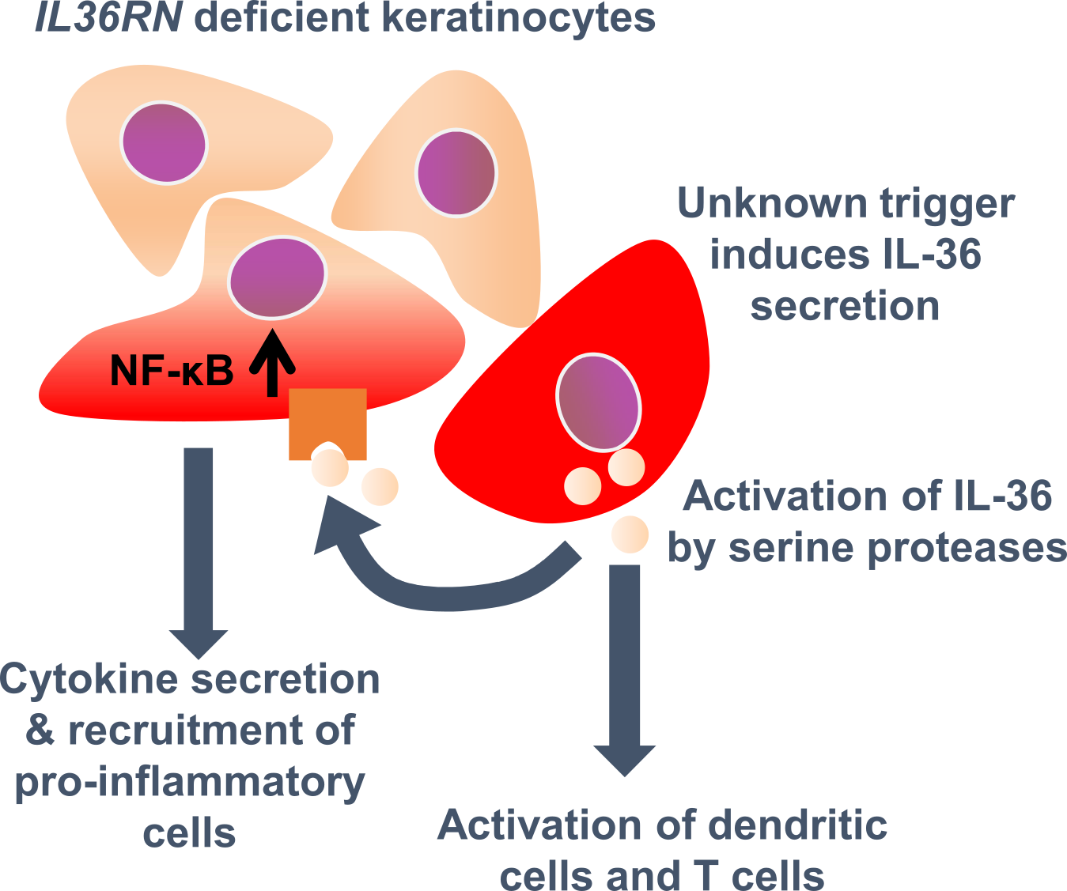
Figure 1: Model of IL36RN-deficient keratinocytes promoting inflammation in GPP.
Keratinocytes secrete IL-36 cytokines triggered by unknown molecules. IL-36 cytokines are activated by serine proteases and are able to activate further keratinocytes, dendritic cells and T cells via binding to the IL-36 receptors {Henry, 2016 #1598;Marrakchi, 2011 #779`,Vigne`, 2011 `#1796;Foster, 2014 #378}. Due to IL36RN-deficiency, the unopposed IL-36 signaling leads to systemic inflammation.

Variants in CARD14
Genome-wide association studies have identified 63 psoriasis susceptibility loci for European individuals {Tsoi, 2017 #1338}. Jordan et al. described variants in CARD14 (Caspase recruitment domain-containing protein 14) to be responsible for psoriasis susceptibility locus 2 (PSORS2) {Jordan, 2012 #602}{Jordan, 2012 #601}. They found 17 rare variants in 6,000 individuals affected by psoriasis, including one GPP patient from Haiti with a de novo variant (p.E138A). The protein functions as a molecular scaffold for the assembly of protein complexes. Pathogenic variants regulate NF-κB, a transcription factor for pro-inflammatory cytokines, e.g. IL-6 and IL-8. While CARD14 is expressed in keratinocytes of the basal layer of healthy skin, the expression is increased in keratinocytes of the granular layer of psoriatic skin. Further studies have confirmed an association of variants in CARD14 with GPP in German and Asian individuals {Mossner, 2018 #1364;Berki, 2015 #86}. The proportion of GPP patients carrying variants in CARD14 are between 1-5% {Mossner, 2018 #1364;Twelves, 2019 #1733}.

Variants in AP1S3
The variants c.11T>G/ p.(Phe4Cys) and c.97C>T/ p.(Arg33Trp) in AP1S3, encoding adaptor related protein complex 1 subunit sigma 3, were identified in two ACH patients of British origin with concomitant GPP {Setta-Kaffetzi, 2014 #1070}. Additionally, one of five GPP patients and four of 112 PPP patients carried the heterozygous c.97C>T [p.Arg33Trp] variant{Setta-Kaffetzi, 2014 #1070}.. In the same study, no disease-associated variants were found in 72 Asian GPP Patients and four African GPP patients. The authors claimed that this is due to a founder effect {Setta-Kaffetzi, 2014 #1070}. One further study did not find these variants to be associated with GPP and PPP in German patients {Mossner, 2018 #1364}. AP1S3-deficiency was described to disturb autophagy in a keratinocyte cell line {Mahil, 2016 #769}. In primary keratinocytes with a knockdown of AP1S3, IL-1 signaling is upregulated and the pro-inflammatory cytokine IL-36α is overexpressed {Mahil, 2016 #769}.

Variants in SERPINA3
In two GPP patients and one PPP patient, two heterozygous loss-of-function variants were identified in SERPINA3 {Frey, 2020 #1702}. The gene encodes serine protease inhibitor A3, which is a known inhibitor of cathepsin G. This serine protease has been shown to activate IL-36β, a pro-inflammatory cytokine, in vitro {Henry, 2016 #1598}. SERPINA3 is located in the upper layer of inflamed pustules, suggesting an interaction with the neutrophilic protease cathepsin G {Frey, 2020 #1702}. Overall, only a small proportion of GPP and PPP patients carried a disease-associated variant in SERPINA3 (2 of 72 and 1 of 319, respectively).
To conclude, the majority of GPP patients do not carry any disease-associated variants in IL36RN, CARD14, AP1S3 and SERPINA3 {Mossner, 2018 #1364; Twelves, 2019 #1733}. Several patients also carry several disease-relevant variants in different genes or just a single heterozygous variant {Mossner, 2018 #1364}. A oligogenic inheritance pattern has been suggested before {Mossner, 2018 #1364; Zhou, 2021 #1916; Neuhauser, 2020 #1917}. Therefore, the genetic basis of GPP is still unknown in most patients.

Further cellular and molecular players in GPP
Several studies provide evidence that IL-17 is promoting inflammation in GPP. The expression of the gene encoding the pro-inflammatory cytokine was increased in psoriatic skin {Johnston, 2017 #1654}. Confirmatory, the inhibition of IL-17A by a monoclonal antibody (infliximab) was described as a successful treatment approach in GPP independent of disease-associated variants {Imafuku, 2016 #1835;Saeki, 2015 #1834;Wilsmann-Theis, 2018 #1363;Yamasaki, 2017 #1836}. The most prominent but not exclusive source of IL-17A are Th17 cells {Park, 2005 #908}. Infiltrating T cells are known to promote inflammation in psoriasis {Mahil, 2017 #1876;Lowes, 2014 #1877}. In patients with IL36RN variants, IL-17A producing T cells have been shown to expand suggesting a potential pathway of the adaptive immune system in which T cells respond to primary IL-36 signaling {Arakawa, 2018 #1810}.
Just recently, the Interferon-I (IFN-I) pathway was shown to correlate with IL-36 activity in GPP by transcriptome analysis in neutrophils and whole blood of patients. This association was also confirmed in severe cases of PsV, although with a much lower correlation coefficient {Catapano, 2020 #1816}.

Research aims

Although recent advances lead to promising therapeutic options {Bachelez, 2019 #1705}, the inflammatory processes leading to very different progression of the disease are barely understood and the majority of GPP patients do not carry variants in known disease genes. Therefore, the discovery of further genetic factors might lead to a better understanding of the disease and potentially to advances in therapy and diagnostics.
The overall aim was to identify new genetic factors in conjunction with their underlying mechanisms and thereby elucidate GPP’s pathogenesis. To achieve this, this thesis focused on the following specific aims:
- Identifying disease-contributing variants in GPP
New findings might support a oligogenic model of inheritance. Moreover, the genotype may correlate with epidemiological and clinical features.
- Revealing potential pathomechanisms caused by disease-associated variants
The second aim is to identify pathways modified by newly discovered variants. How do these pathways promote inflammation or prevent the resolution of inflammation? Which key molecules/ cells are involved?
- Analyzing new disease-associated variants in other psoriatic diseases
Successful identification of new genetic preposition in GPP raises the question of whether these variants also play an important role in other psoriatic subtypes, such as PsV, PsA, SAPHO syndrome and PPP. Therefore, the third aim is the genetic analysis in psoriatic subtypes in conjunction with several phenotypic aspects, e.g. age of onset.
- Unraveling inflammatory processes in GPP
To understand the disease, systematic approaches like transcriptome analysis of circulating immune cells of patients are promissing. These methods may shed some light on further key molecules/ cells responsible for the escalation of inflammatory reactions in GPP.

Results

Identification of genetic factors and heritability models in generalized pustular psoriasis

Identification of MPO variants in GPP patients
As the genetic background of the majority of GPP cases is unknown, whole-exome sequencing in 31 patients without variants in IL36RN was performed. The analysis was based on rare variants (minor allele frequency [MAF] <0.1%) affecting the same genes. By looking for homozygous variants in two or more patients, an autosomal recessive model was considered. Compound-heterozygous variants were omitted, as parental DNA was not available. The analysis resulted in two possible gene candidates: MPO and MUC4 encoding myeloperoxidase and mucin 4 (Table 1).
Table 1: Characteristics of homozygous variants in MPO and MUC4 detected by WES in at least two patients.
NFE: Non-Finnish European individuals of gnomAD {Karczewski, 2020 #1771}; Combined Annotation Dependent Depletion (CADD) {Kircher, 2014 #1334}
Gene name | Variant at nucleotide/ protein level | Position in hg19 (dbSNP-ID) | Frequency in NFE of gnomAD (proportion of rare allele) | CADD
MPO | c.1768C>T/ p.Arg590Cys (NM_000250.2) | Chr17: 56,350,133 (rs142082076) | 0.004% (9/129,050) | 34
MPO | c.265_275dup/ p.Ser94Alafs*24 (NM_000250.2) | Chr17: 56,357,348 (rs1188888247) | 0.0065% (1/15,406) | n.a.
MUC4 | c.11698_11745del/ p.Arg3900_Thr3915del (NM_018406.7) | Chr3: 195,506,712-195,506,759 (rs1299856820) | 0% (0/48,894) | n.a.
MUC4 | c.7792A>G/ p.Thr2598Ala (NM_018406.7) | Chr3: 195,510,659 (rs200280829) | 0.0071% (3/42,206) | 0.044

MUC4 is a very large gene with repetitive regions, resulting in a higher number of variants by chance and presumably technical artifacts when sequenced. In contrast, MPO is the main enzyme in neutrophils catalyzing the reaction of hydrogen peroxide to hypohalous acid, a potent antimicrobial agent. Neutrophils are overly abundant in pustules of GPP patients and MPO-deficiency has been described in several case reports of GPP patients {De Argila, 1996 #1678;Stendahl, 1984 #1676;Nguyen, 1997 #1857}. Consequently, MPO was considered the better candidate gene for contributing to GPP and was selected for further investigation.
The analysis was extended by reanalysis of WES and targeted sequencing of MPO in 82 patients in total; among them, six patients were affected by acrodermatitis continua suppurativa Hallopeau (ACH) and two by acute generalized exanthematous pustulosis (AGEP) (Table 5). Patients affected with ACH and AGEP have been described to carry pathgenic variants in IL36RN and may, therefore, have a similar genetic basis {Setta-Kaffetzi, 2013 #1069;Navarini, 2013 #857}.
The analysis identified six further variants in 14 patients (Table 2). While no functional studies of the variants c.265_275/ p.(Ser94Alafs*24), c.1642C>T/ p.(Arg548Trp) and c.1768C>T/ p.(Arg590Cys) were available, five variants were reported as functionally relevant {Romano, 1997 #1667;Marchetti, 2004 #1668;Nauseef, 1994 #1692;Reumaux, 2003 #1754}.

Table 2: Characteristics of variants in MPO found in 82 Patients
Variant at nucleotide/ protein level | Position on Chr. 17 in hg19 (dbSNP-ID) | Reported previously in | Frequency in 82 patients (proportion of rare allele)
c.265_275dup11/ p.Ser94Alafs*24 | 56,357,348 (rs1188888247) | not reported | 1.2% (2/164)
c.752T>C/ p.(Met251Thr) | 56,356,502 (rs56378716) | {Romano, 1997 #1667} | 1.2% (2/164)
c.995C>T/ p.(Ala332Val) | 56,355,397 (rs28730837) | {Reumaux, 2003 #1754} | 1.8% (3/164)
c.1555_1569del14/ p.Met519Profs*21 | 56,350,827 (rs963955387) | {Romano, 1997 #1667} | 1.2% (2/164)
c.1642C>T/ p.(Arg548Trp) | 56,350,259 (rs148802625) | not reported | 0.6% (1/164)
c.1705C>T/ p.(Arg569Trp) | 56,350,196 (rs119468010) | {Nauseef, 1994 #1692} | 1.8% (3/164)
c.1768C>T/ p.(Arg590Cys) | 56,350,133 (rs142082076) | not reported | 1.2% (2/164)
c.2031-2A>T | 56,348,226 (rs35897051) | {Reumaux, 2003 #1754}  {Marchetti, 2004 #1668} | 3.6% (6/164)

In summary, homozygous and heterozygous variants in MPO were identified in three and 13 patients, respectively. One patient was compound heterozygous for the MPO variants c.995C>T/ p.Ala332Val and c.2031-2A>C/ p.(Phe678*). This suggests a key role for MPO-deficiency in GPP and potentially in the pustular skin diseases ACH and AGEP.

Functional characterization of MPO variants
In order to assess the potential impact of the MPO variants on the function of the enzyme, several functional tests and structure predictions were performed. Structural modeling of two novel variants c.1642C>T/ p.(Arg548Trp) and c.1768C>T/ p.(Arg590Cys) was performed to predict potential steric alterations or effects on interacting molecules. Arg590 builds hydrogen bonds to the propionate group of the heme molecule, which is a cofactor for MPO (Figure 2a). An exchange of arginine to cysteine prevents the building of a hydrogen bond, as the side chain is shorter and uncharged (Figure 2a-b). This may affect the catalytic function of MPO due to the reduced binding of the heme molecule. The residue of Arg548 is in close proximity to Ile709 forming hydrophobic interactions (Figure 2c, green arrow). The side chain of Trp548 does not match due to the large aromatic ring structure possibly leading to protein instability (Figure 2c, red arrow).
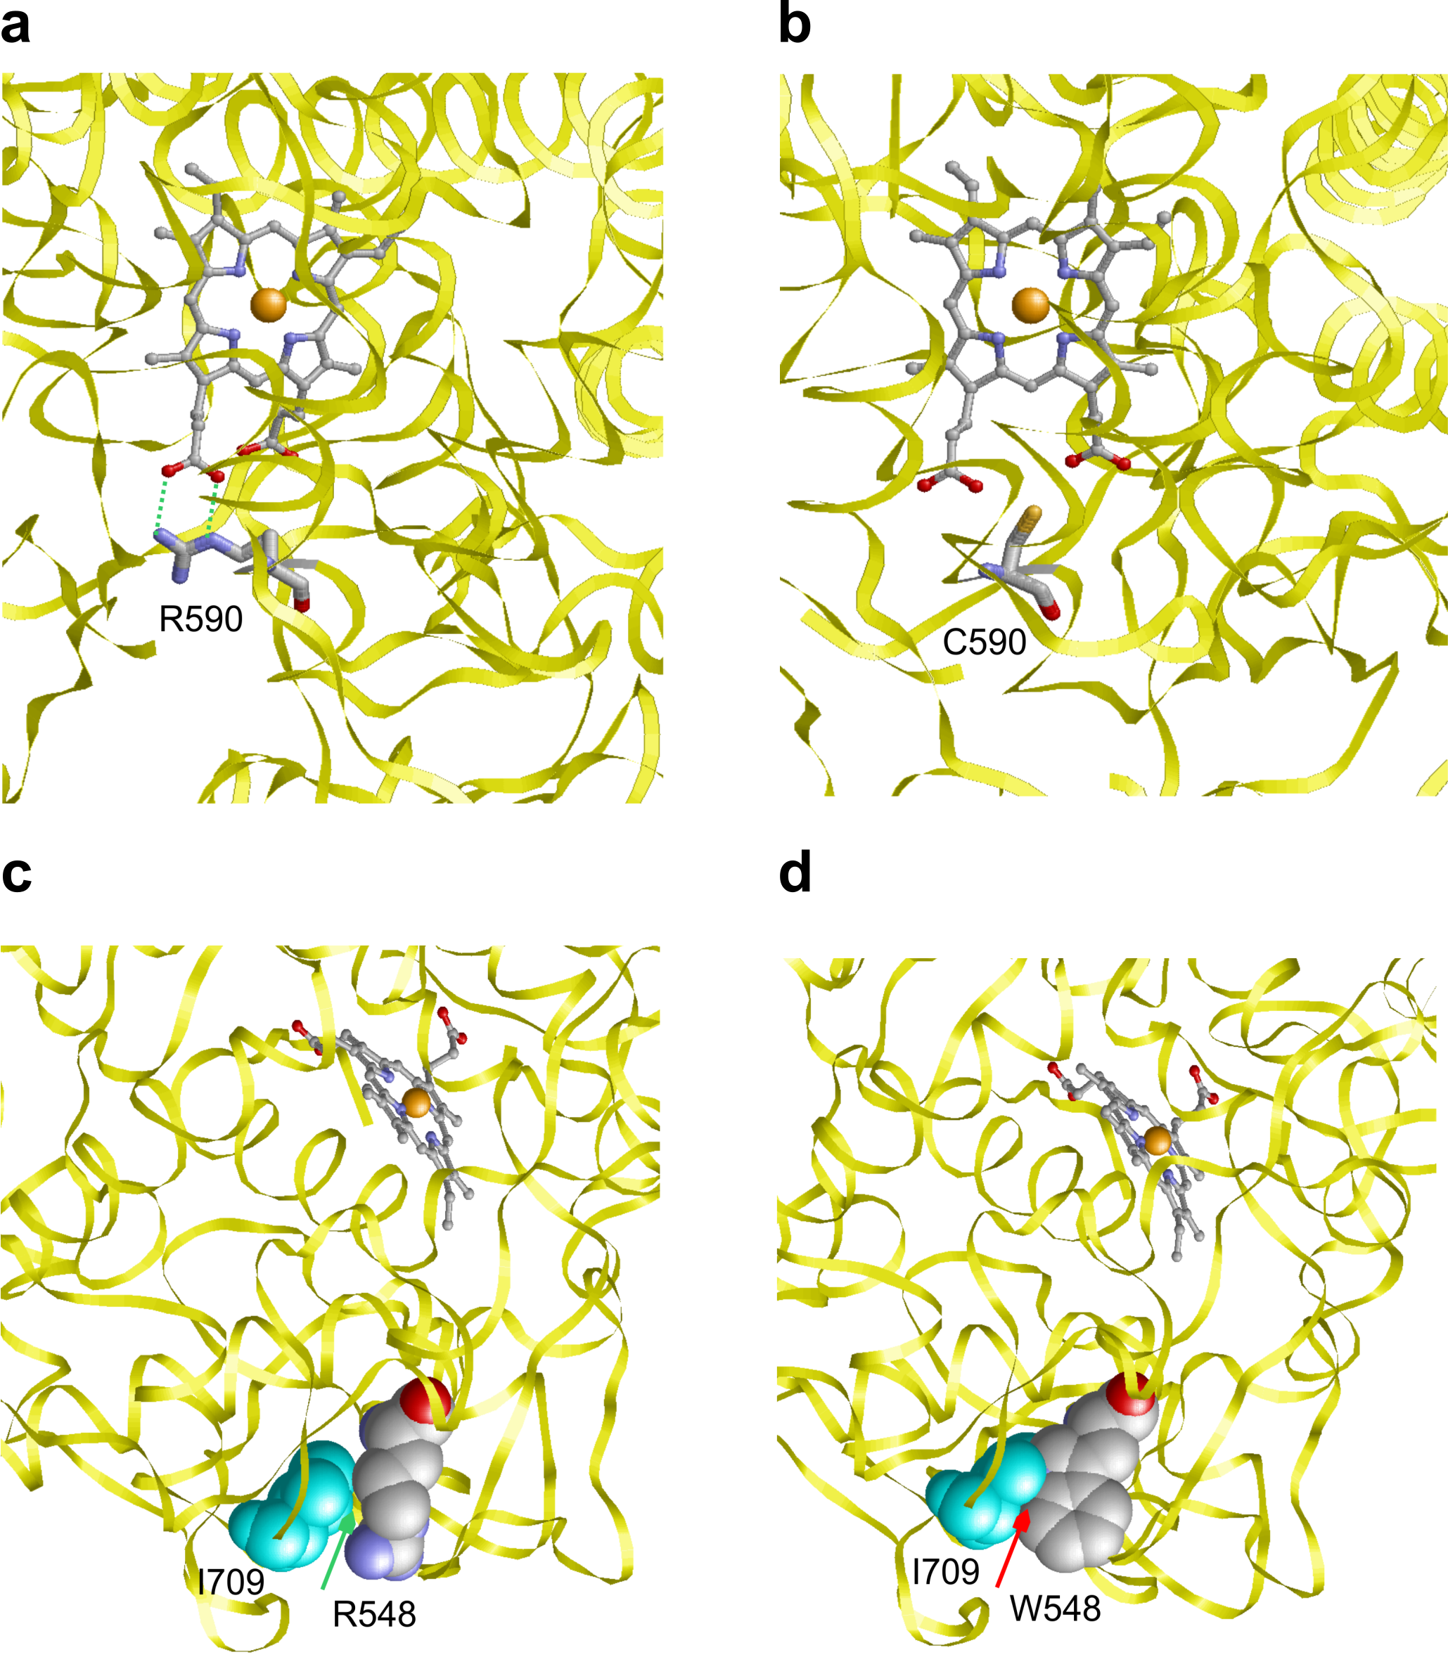
Figure 2: Structural models of MPO affected by the variants p.Arg590Cys and p.Arg548Trp
a The formation of hydrogen bonds between Arg590 and the heme molecule is highlighted by dotted green lines. b The side chain of Cys590 is unable to form hydrogen bonds. c A space-filled model of the interactions of I709 and R548. The green arrow indicates hydrophobic interactions. d A space-filled model of the interactions of I709 and W548. The red arrow indicates steric effects, a potential cause of protein instability.

MPO staining of neutrophils of a donor harboring the variant c.265_275dup(p.Ser94Alafs*24) was negative, indicating complete deficiency (Figure 3a). The splice site variant c.2031-2A<C was investigated by reverse transcription polymerase chain reaction (RT-PCR) in neutrophils of two patients, one heterozygous and one homozygous for this variant (Figure 3b). When sequenced, the more abundant splice product showed an inclusion of intron 11. A second splice product resulted from the inclusion of 109bp of intron 11 and was detected in case of the homozygous carrier as described previously {Marchetti, 2004 #1668}. Both splice products led to complete deficiency by a frameshift. To assess the further variants, mutant plasmids were generated and transfected in HEK cells followed by the determination of residual MPO activity in the supernatant. In comparison to the wild-type plasmid, the variants c.1642C>T/ p.(Arg548Trp), c.1705C>T/ p.(Arg569Trp) and c.1768C>T/ p.(Arg590Cys) lead to complete deficiency (Figure 3c). In contrast, the variants c.752T>C/ p.(Met251Thr) and c.995C>T/ p.(Ala332Val) had a residual activity of 15% and 37%, respectively. Considering the high number of heterozygous patients for an autosomal recessive disease model, quantitative changes of all coding regions were assessed to detect potential intragenic duplications or depletions, but not observed in any patient. The number of variants correlated significantly with MPO activity as measured with a fluorometric test ((Figure 3d, p=0.00093).
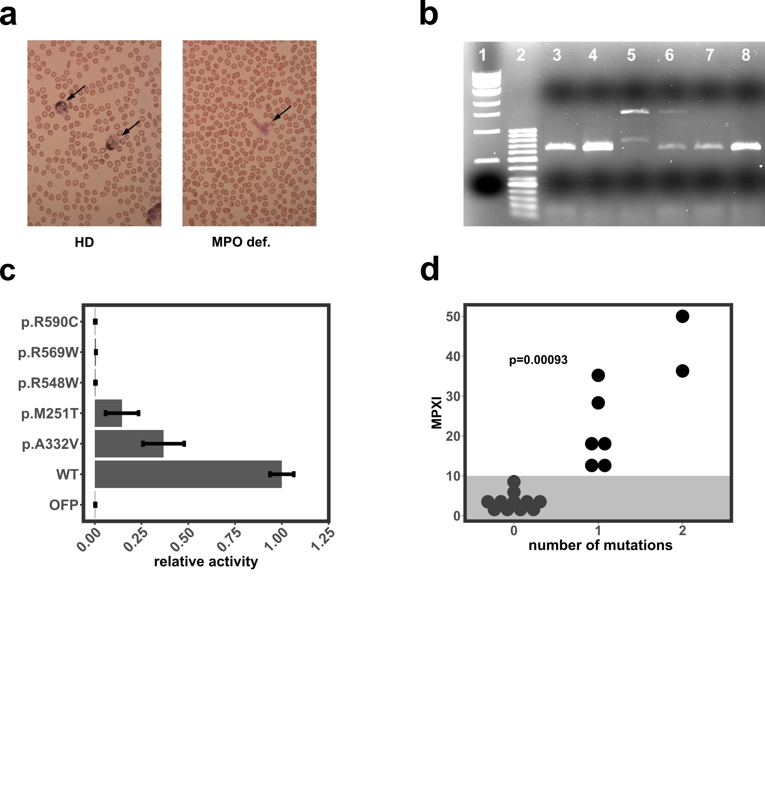
Figure 3: Functional tests of variants in MPO.
a MPO in neutrophils of a healthy donor (left) and of a patient with the homozygous variant c.265_275dup/ (p.Ser94Alafs*24) (right) were stained and analyzed visually by microscope. Neutrophils are marked by arrows and MPO is colored in blue-violet. b Gel electrophoreses of the splicing analysis of the variant c.2031-2A>C with two healthy donors (lane 3-4), one patient in homozygous state (l. 5), one heterozygous patient (l. 6) and two patients with a missense variant. Splicing analysis was performed by RT-PCR on RNA of neutrophils. The two alternative splicing products r.[2030_2031ins[2031-109_2031-1] and 2030_2031ins[2030+1_2031-1] are caused by insertion of 109 intronic base pairs and by insertion of intron 11, respectively. l.1: 1 kb ladder, l.2: 0.5 kb ladder. c Relative activity of mutant proteins in relation to the wild-type (WT) protein obtained from the supernatant of transfected of HEK cells. The orange fluorescent protein (OFP) was used as negative control. d The number of MPO variants correlated with MPO activity (MPXI) measured by a fluorometric and flow cytometry based method. A MPXI >10 indicates MPO-deficiency (white background). P-value obtained by ANOVA of a linear model. MPO def.= MPO-deficient, MPXI= Mittlerer (German: mean) Peroxidase Index
Overall, the frequency of functionally relevant variants (missense, truncating and splicing variants) were significantly higher in patients than in control individuals (12.8% versus 5.3%; p= 1.87E-04; OR = 2.61, Table 3). Variants leading to complete deficiency were significantly more frequent in GPP patients (9.8% versus 1.6%, p= 1.85E-08), while variants causing partial deficiency were not (3% versus 3.7%). These results strongly underlined that MPO-deficiency promotes GPP.
Table 3: Cumulative frequencies of MPO variants resulting in different degrees of MPO-deficiency.
P-values were calculated by Fisher’s exact test. NFE: non-Finnish European individuals of gnomAD {Karczewski, 2020 #1771}; OR= odds ratio; CI= confidence interval
Degree of MPO-deficiency by rare variants | Cumulative frequency in 82 patients (proportion of rare alleles) | Cumulative frequency in NFE of gnomAD (proportion of rare alleles) | p-value/ OR [95% CI]
Partial and complete | 12.8% (21/164) | 5.3% (5,858/110,052) | 1.87E-04/ 2.61 [1.57-4.15]
Complete | 9.8% (16/164) | 1.6% (1,809/110,052) | 1.85E-08/ 6.47 [3.60-10.89]
Partial | 3.0% (5/164) | 3.7% (4,049/110,052) | 0.84/ 0.82 [0.26-1.96]

IL36RN and MPO - an oligogenic model
To obtain evidence for an autosomal dominant or recessive model, the frequencies of individuals with one or with two variants in MPO and /or IL36RN in patients and control individuals were compared. The odds ratio was approximately ten times higher in case of the recessive model (31.6 versus 4.9). As expected, the odds ratios were higher when focusing on variants leading to complete deficiency (46.8 versus 10.9) and lower for variants leading to partial deficiency for both models (15.23 versus 1.46) (Table 4).

Table 4: Statistical analyses of different modes of inheritance based on 82 patients and 4,937 controls (1000 Genome Project, in-house exomes).
P-value calculated with Mann-Whitney U test. Abbreviations: 95% CI= 95% confidence interval; MPO-def.= MPO-deficiency; no.= number; OR= odds ratio.
 | Recessive |  |  | Dominant
Patients grouped by number of MPO variants and variants’ functional relevance (complete or partial MPO-deficiency) | Cumulative number of cases (frequency) | Cumulative number of controls (frequency) | p/ OR [95% CI] | Cumulative number of cases (frequency) | Cumulative number of controls (frequency) | p/ OR [95% CI]
All variants  - individuals with v.  - individuals without v. | 4 (4.9%) | 8 (0.16%) | <0.0001/  31.6 [9.32-107.12] | 17 (20.7%) | 250 (5.06%) | 0.0154/  4.90 [2.83-8.49]
 | 78 (95.1%) | 4,929 (99.84%) |  | 65 (79.3%) | 4,687 (94.9%)
Variants resulting in complete MPO-def.  - individuals with v.  - individuals without v. | 3 (3.7%) | 4 (0.1%) | <0.0001/  46.83 [10.31-212.72] | 13 (15.9%) | 84 (1.7%) | <0.0001/  10.88 [5.79-20.45]
 | 79 (96.3%) | 4,933 (99.9%) |  | 69 (84.1%) | 4,853 (98.3%)
Variants resulting in partial MPO-def.  - individuals with v.  - individuals without v. | 1 (1.2%) | 4 (0.1%) | 0.0154/  15.23 [1.68-137.73] | 4 (4.9%) | 168 (3.4%) | 0.47/  1.46 [0.53-4.02]
 | 81 (98.8%) | 4,933 (99.9%) |  | 78 (95.1%) | 4,769 (96.6%)
Σ = sum; n = number of patients; indiv. = individuals, WT = wildtype, v.= variant

Five of 17 patients with MPO variants did also carry variants in IL36RN, which raised the question whether the number of variants in IL36RN and MPO is a predictor for GPP. To investigate this gene dosage effect, the number of variants per individual in 82 patients and 4,937 controls (1000 Genomes and exomes of in-house control individuals) were determined. Only functionally relevant variants in MPO and IL36RN were considered (Table S 1, page 126). Patients carried significantly more variants in MPO than control individuals (Figure 4a, p=1.1 E-8). By including individuals with heterozygous IL36RN variants and omitting those with two variants in IL36RN, the difference was even more significant (Figure 4b, p=2.3E-12). Although the age of onset was comparable between patients with and without variants in MPO, four patients with two MPO variants had a lower age of onset (14.75 years) compared to 5 patients with single variants in both genes (24.60 years) and 65 patients without any variant in MPO (33.93 years; Table 5). The number of variants in MPO and IL36RN correlated inversely with age of onset (Figure 4c, p= 0.0018).
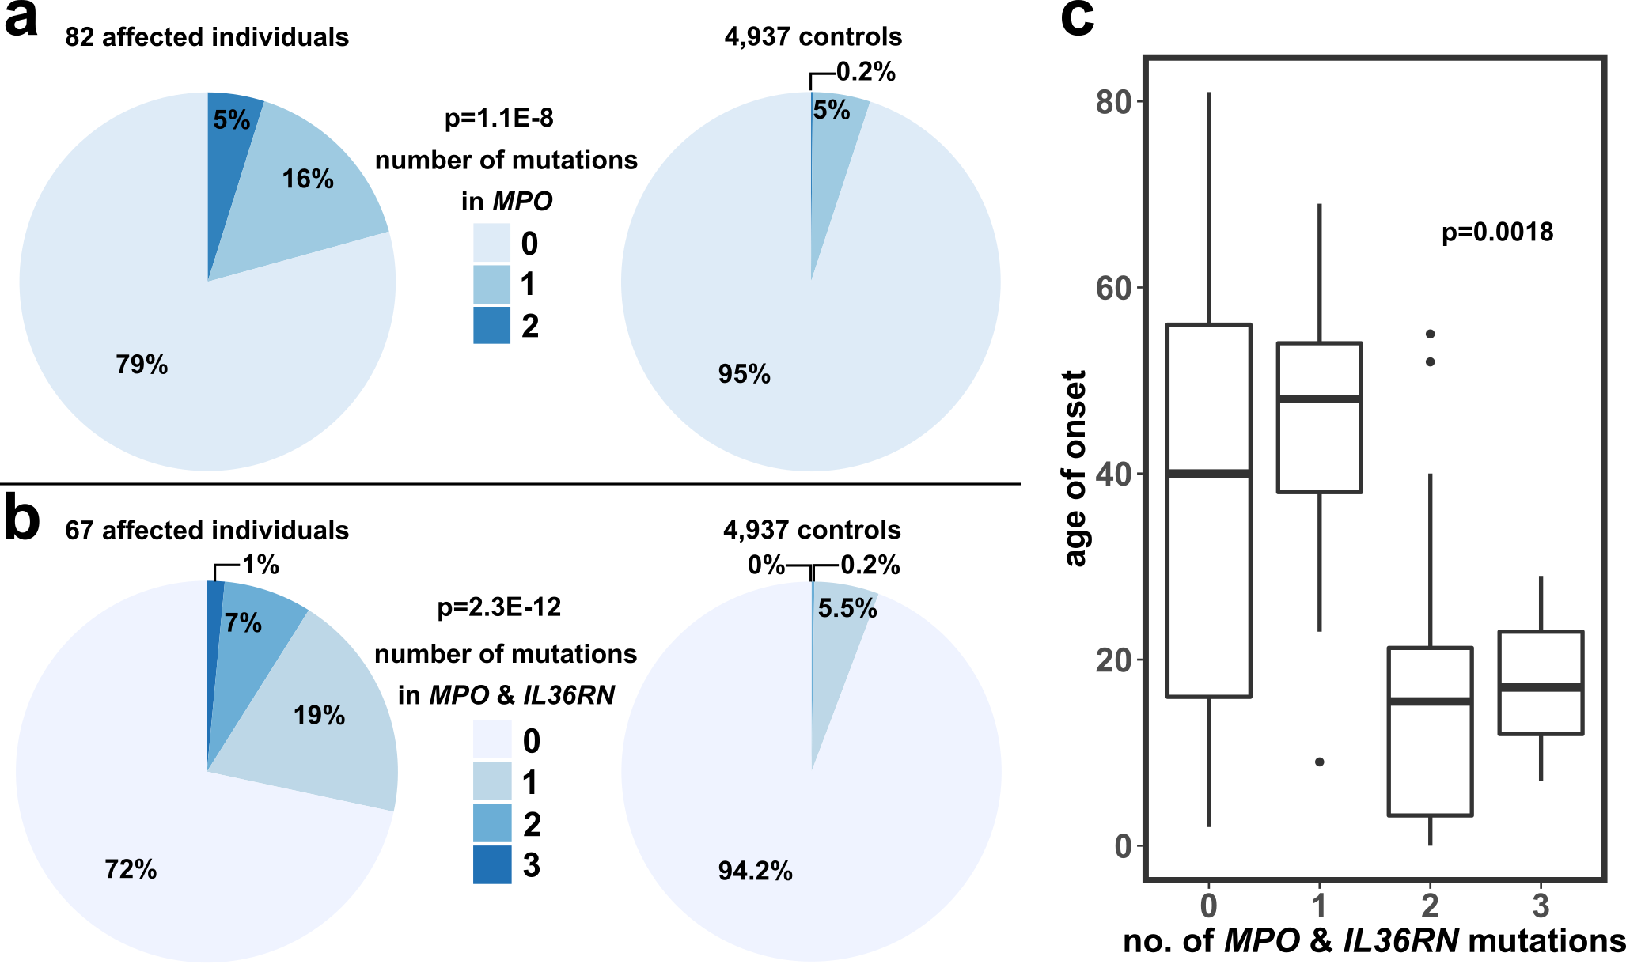
Figure 4: Number of disease-associated variants in IL36RN and MPO in patients with GPP and controls and relation to age of onset.
a-b Number of disease-associated variants in MPO (a) and both MPO and IL36RN (b) in patients (left) and control subjects (right) (in-house exomes, the 1000 Genomes project {Genomes Project, 2015 #1697}. The corresponding legend for each pie chart is positioned in the middle. In b, patients carrying homozygous variants in IL36RN are omitted. P-values were calculated by ANOVA of Firth’s logistic regression. c A boxplot illustrating the relation between the number of variants in MPO and IL36RN and the age of onset. P-value obtained by ANOVA of a linear model.
In summary, we found eight functionally relevant MPO variants in 17 GPP patients (~20% of patients). GPP is significantly associated with MPO variants leading to complete deficiency.

Phenotypic analysis of patients with and without variants in MPO
Out of 82 patients, more than 65% were female and the mean age at recruitment was 48.02 years. The disease course of most patients (76.8%) was episodic and average age of onset was 32.98 years. 61.5% of patients were additionally affected by other psoriatic diseases, including PsV(41.6%) and PPP (13.2%). About a quarter of patients were affected by inflammatory joints as well as nail and tongue involvement. Cholangitis was only present in two patients (2.6%) and 40.3% of patients had a positive family history of psoriasis.
Phenotypic analyses showed that, patients with variants in MPO were more frequently affected by concomitant palmoplantar pustular psoriasis (PPP), tongue involvement and a positive history of psoriasis and joint disease than patients without (Table 5). Patients with two variants in MPO or one variant in MPO and IL36RN had a lower age of onset compared to patients without MPO variants. The course of disease and the frequencies of further concomitant diseases were comparable between the groups.

Table 5: Clinical and phenotypic data of 82 patients summarized in total or grouped by variants in MPO and further sub-grouped by variants in IL36RN and by number of variants in MPO.
clinical characteristics | 82 cases | Σ 17 cases with MPO variants |  | Σ 17 cases with MPO variants |  | 65 cases without MPO variants
 |  | 4 cases with two MPO variants | 13 cases with one MPO variant | 5 cases with IL36RN & MPO variants | 12 cases with MPO but without IL36RN variants
gender - female  male | 54 (65.9%)  28 (34.1%) | 3 ((75.0%)  1 (25.0%) | 10 ((76.9%)  3 (23.1%) | 4 (80%)  1 (20%) | 9 (75.0%)  3 (25.0%) | 41 (63.1%)  24 (36.9%)
age at recruitment (average ± standard deviation; in years) | 48.02 ± 18.48 | 30.50 ± 20.49 | 55.58 ± 14.79 | 39.0 ± 14.71 | 50.36 ± 22.82 | 47.68 ± 18.43
age of onset (average ± standard deviation; in years) | 32.98 ± 22.46 | 14.75 ± 11.18 | 34.27 ± 20.95 | 24.60 ± 18.73 | 31.30 ± 21.93 | 33.93 ± 22.97
course of disease episodic  constant | 53 (76.8%)  16 (23.2%) | 2 (66.7%)  1 (33.3%) | 10 (83.3%)  2 (16.7%) | 4 (80%)  1 (20%) | 8 (66.7%)  2 (33.3) | 41 (75.9%)  13 (24.1%)
concomitant psoriatic disease (any) yes  no | 48 (61.5%)  30 (38.5%) | 4 (100%)  0 (0%) | 7 (41.7%)  5 (58.3%) | 5 (100%)  0 (0%) | 6 (54.5%)  5 (45.5%) | 37 (59.7%)  25 (40.3%)
palmoplantar pustular psoriasis yes  no | 10 (13.2%)  66 (86.8%) | 1 (25.0%)  3 (75.0%) | 3 (25.0%)  9 (75.0%) | 1 (20%)  4 (80%) | 3 (27.3%)  8 (72.7%) | 6 (10.0%)  54 (90.0%)
clinical characteristics | 82 cases | Σ 17 cases with MPO variants |  | Σ 17 cases with MPO variants |  | 65 cases without MPO variants
 |  | 4 cases with two MPO variants | 13 cases with one MPO variants | 5 cases with IL36RN & MPO variants | 12 cases with MPO but none in IL36RN variants
psoriasis vulgaris yes  no | 32 (41.6%)  45 (58.4%) | 1 (25.0%)  3 (75.0%) | 5 (41.7%)  7 (58.3%) | 2 (40%)  3 (60%) | 4 (36.4%)  7 (63.6%) | 26 (42.6%)  35 (57.4%)
inflammatory joint involvement yes  no | 19 (24.7%)  58 (75.3%) | 1 (25.0%)  3 (75.0%) | 2 (16.7%)  10 (83.3%) | 2 (40%)  3 (60%) | 1 (9.1%)  10 (90.9%) | 16 (26.2%)  45 (73.8%)
nail involvement yes  no | 21 (27.3%)  56 (72.7%) | 1 (25.0%)  3 (75.0%) | 3 (25.0%)  9 (75.0%) | 2 (40%)  3 (60%) | 2 (18.2%)  9 (81.8%) | 17 (27.9%)  44 (72.1%)
tongue involvement yes  no | 20 (27.0%)  54 (73.0%) | 3 (75.0%)  1 (25.0%) | 5 (41.7%)  7 (58.3%) | 3 (60%)  2 (40%) | 5 (45.5%)  6 (54.5%) | 12 (20.7%)  46 (79.3%)
cholangitis yes  no | 2 (2.6%)  75 (97.4%) | 0 (0%)  4 (100%) | 0 (0%)  12 (100%) | 0 (0%)  5 (100%) | 0 (0%)  11 (100%) | 2 (3.3%)  59 (96.7%)
family history positive  negative | 31 (40.3%)  46 (59.7%) | 2 (50.0%)  2 (50.0%) | 7 (58.3%)  5 (41.7%) | 4 (80%)  1 (20%) | 5 (45.5%)  6 (54.5) | 22 (36.1%)  39 (63.9%)

Pathomechanisms in GPP triggered by MPO-deficiency

Enzyme activity of serine proteases inversely correlated with MPO activity
The activity of serine proteases NE, CTSG, PR3 and the monocytic protease CTSS was analysed in neutrophilic or monocytic lysate of patients and correlated it with the MPO activity. The activity of all four proteases negatively correlated with MPO activity (Figure 5a). The correlation may be rather exponential than linear, especially in the case of MPO and the monocytic protease CTSS. These findings suggest that, at high MPO activity, fewer IL-36 cytokines are activated by those enzymes, but at low MPO activity, many IL-36 cytokines are activated. The overall activity of these proteases was not different compared to four HDs (Figure 5b). This prompted the investigation of further potential mechanisms.
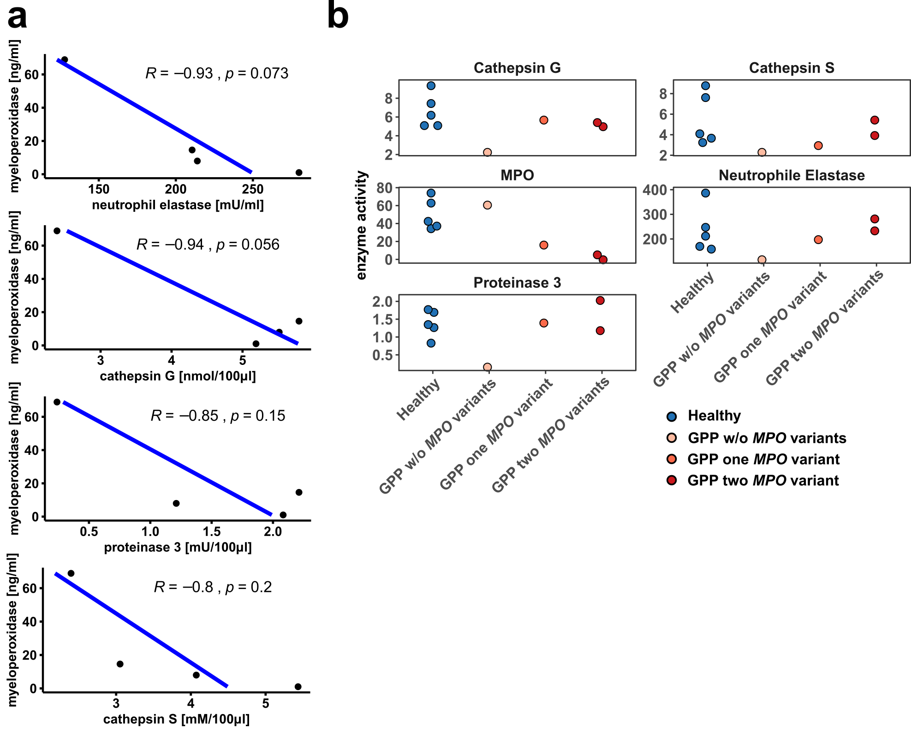
Figure 5: Correlation of the enzyme activity of MPO and the activities of four serine proteases in patients and healthy donors.
a Negative correlation of enzyme activity of MPO and four serine proteases in four patients. R= Spearman’s correlation coefficient, p-value according to Pearson’s correlation. b Enzyme activity of four different serine proteases. Data obtained from five healthy donors and four patients with different degrees of MPO-deficiency. Units of enzyme activities are the same as in a. w/o= without

MPO-deficiency impaired the formation of neutrophil extracellular traps
As MPO is the main neutrophilic enzyme, the formation of neutrophil extracellular traps (NETs) induced by two pathways was investigated. PMA-stimulated neutrophils of MPO-deficient patients showed a significantly reduced NET formation compared to HDs (p=0.015, Figure 6). No difference was observed after adding the calcium ionophore A23187 or in unstimulated neutrophils.
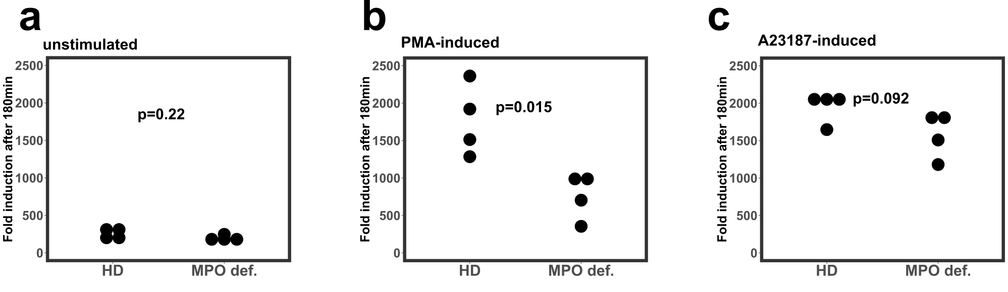
Figure 6: Analysis of the formation of neutrophil extracellular traps in three MPO-deficient patients and four healthy donors (HDs).
a-c NET formation was investigated without stimulation (a), with PMA (b) and A23187 (c). Data normalized to vehicle control and shown as fold induction compared to the starting point. MPO def.= MPO-deficient

MPO-deficiency reduced phagocytosis of neutrophils by monocytes
Histologically, pustules filled with neutrophils are typical for GPP. The process of removal of dying neutrophils by phagocytes (e.g. monocytes) is called efferocytosis. In order to investigate whether the accumulation of neutrophils is due to reduced efferocytosis, murine Mpo^{-/-} monocytes and neutrophils were co-cultured for one day and the number of residual neutrophils was determined. The number of remaining neutrophils was significantly higher compared to WT controls (p=0.02, Figure 7a). When efferocytosis of neutrophils by CD14⁺ monocytes was assessed in cells of MPO-deficient patients compared to healthy donors (HDs), the difference was even more significant compared to the murine model (p= 0.0046, Figure 7b). The number of remaining neutrophils of the patient without MPO variants was lower compared to MPO-deficient patients but higher than in healthy donors. Since MPO is expressed in neutrophils and monocytes, neutrophils of HDs were combined with MPO-deficient monocytes and vice versa. The results suggested that MPO-deficiency of both - monocytes and neutrophils - contributed to reduced efferocytosis (Figure 7c).
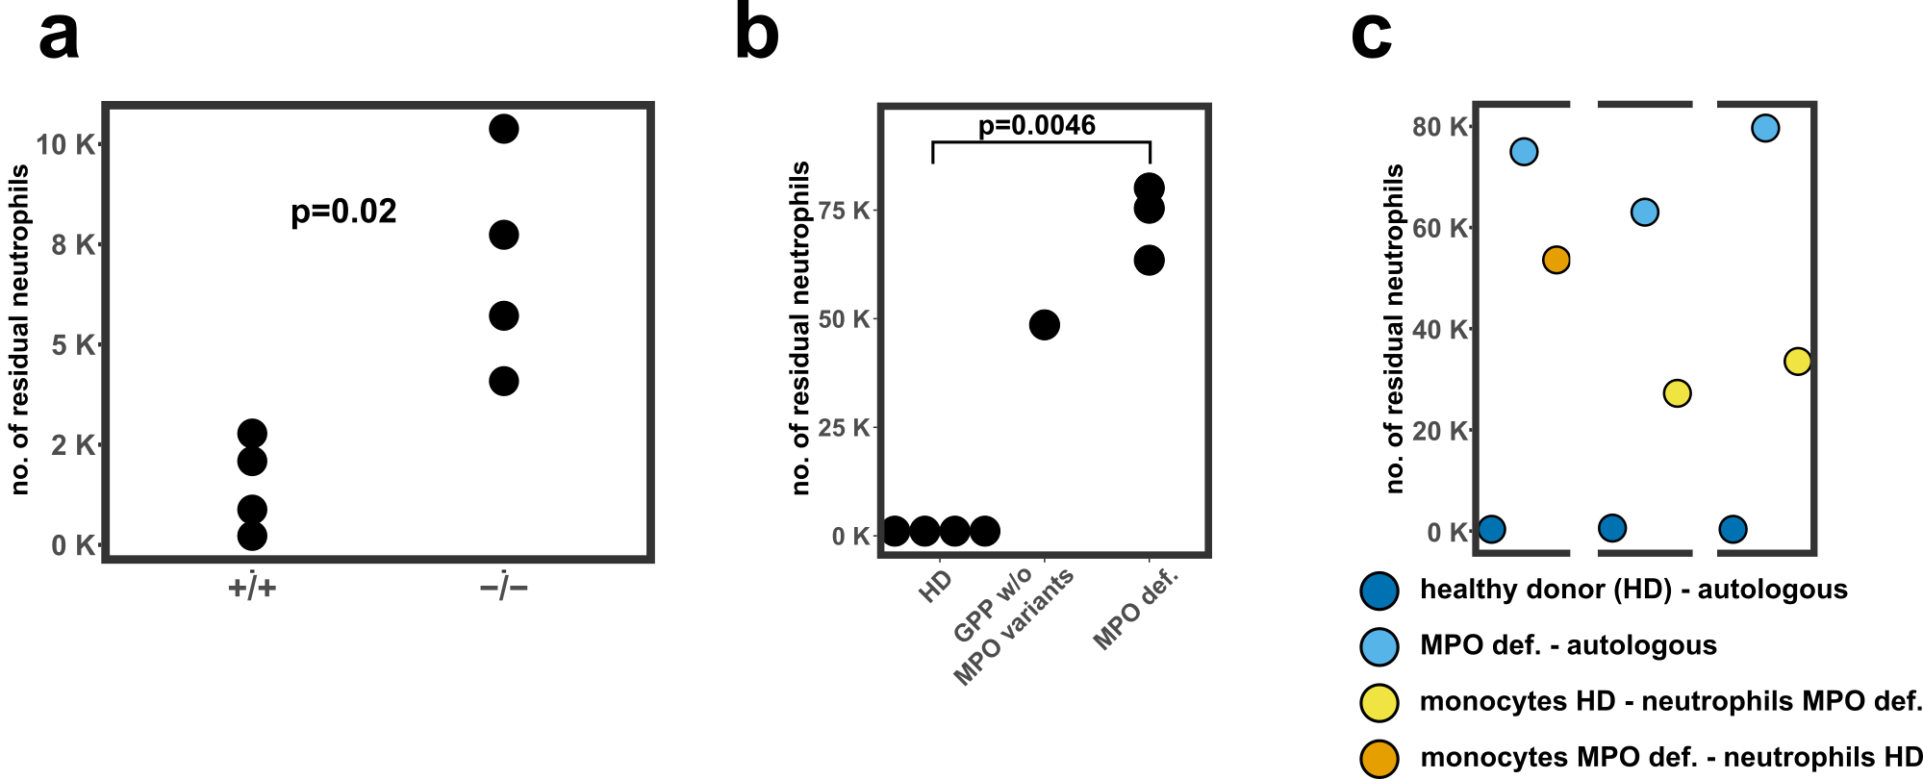
Figure 7: Phagocytosis of neutrophils by monocytes in mice and human with MPO-deficiency.
a-c Number of residual neutrophils indicating non phagocytosed neutrophils after one day of co-incubation of monocytes and neutrophils (a) in wild type (+/+) and Mpo-deficient mice (-/-), (b) in human donors including four healthy donor (HDs), one patient without and three patients with MPO-deficiency and (c) with combinations of neutrophils and monocytes from patients and HDs. Each of the separated parts contains two autologous combinations of one patient and one HD together with the corresponding allogenic one (orange or yellow). P-values were calculated with Welch Two Sample t-test. MPO def.= MPO-deficient, w/o= without
Flow cytometry analysis demonstrated that CD47, one of the molecules known to be involved in efferocytosis, was nominally, but not significantly higher expressed on MPO-deficient neutrophils compared to neutrophils of HDs (p=0.17, Figure 8a). When pathway analysis of differentially expressed genes (DEGs) based on scRNAseq in CD14⁺ monocytes was performed (Figure 8b), several pathways related to phagocytosis were detected as significantly downregulated: “autophagy”, “phagocytosis of phagocytes”, “immune responses of phagocytes”, “phagocytosis of myeloid cells”. Four of 20 most downregulated pathways were related to efferocytosis. Two exemplary genes contributing to the enrichment of these pathways were SPI1 and CYBA (Figure 8c). These genes were downregulated 1.93-fold and 2.63-fold in MPO-deficient patients, respectively.
To sum up, MPO-deficiency altered neutrophilic and monocytic functions. Consequently, the activity of IL-36 activating enzymes were increased and NET formation as well as the phagocytosis of neutrophils by monocytes was impaired in vitro.
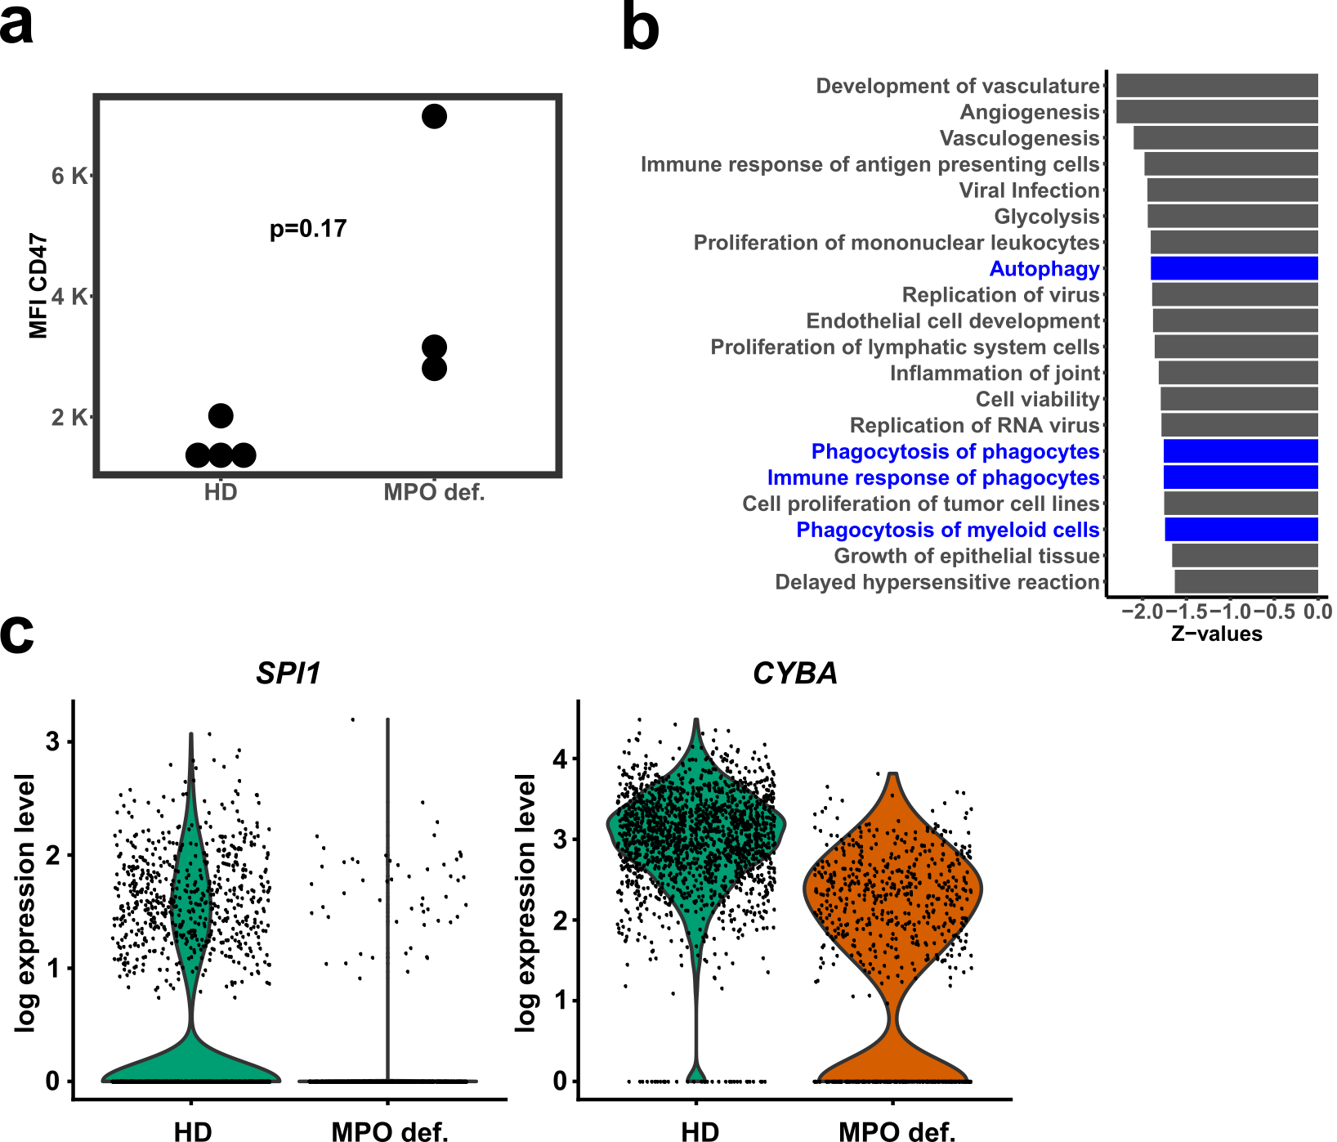
Figure 8: Staining of CD47 on neutrophils and transcriptional analysis of monocytes of MPO-deficient patients and healthy donors.
a Mean fluorescent intensity (MFI) of CD47 expression on neutrophils of four healthy donors (HDs) and three MPO-deficient (MPO def.) patients. P-value was calculated with Welch Two Sample t-test. b The most downregulated pathway in CD14⁺ monocytes of patients compared to HDs resulted from Ingenuity pathway analysis (Qiagen) based on differentially expressed genes. Only the most downregulated pathways are listed and pathways connected to phagocytosis are colored in blue. c Violin plot illustrating the expression level of each cell (dots) and the distribution of the expression in HDs and MPO-deficient patients. Both genes are part of downregulated phagocytosis pathways. MPO def.= MPO-deficient

The role of MPO in other psoriatic diseases

Segregation analysis in eight families of MPO-deficient patients
As described in chapter 4.1.3, GPP patients with MPO variants were affected more often by PPP and exhibited more often a family history of psoriasis than those without (Table 5). }Therefore, the association of variants in MPO and other psoriatic diseases was investigated. Segregation analysis of variants in MPO, IL36RN, and CARD14 was performed in 25 available family members of seven patients with GPP and one with AGEP (Figure 9). Four index patients carried a heterozygous MPO variant, while two were homozygous and one compound heterozygous for MPO variants. Only the index patients were affected by GPP or AGEP in their families. Out of 25 family members, one was affected by PPP, two by inflammatory joint disease and 14 by PsV. Six out of twelve sequenced members with PsV were heterozygous for MPO variants (50%), while eight of 13 healthy members were heterozygous for MPO variants (62%).
Considering only variants leading to complete deficiency, the majority of members with PsV were heterozygous (6 of 10, 60%), while the proportion of healthy members with those MPO variants was slightly higher (7 of 11, 64%). In pedigree VI & VII, two fathers with two heterozygous variants in IL36RN and MPO were unaffected, while the corresponding mothers carrying one and two IL36RN variant were affected by PsV (Figure 9, Pedigree VI & VII).

Genetic analysis of MPO variants in four psoriatic subtypes
The segregation analysis was inconclusive as to whether variants in MPO may contribute to susceptibility for psoriatic diseases. Therefore, we genotyped 3,663 individuals affected by PsV (n=1,105), PsA (n=1,313), PPP (n=271) and by SAPHO syndrome (n=52) as well as 922 control individuals for the seven most common variants in MPO (Table 6). Quality control was performed by additional sanger sequencing of all rare genotypes and random controls as well as genotyping the numerous subjets with different assays. We determined the cumulative frequencies of these MPO variants in four psoriatic subtypes and two control groups including German individuals and 64,591 non-Finnish Europeans from gnomAD. The cumulative frequencies in PsA and PsV were comparable to the two control groups, while the one in SAPHO syndrome was slightly increased. In contrast, the frequency of MPO variants was significantly increased in patients with PPP (controls: 4.35%, PPP: 6.7%, p=0.015, Table 6). At single SNP level, the variant c.995C>T/p.(Ala332Val) was significantly more frequent in PPP patients (p= 0.008), and c.1555_1568del/p.(Met519Profs*21) in PsV patients (p=0.032).

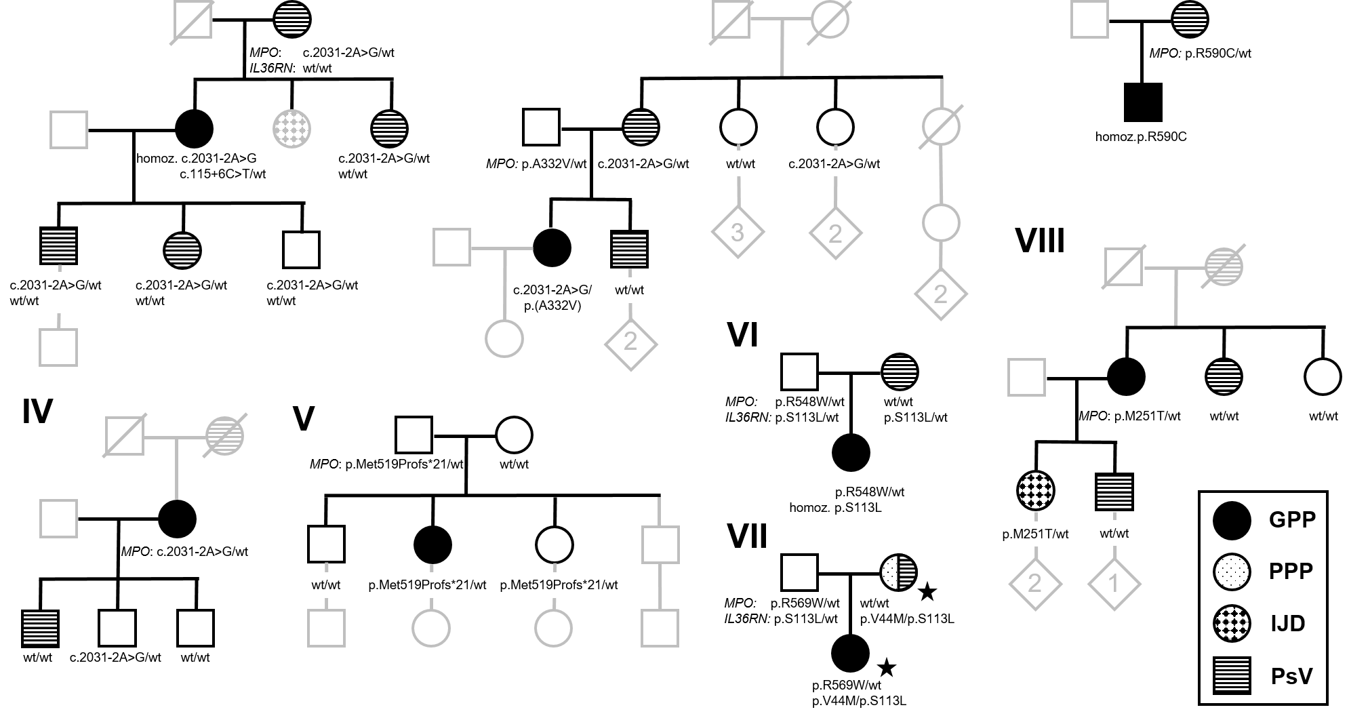
Figure 9: Segregation analysis of MPO and IL36RN variants in eight families of MPO-deficient GPP and AGEP patients.
The legend (right lower corner) explains the meaning of different symbols. Faded symbols represent individuals that were unavailable for analysis. Variants in MPO and IL36RN are below each symbol, while CARD14 variants were not identified in the index patients. The star highlights IL36RN variants in compound heterozygous state in family VII. GPP, generalized pustular psoriasis; homoz., homozygous; IJD, inflammatory joint disease; PPP, palmoplantar pustulosis; PsV, psoriasis vulgaris; wt, wild type.

The number of variants in MPO did not differ significantly between patients and controls, even though the overall frequency of patients with two variants was 1.5-fold increased compared to controls (Table 7). The highest frequency of individuals with two variants was in PPP (0.74%) and PsV patients (0.54%) compared to controls (0.4%). When numbers of variants in MPO and IL36RN were considered together, no significant differences were detected (Table 8).
In total, we found eleven patients and two controls with two variants in MPO (Table 9). Most combinations lead to an estimated deficiency between 65-90%. Of note, one patient with PsA with total MPO-deficiency (homozygous for c.1555_1568del/ p.(Met519Profs*21)) had the lowest age of onset (10 years). Overall, the age of onset did not correlate with the number of MPO variants in each disease group and all patients combined (Figure 10). Moreover, the severity of PsV and a positive family history of psoriasis were not associated with variants in MPO (Table 10, Table 11).
In summary, variants in MPO were significantly associated with PPP due to the variant c.995C>T/ p.(Ala332Val) (p=0.015). However, the p-value did not withstand correction for multiple comparisons according to Bonferroni. Bi-allelic variants in MPO may contribute to PPP and PsV.

Table 6: Allele numbers and frequencies of pathogenic variants in MPO in patients affected with PsV (n= 1,105), PsA (n= 1,313), PPP (n= 271) and SAPHO syndrome (n= 52) compared to 922 German control individuals and 64,591 Non-Finnish European individuals (NFE) of gnomAD {Karczewski, 2020 #1771}.
P-values were calculated with Fisher’s exact test, but not adjusted for the number of tests (four psoriatic subtypes).
 | Psoriasis subtypes |  |  |  | Control individuals
Variant at nucleotide/ protein level | PsV  n (%) | PsA  n (%) | PPP  n (%) | SAPHO syndrome  n (%) | Control indiv.  n (%) | NFE indiv.  n (%)
c.752T>C/p.(Met251Thr) | 27 (1.22) | 38 (1.45) | 8 (1.48) | 2 (1.92) | 25 (1.36) | 1,735 (1.34)
c.995C>T/p.(Ala332Val) | 33 (1.49) | 38 (1.45) | 19 (3.51) | 1 (0.96) | 34 (1.84) | 2,314 (1.79)
c.1555_1568del/ p.(Met519Profs*21) | 6 (0.27) | 6 (0.23) | 2 (0.37) | 1 (0.96) | 2 (0.11) | 0 (.15)
c.1642C>T/p.(Arg548Trp) | 0 (0) | 0 (0) | 0 (0) | 0 (0) | 1 (0.05) | 67 (0.05)
c.1705C>T/p.(Arg569Trp) | 6 (0.27) | 6 (0.23) | 3 (0.55) | 1 (0.96) | 3 (0.16) | 370 (0.29)
c.1768C>T/p.(Arg590Cys) | 0 (0) | 0 (0) | 0 (0.00) | 0 (0.00) | 0 (0) | 9 (0.01)
c.2031-2A>C | 15 (0.68) | 15 (0.57) | 4 (0.74) | 1 (0.96) | 11 (0.6) | 936 (0.72)
Σ mutant alleles | 87 (3.94) | 103 (3.92) | 36 (6.64) | 6 (5.77) | Σ 5,696 (4.35)
Σ WT alleles | 2,123 (96.06) | 2,523 (96.08) | 506 (93.36) | 98 (94.23) | Σ 125,330 (95.65)
p-value | n.s (0.399) | n.s. (0.333) | 0.015 | n.s.(0.464)
Σ = sum; n = number of patients; indiv. = individuals, WT = wildtype.

Table 7: Numbers and frequencies of MPO variants in patients affected with PsV (n= 1,105), PsA (n= 1,313), PPP (n= 271) and SAPHO syndrome (n= 52) compared to control individuals (922 German control individuals, 404 of Non-Finnish European individuals from the 1000 Genomes Project, 2,433 in-house exomes).
A logistic regression analysis was performed and the p-value was calculated by ANOVA.
No. of MPO variants | PsV  n (%) | PsA  n (%) | PPP  n (%) | SAPHO syndrome  n (%) | 2,741 psoriasis patients  n (%) | 3,759 control indiv.  n (%)
2 | 6 (0.54) | 3 (0.23) | 2 (0.74) | 0  (0) | 11  (0.40) | 10  (0.27)
1 | 75 (6.79) | 97 (7.39) | 24 (8.86) | 6  (11.54) | 202  (7.37) | 285  (7.58)
0 | 1,024 (92.67) | 1,213 (92.38) | 245 (90.41) | 46  (88.46) | 2,528  (92.23) | 3,464  (92.15)
 |  |  |  |  | p-value: 0.94
n= number of patients, no.= number, indiv.= individuals

Table 8: Numbers and frequencies of MPO and IL36RN variants in patients affected with PsV (n= 1,105), PsA (n= 1,313), PPP (n= 271) and SAPHO syndrome (n= 52) compared to control individuals (922 German control individuals, 404 of Non-Finnish European individuals from the 1000 Genomes Project, 2,433 in-house exomes).
A logistic regression analysis was performed and the p-value was calculated by ANOVA.
No. of MPO & IL36RN variants | PsV  n (%) | PsA  n (%) | PPP  n (%) | SAPHO syndrome  n (%) |  | 1,771 psoriasis patients  n (%) | 3,759 control indiv.  n (%)
2 | 4  (0.56) | 1  (0.13) | 2  (0.79) | 0  (0) |  | 7  (0.4) | 15  (0.4)
1 | 58  (8.2) | 62 (8.17) | 28 (11.07) | 8  (15.69) |  | 156  (8.81) | 310  (8.25)
0 | 646 (91.24) | 696 (91.7) | 223 (88.14) | 43  (84.31) |  | 1,608  (90.8) | 3,434  (91.35)
 |  |  |  |  |  | p-value: 0.53
n= number of patients, no.= number, indiv.= individuals

Table 9: Phenotypical characteristics of eleven patients and ten controls with two MPO variants.
Psoriasis subtype/ control group | Variant at nucleotide/ protein level | estimated MPO-deficiency in % | Age of onset | Family history of psoriasis | Severity of disease | Details on manifestations, concomitant psoriatic disease
PsV | c.2031-2A>C + c.752T>C/ p.(Met251Thr) | 90% | 39 | unknown | unknown | plaques at hands
PsV | c.995C>T/ p.(Ala332Val) + c.1705C>T/ p.(Arg569Trp) | 83% | unknown | unknown | unknown | unknown
PsV | c.995C>T/ p.(Ala332Val) + c.1555_1568del/ p.(Met519Profs*21) | 83% | 27 | negative | mild | nails affected
PsV | c.995C>T/ p.(Ala332Val) + c.1555_1568del/ p.(Met519Profs*21) | 83% | 20 | positive | unknown | unknown
PsV | c.752T>C/ p.(Met251Thr) + c.995C>T/ p.(Ala332Val) | 73% | 25 | positive | intermediate | nail dystrophy
PsV | homoz. c.995C>T/ p.(Ala332Val) | 65% | 23 | positive | mild | toenails affected
PsA | homoz. c.1555_1568del/ p.(Met519Profs*21) | 100% | 10 | negative | n.a. | polyarthritis; PsV
PsA | c.2031-2A>C + c.752T>C/ p.(Met251Thr) | 90% | 21 | negative | n.a. | oligoarthritis; hands affected; PsV
PsA | homoz. c.752T>C/ p.(Met251Thr) | 80% | 22 | positive | n.a. | enthesitis; polyarthritis; hands affected; PsV
PPP | c.995C>T/ p.(Ala332Val) + c.1555_1568del/ p.(Met519Profs*21) | 83% | 46 | positive | n.a. | number of pustules >60; hands and palms affected; nails affected; PsV capitis
PPP | c.995C>T/ p.(Ala332Val) + c.1555_1568del/ p.(Met519Profs*21) | 83% | 20 | negative | n.a. | number of pustules >60; hands and palms affected; nails affected; PsV capitis
German control | c.2031-2A>C + c.752T>C/ p.(Met251Thr) | 90%
German control | c.2031-2A>C + c.752T>C/ p.(Met251Thr) | 90%
German control | c.752T>C/ p.(Met251Thr) + c.995C>T/ p.(Ala332Val) | 73%
in-house exomes | c.2031-2A>C + c.1907C>T/ p.(Thr636Met) | 100%
in-house exomes | c.2031-2A>C + c.1907C>T/ p.(Thr636Met) | 100%
in-house exomes | c.752T>C/ p.(Met251Thr) + c.1555_1568del/ p.(Met519Profs*21) | 90%
in-house exomes | homoz. c.325delA/ p.(A108fs5) | 100%
1000 Genomes | c.1642C>T/ p.(Arg548Trp) + c.518A>G/ p.(Tyr173Cys) | 100%
1000 Genomes | c.2031-2A>C + c.752T>C/ p.(Met251Thr) | 90%
1000 Genomes | homoz. c.752T>C/ p.(Met251Thr) | 80%

homoz. = homozygous, n.a. = not applicable

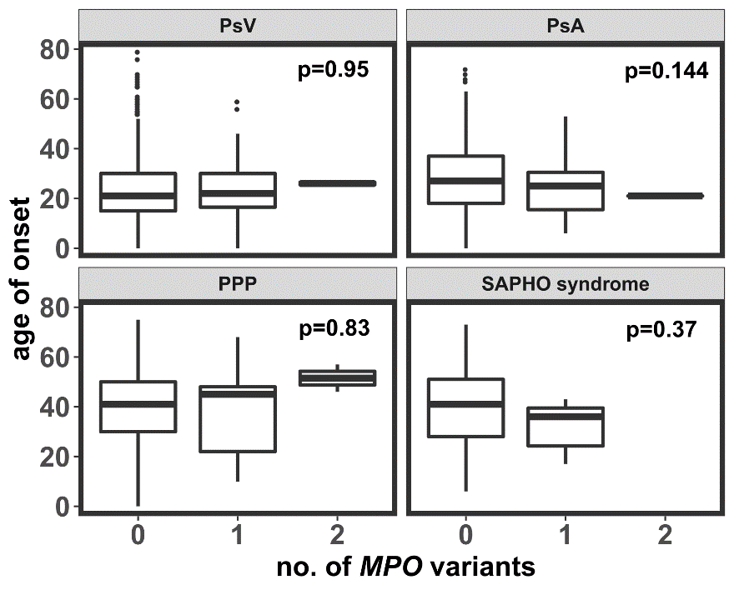
Figure 10: The correlation of age of onset and variants in MPO in patients affected with PsV (n= 1,003), PsA (n= 1,145), PPP(n= 201) and SAPHO syndrome (n= 48).
P-values obtained by ANOVA of a linear model
Table 10: Numbers and frequencies of the number of MPO variants and the severity of PsV in 580 patients. Severity was assessed by dermatologists considering the PASI score and general symptoms.
P-values obtained by ANOVA of a linear model indicate the difference between patients with no variant and patients with one or two variants.
 | Severity of PsV
No. of MPO variants | mild  n (%) | intermediate  n (%) | severe  n (%) | p-value
0 | 200  (90.5) | 232  (93.17) | 105  (95.45) | 0.09
1 | 20  (9.05) | 16  (6.43) | 5  (4.55)
2 | 1  (0.45) | 1  (0.4) | 0  (0)
n = number of patients

Table 11: Family history of psoriasis in patients (PsV: n=1,214 with, PsA: n=1,054, PPP: n=192, SAPHO syndrome: n=28) with and without variants in MPO.
Psoriasis subtype | family history of psoriasis |  |  |  | P-value
 | negative |  | positive
 | Patients without MPO variant  n (%) | Patients with MPO variant  n (%) | Patients without MPO variant  n (%) | Patients with MPO variant  n (%)
PsV | 621 (93.2) | 44 (6.6) | 507 (92.3) | 42 (7.7) | n.s.
PsA | 588 (93.2) | 43 (6.8) | 388 (91.9) | 35 (8.3) | n.s.
PPP | 108 (85.7) | 18 (14.3) | 58 (87.9) | 8 (12.1) | n.s.
SAPHO  syndrome | 20 (87) | 3 (13) | 4 (80) | 1 (20) | n.s.
Σ | 1,337 (92.5) | 108 (7.5) | 957 (91.8) | 86 (8.2) | n.s.
n = number of patients, Σ = sum, n.s. = not significant

Cellular and molecular features in GPP patients
To understand molecular and cellular players mediating inflammation in GPP, transcriptome analysis of peripheral immune cells was performed in two patients in relatively stable disease state and in one patient during an acute episode.

Cellular composition of PBMCs in GPP patients
To investigate cellular factors in GPP, scRNAseq was performed in two MPO-deficient GPP patients (GPP1 and GPP2) with MPO variants on both alleles and three HDs. GPP1 also carried a heterozygous variant in IL36RN (Table S 2, page 133). This patient was analyzed in two separate experiments, as the number of cells was low in the first experiment. .
In total 20,508 cells passed the quality control, and annotation of the cells by multimodal reference mapping was based on a dataset with more than 100k cells containing the information of the transcriptome and expression of 228 antigens on single-cell level {Hao, 2021 #1856}. Overall, 31 different cell types were annotated and visualized in the reference uniform manifold approximation and projection (refUMAP), which is a dimensionality reduction plot (Figure 11a). While some clusters could have been easily assigned by known markers (Figure 11b), rarer cell types such as innate lymphoid cells could not be identified by single markers. In general, the T cell landscape of GPP patients was dominated by T cell effector cells, while the one of HDs was dominated by naïve T cells (Figure 12a-b). The largest difference was visible in CD4⁺ cytotoxic T cells (CTLs), as cells of GPP patients made up 92.5% of this cluster (Figure 12a-b). The same tendency was observed in case of CD4⁺ effector memory T cells (71%) and CD8⁺ effector memory T cells (62%). CD4⁺ naïve cells (76.6%) and CD8⁺ naïve T cells (71.8%)were more frequent in HDs . Considering rarer cell types, innate lymphoid cells (ILCs) and gamma delta T cells (gdT cells) were more frequent in GPP patients (76% and 65%, respectively), while plasmablasts were very common in HDs (92.8%).
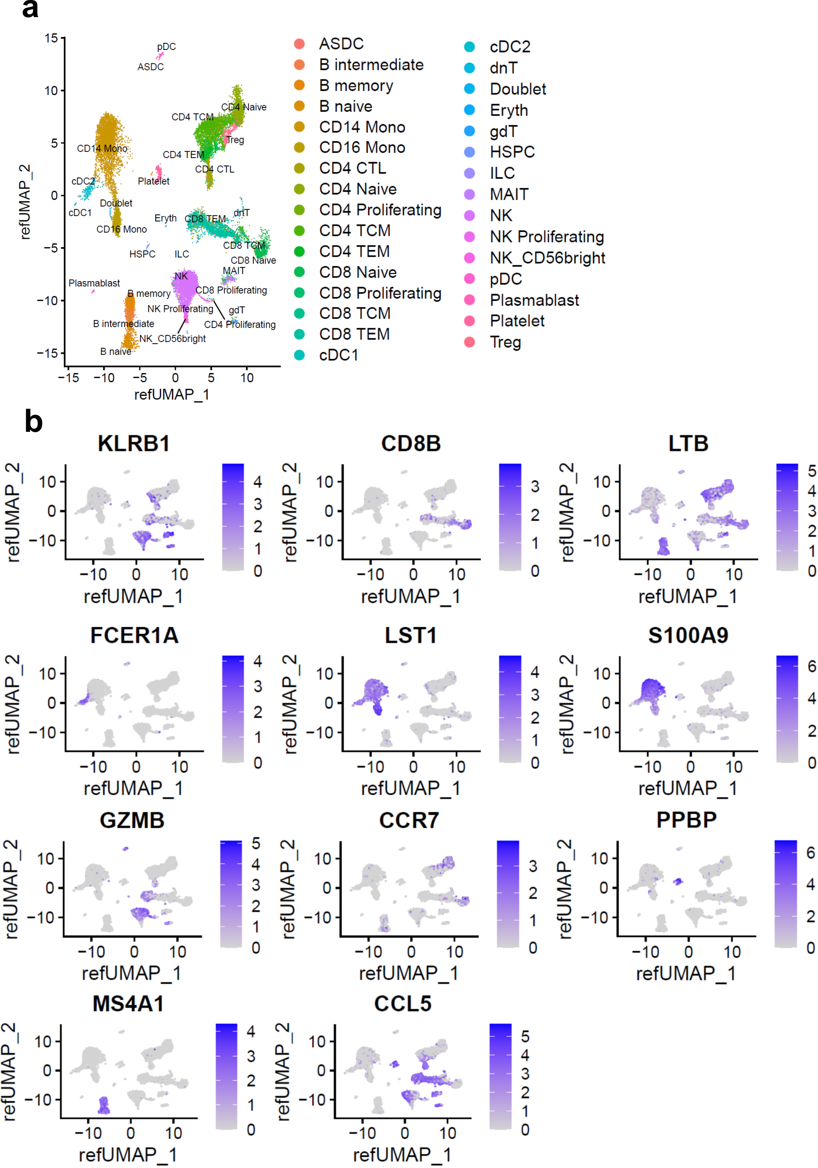
Figure 11: Single-cell RNA transcriptomics of peripheral mononuclear blood cells (PBMCs) obtained from two MPO-deficient patients and three healthy donors.
a RefUMAP of PBMCs colored by cluster annotation. Descriptions of cell types are given in Table 12. b RefUMAP colored by the expression of known markers for prominent cell types: KLRB1 - NK cells and T cell effector cells , CD8B - CD8⁺ T cells, LTB - lymphocytes, FCER1A - dendritic cells, LST1 - monocytes and dendritic cells, S100A9 - CD14⁺ monocytes, GZMB - cytotoxic lymphocytes, CCR7 - naïve T cells, PPBP - platelets, MS4A1 - B cells, CCL5 - T cell effector cells. refUMAP: reference uniform manifold approximation and projection
Table 12: Description of cell types annotated by multimodal reference mapping as described previously {Hao, 2021 #1856}.
cell types | description
ASDC | dendritic cells defined by the expression of AXL and SIGLEC6
B intermediate | intermediate B cells
B memory | memory B cells
B naive | naive B cells
CD14 Mono | CD14⁺ monocytes
CD16 Mono | CD16⁺ monocytes
CD4 CTL | CD4⁺ cytotoxic T lymphocyte
CD4 Naive | CD4⁺ naive T cell
CD4 Proliferating | CD4⁺ proliferating T cell
CD4 TCM | CD4⁺ central memory T cell
CD4 TEM | CD4⁺ effector memory T cell
CD8 Naive | CD8⁺ naive T cell
CD8 Proliferating | CD8⁺ proliferating T cell
CD8 TCM | CD8⁺ central memory T cell
CD8 TEM | CD8⁺ effector memory T cell
cDC1 | CD141⁺ conventional dendritic cell
cDC2 | CD1C⁺ conventional dendritic cell
dnT | double negative (CD4, CD8) T cell
Doublet | CD16⁺ CD14⁺ monocytes
gdT | gamma/delta T cell
HSPC | hematopoietic stem cell progenitor cell
ILC | innate lymphoid cell
MAIT | mucosal associated invariant T cell
NK | natural killer cell
NK Proliferating | proliferating natural killer cell
NK_CD56bright | natural killer cell with high expression of CD56
pDC | plasmacytoid dendritic cells
Plasmablast | Plasmablast
Treg | regulatory T cell

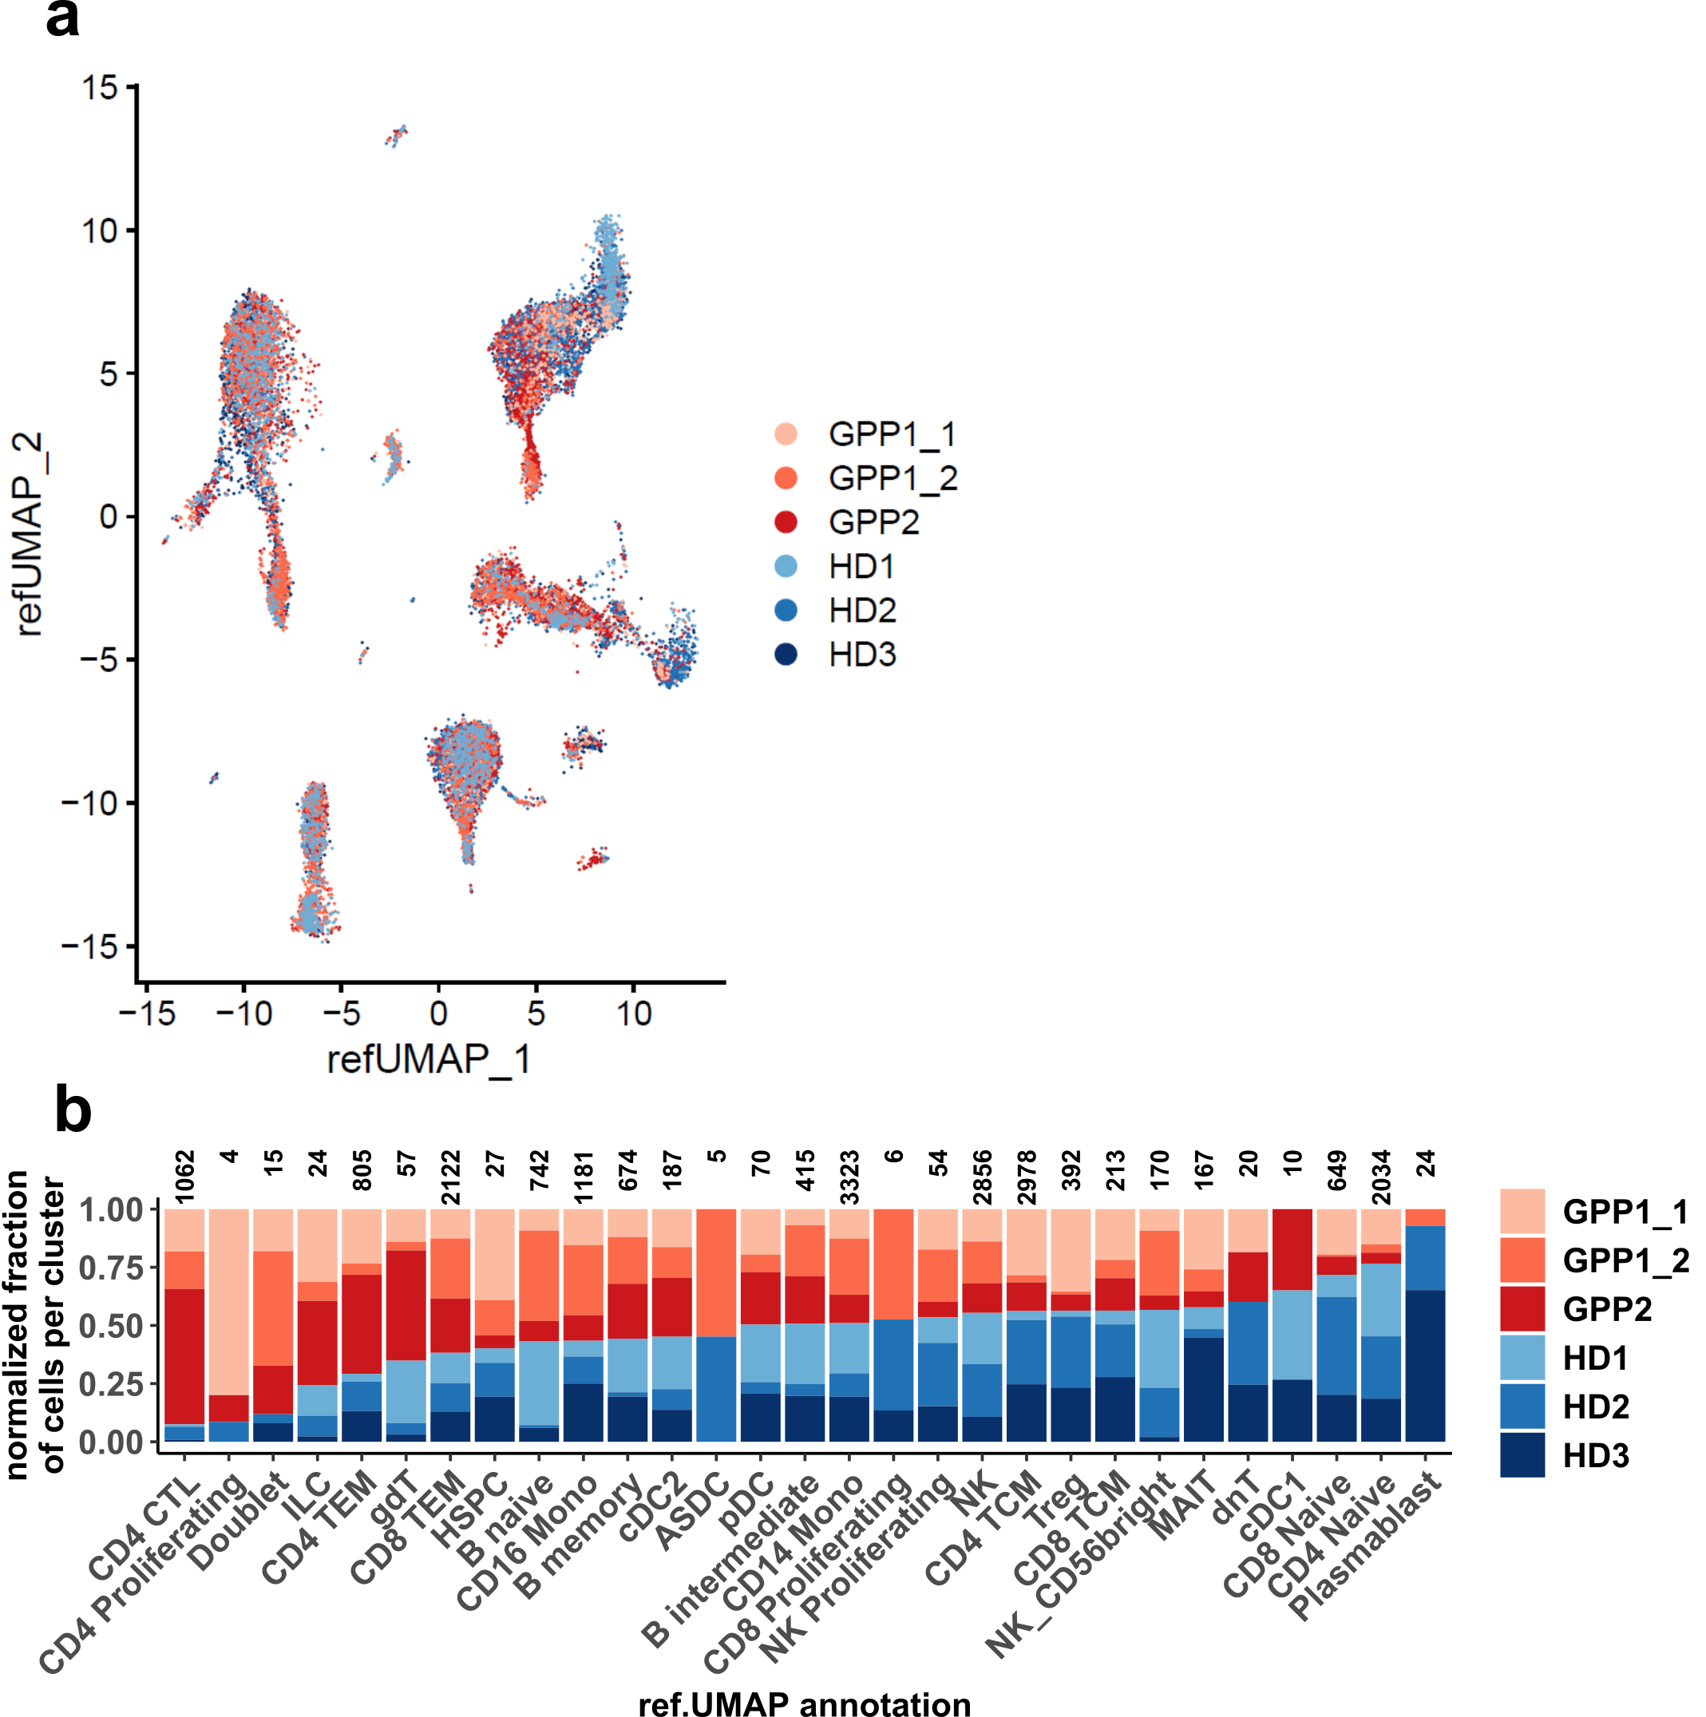
Figure 12: Proportions of cell types of PBMCs based on single-cell RNA transcriptomics.
a RefUMAP of PBMCs colored by individual sample. b Proportions of cell type per donor normalized on total number of cells per donor and ordered by descending proportions of GPP cells. Numbers at the top show total raw cell counts for each cell type. Descriptions of cell types are given in Table 12.
In order to investigate, if these findings could also be confirmed by unsupervised clustering on RNA level only, a UMAP was calculated resulting in 16 clusters (Figure 13a). The resolution between CD4⁺ and CD8⁺ T cell subset was less sharp compared to the RefUMAP (Figure 13a,c). GPP cells were more common in cluster 1 (75%), which represented mainly CD4⁺ CTLs (35%) and CD8⁺ TEMs (35%) according to the reference mapping (Figure 13b,d). The majority of cells in cluster 11 were cells of HDs (75%) and cluster 11 represented mainly CD4⁺ naïve (65%). To conclude, the skewed T cell distribution was detected on RNA level as well, also demonstrated by the UMAP colored by individuals (Figure 13d).
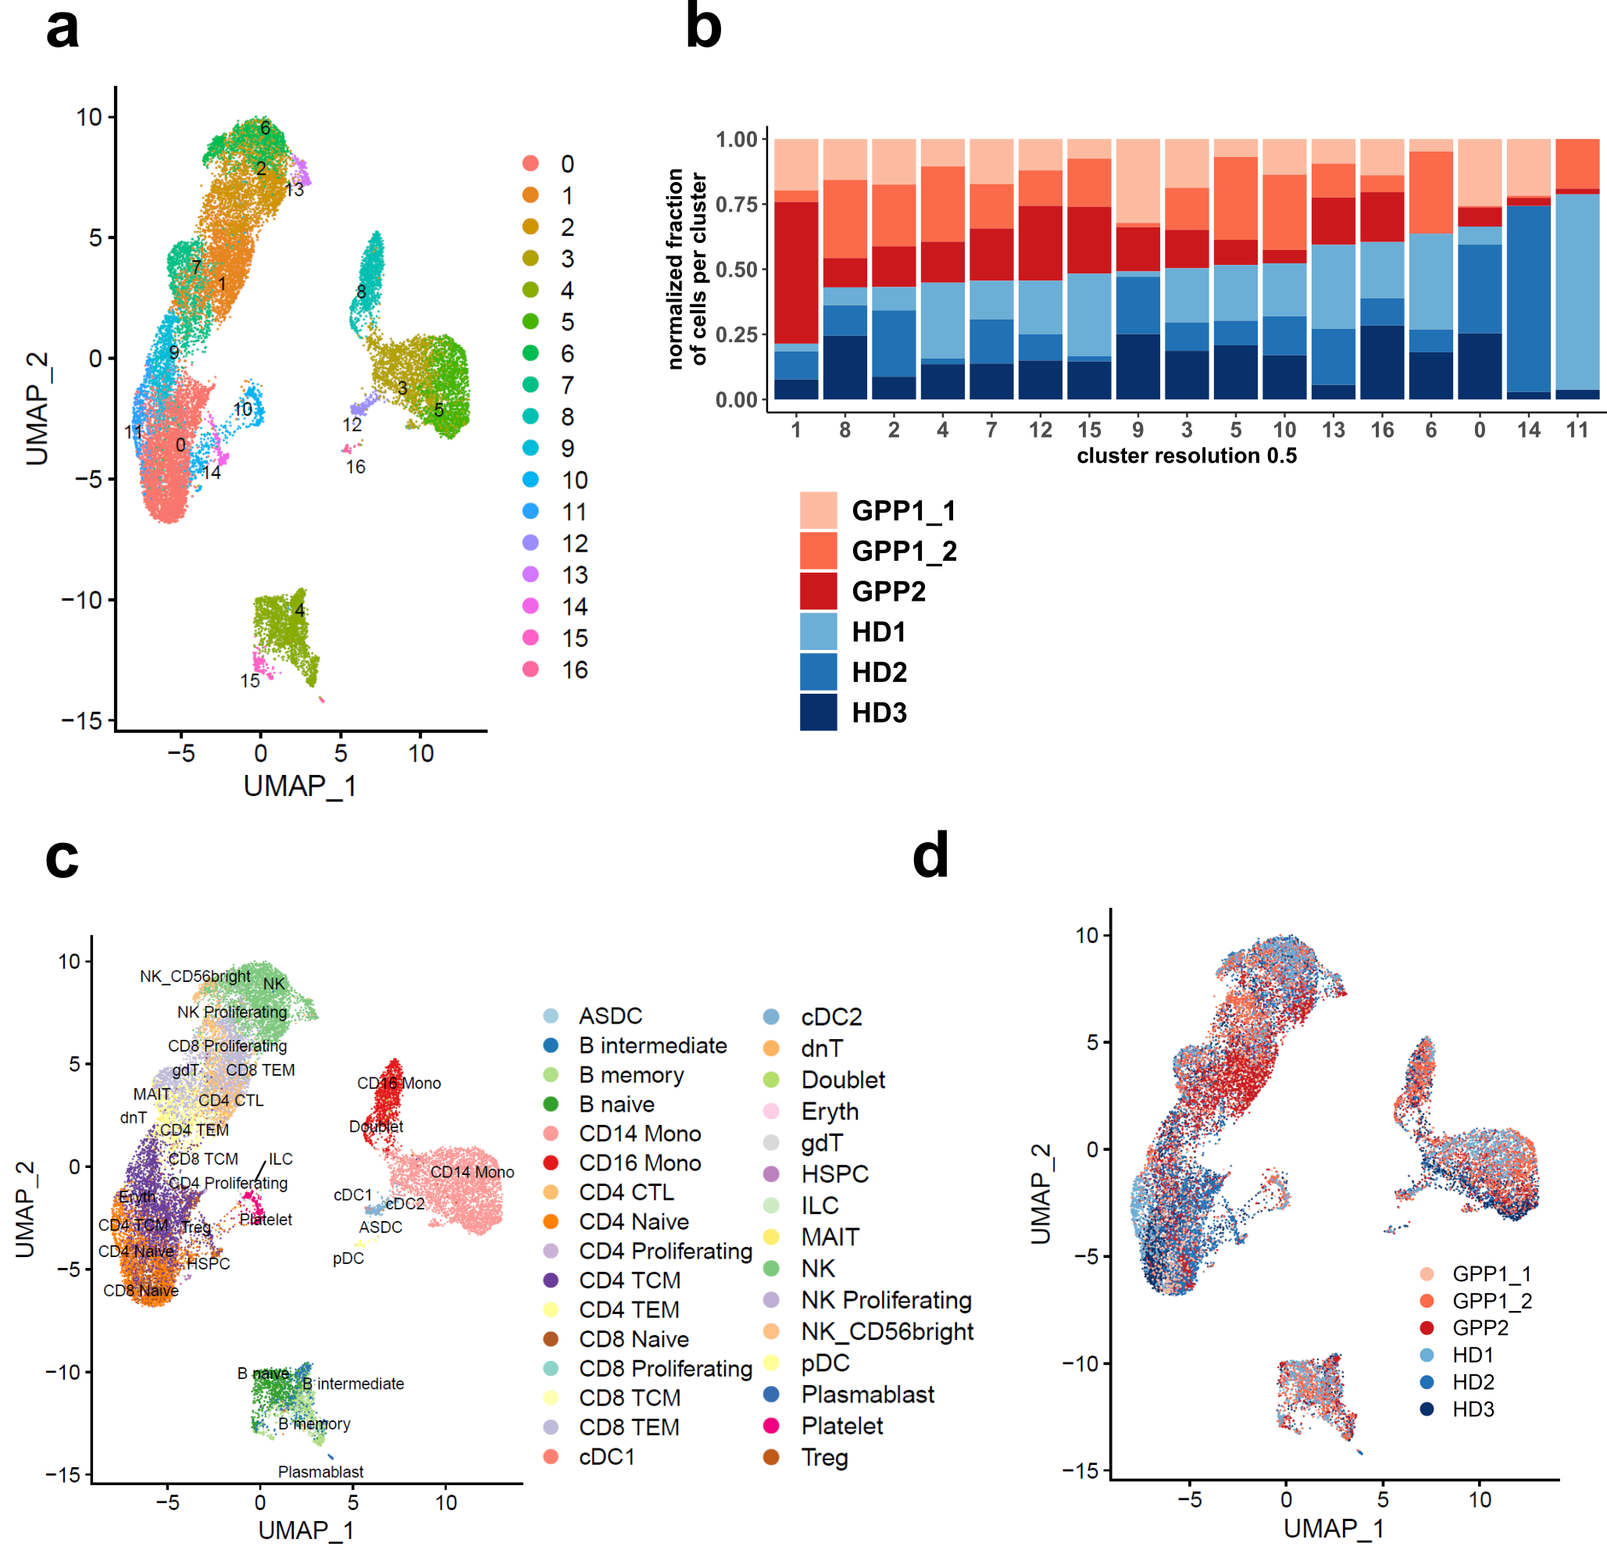
Figure 13: Analysis of single-cell RNA sequencing data using an unsupervised clustering algorithm.
a UMAP colored by 17 clusters based on unsupervised clustering using shared nearest neighbor clustering algorithm. b Proportions of cell type per donor normalized on the total number of cells per donor based on unsupervised clustering. c-d UMAP colored by 31 annotated cell types of refUMAP (c) or by sample (d). Description of cell types as given in Table 12).
In the next step, I aimed to confirm the different cluster proportions of CD4⁺ CTLs, CD4⁺ TEMs and CD8⁺ TEMs, since the cluster annotation based on multimodal reference mapping is a new method. The intracellular proteins GZMA, GZMK and KSP37 (encoding FGFBP2) were the best-conserved markers between patients and healthy donors of each cell type based on scRNAseq data with a commercially available antibody for flow cytometry analysis (Figure 14a). The expression of these markers in conjunction with the known broad cell markers CD3, CD4, CD8 and CD56 were used for flow cytometry analysis of three MPO-deficient patients (GPP1, GPP2 and GPP3 (partially deficient) and four HDs (Table 13 & Figure 14c)). Flow cytometry analysis confirmed the significantly higher proportions of CD4⁺ CTLs based on their corresponding markers KSP37 and Granzyme A in GPP patients compared to healthy donors (CD4⁺ CTLs p= 0.04, Figure 14b), while the proportions of CD8⁺ TEMs and CD4⁺ TCM were nominally, but not significantly increased. In contrast to the proportions based on the RefUMAP (Figure 12b), NK cells were significantly decreased in GPP patients (p= 0.02). Although CD8⁺ TCM were decreased in GPP patients compared to HD, this difference was not significant. The proportions of CD4⁺ TEMs were similar between groups.
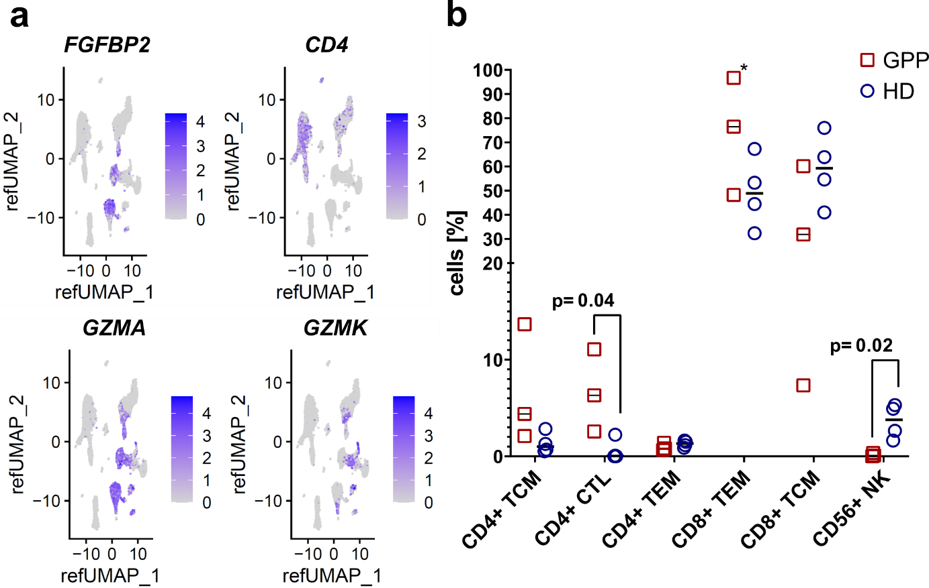
Figure 14: Markers of effector T cell subsets and their protein expression analyzed by flow cytometry.
a RefUMAP colored by gene expression of four markers of T cell subsets including CD4⁺ CTLs and CD8⁺ TEMs. b Analysis of proportions of lymphocytes subsets based on protein expression of GZMA, GZMK and KSP37 (FGFPB2) in CD4⁺ T cells, CD8⁺ T cells and CD56⁺ NK cells detected by flow cytometry. The identifying markers are given in Table 13. GPP1 was completely MPO-deficient, while GPP2 (two variants) and GPP3 (one variant) were partially MPO-deficient. The percentage of CD8+ TEMs of patient GPP3 are marked with an asterisk.
Table 13: Combination of protein markers for T cell subsets used for flow cytometry.
cell type | combination of markers
 | GZMA | KSP37 | GZMK
CD4⁺ CTLs | + | + | -
CD4⁺ TCM | + | - | -
CD4⁺ TEM | - | - | +
CD8⁺ TEM* | +* | +* | +*
CD8⁺ TCM | - | - | -
CD56⁺ NK | + | + | +
*CD8⁺ cells that were positive for either GZMA, KASP37 or GZMK were defined as CD8⁺ TEM
Additionally, the skewed T cell distribution was confirmed by an independent flow cytometry analysis using a different set of markers. The effector T cells CD4⁺ EFF and CD4⁺ TEM were both significantly increased in GPP patients compared to healthy donors ( p= 0.0095 and p= 0.0332, respectively). As expected, the proportions of CD4⁺ naïve T cells and CD4⁺ helper T cells were significantly decreased in GPP. The proportions CD8⁺ T cell subsets were not significantly different, while CD8⁺ Eff was nominally increased in GPP patients. When the proportions of T cell effector subsets Th1, Th2, Th17 and Tregs were compared, I did not detect significant difference.

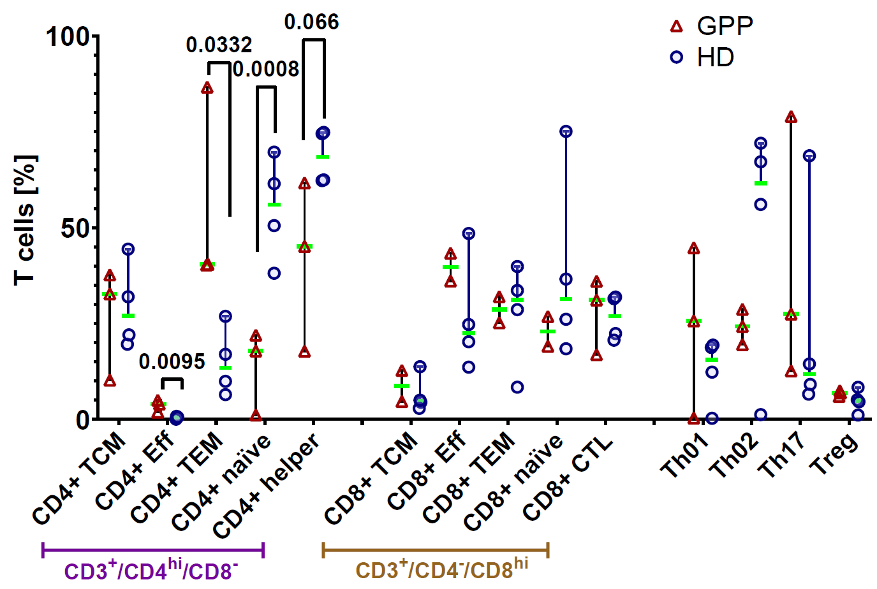
Figure 15: The proportions of T cell subsets analyzed by flow cytometry
Flow cytometry analyses of three MPO-deficient patients and four healthy donors. All T cells are CD3⁺. Cell types are defined the following: CD4+ TCM: CD197⁺ CD45RA⁻, CD4+ EFF: CD197⁻CD45RA⁺, CD4+ TEM: CD197⁻CD45RA⁻, CD4+ naïve: CD197⁺CD45RA⁻, CD4+ helper: CD4⁺, CD8+ TCM: CD197⁺ CD45RA⁻, CD8+ EFF: CD197⁻CD45RA⁺, CD8+ TEM: CD197⁻CD45RA⁻, CD8+ naïve: CD197⁺CD45RA⁻, CD8+ CTL: CD8⁺, Th01: CD3⁺CD4⁺CD183⁺CD196⁻, Th02: CD3⁺CD4⁺CD183⁻CD196⁻, Th17: CD3⁺CD4⁺CD183⁻CD196⁺, Treg: CD3⁺CD4⁺CD25⁺CD127^{lo/-}{Ruhle, 2016 #1882}
To investigate if CD4⁺ CTLs and CD8⁺ TEMs are more common in patients, targeted gene expression analysis of the marker gene FGFBP2 in RNA from whole blood was performed. The study group included five HD and five GPP patients without pathogenic variants in IL36RN and MPO, three patients with one (n=1) or two (n=2) IL36RN variants, five patients with one (n=4) or two (n=1) variants in MPO and two patients with variants in both genes (Table S 2, page 133). The expression of FGFBP2 was significantly higher in patients with disease-associated variants in IL36RN and MPO compared to HDs and patients without variants (Figure 16a, p= 0.0015). FGFBP2 was also expressed in NK cells. However, NK cells were equally distributed in GPP patients and HDs based on our scRNAseq data and less frequent in GPP according to the flow cytometry analysis (Figure 12b & Figure 14b). Based on these observations, differential expression of FGFBP2 is largely due to changed proportions of CD4⁺ CTLs and to a lesser degree of CD8⁺ TEMs. Confirmatory to that, GPP2 had more CD4⁺ CTLs and a higher expression of FGFBP2 compared to GPP1 (Figure 12b, Figure 16a).
Many patients received immunosuppressive drugs potentially suppressing T cell activation. Therefore, the expression of FGFBP2 was evaluated based on seven treatment groups of GPP patients (Figure 16b). We did not observe significant differences of expression. In each treatment group with at least three patients, the patient without any disease-associated variant had the lowest expression in FGFBP2. This observation suggests that the disease-associated variants had a larger impact on the proportion of CD4⁺ CTLs compared to therapeutic treatment.
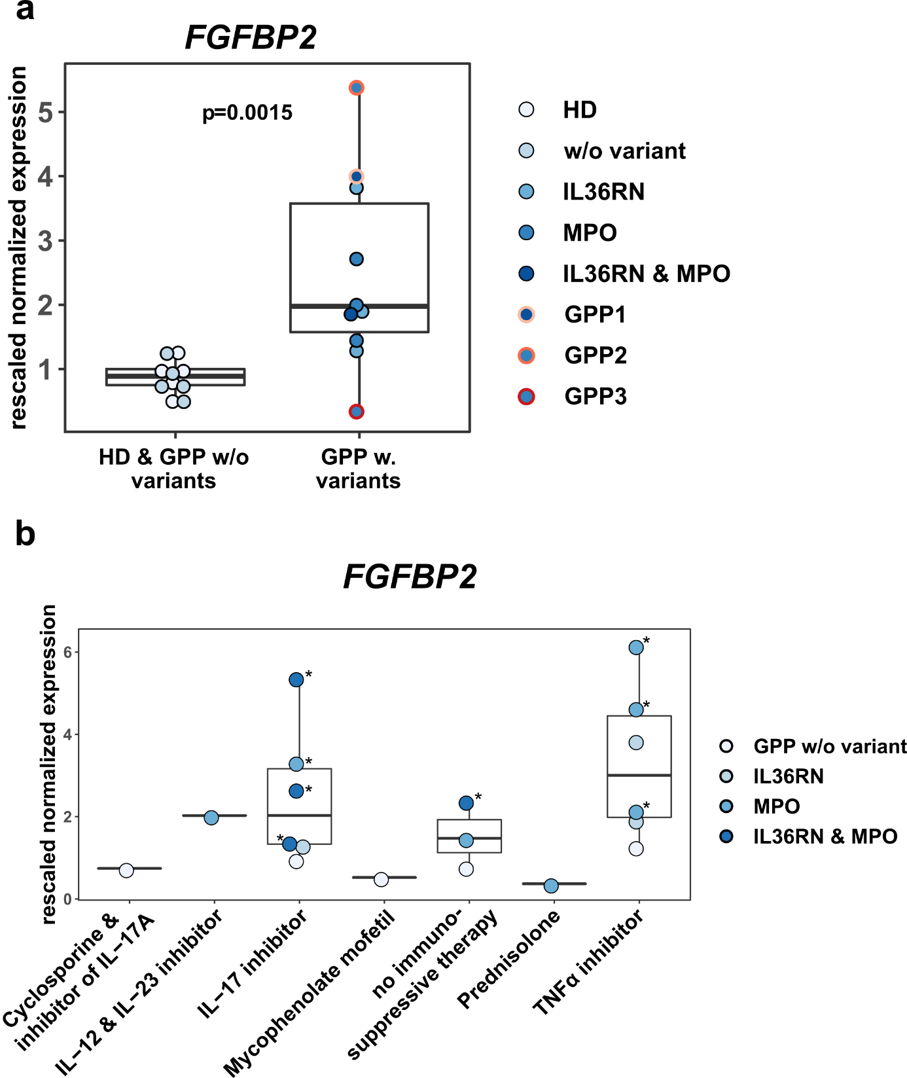
Figure 16: Targeted gene expression analysis of FGFBP2 of five healthy donors and 15 patients labeled by variants in MPO and IL36RN.
a-b: Gene expression of FGFBP2 grouped (a) by individuals with and without disease-associated variants in IL36RN and MPO and (b) by the systemic medical treatment of 15 patients (four patients with two samples marked each with an asterisk). P-value in (a) was calculated with Wilcoxon.
ILCs were more frequent in GPP patients compared to HD based on scRNAseq data, but not significantly. Therefore, the composition of ILCs was analyzed by flow cytometry. The mean percentage of ILCs on lymphoid cells was higher in GPP compared to HDs, although it did not appear to be dependent on the degree of MPO-deficiency (Figure 17). Focusing on the ILC subsets, an increased frequency of ILC3s at the expense of ILC2s was observed in GPP patients compared to HDs.
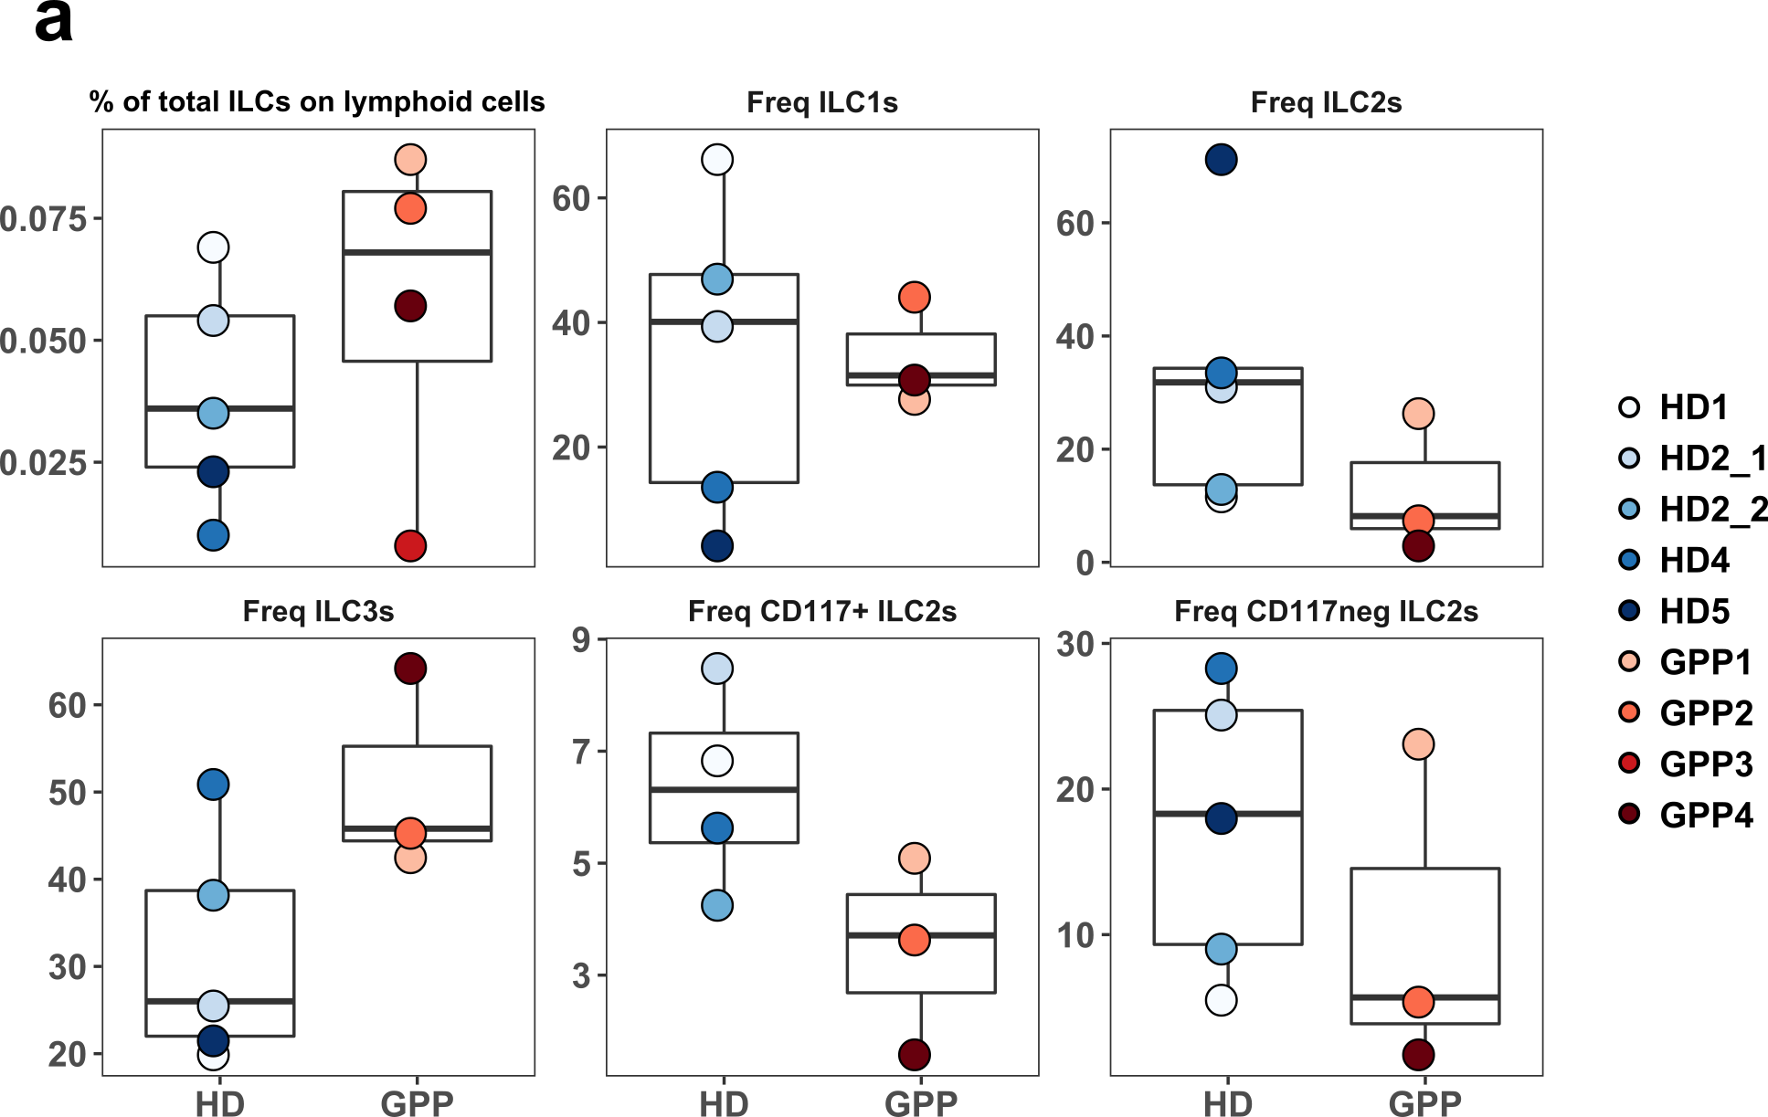
Figure 17: Flow cytometry analysis of innate lymphoid cells (ILCs) in four GPP patients and four healthy donors.
For GPP3, reliable analysis of ILCs subsets was not possible due to low numbers of total ILCs. Freq= frequency

Pathway analysis of PBMCs
Pathway analyses of DEGs based on Gene Ontology (GO) terms listed “negative regulation of leukocyte apoptotic process” and “positive regulation of cytokine production” as most significant pathways in CD4⁺ CTLs (Figure 18). In case of CD8⁺ TEMs, DEGs were enriched for the pathway “regulation of B cell activation” at the highest level of significance. DEGs of CD4⁺ TEM were most enriched for “immune response-regulating signaling pathway”, “cell killing” and “response to interferon-γ”. The latter was also most enriched in CD16⁺ monocytes followed by “response to peptide”. To conclude, these results suggested an activated state especially in CD8⁺ TEMs and CD4⁺ CTLs in GPP.
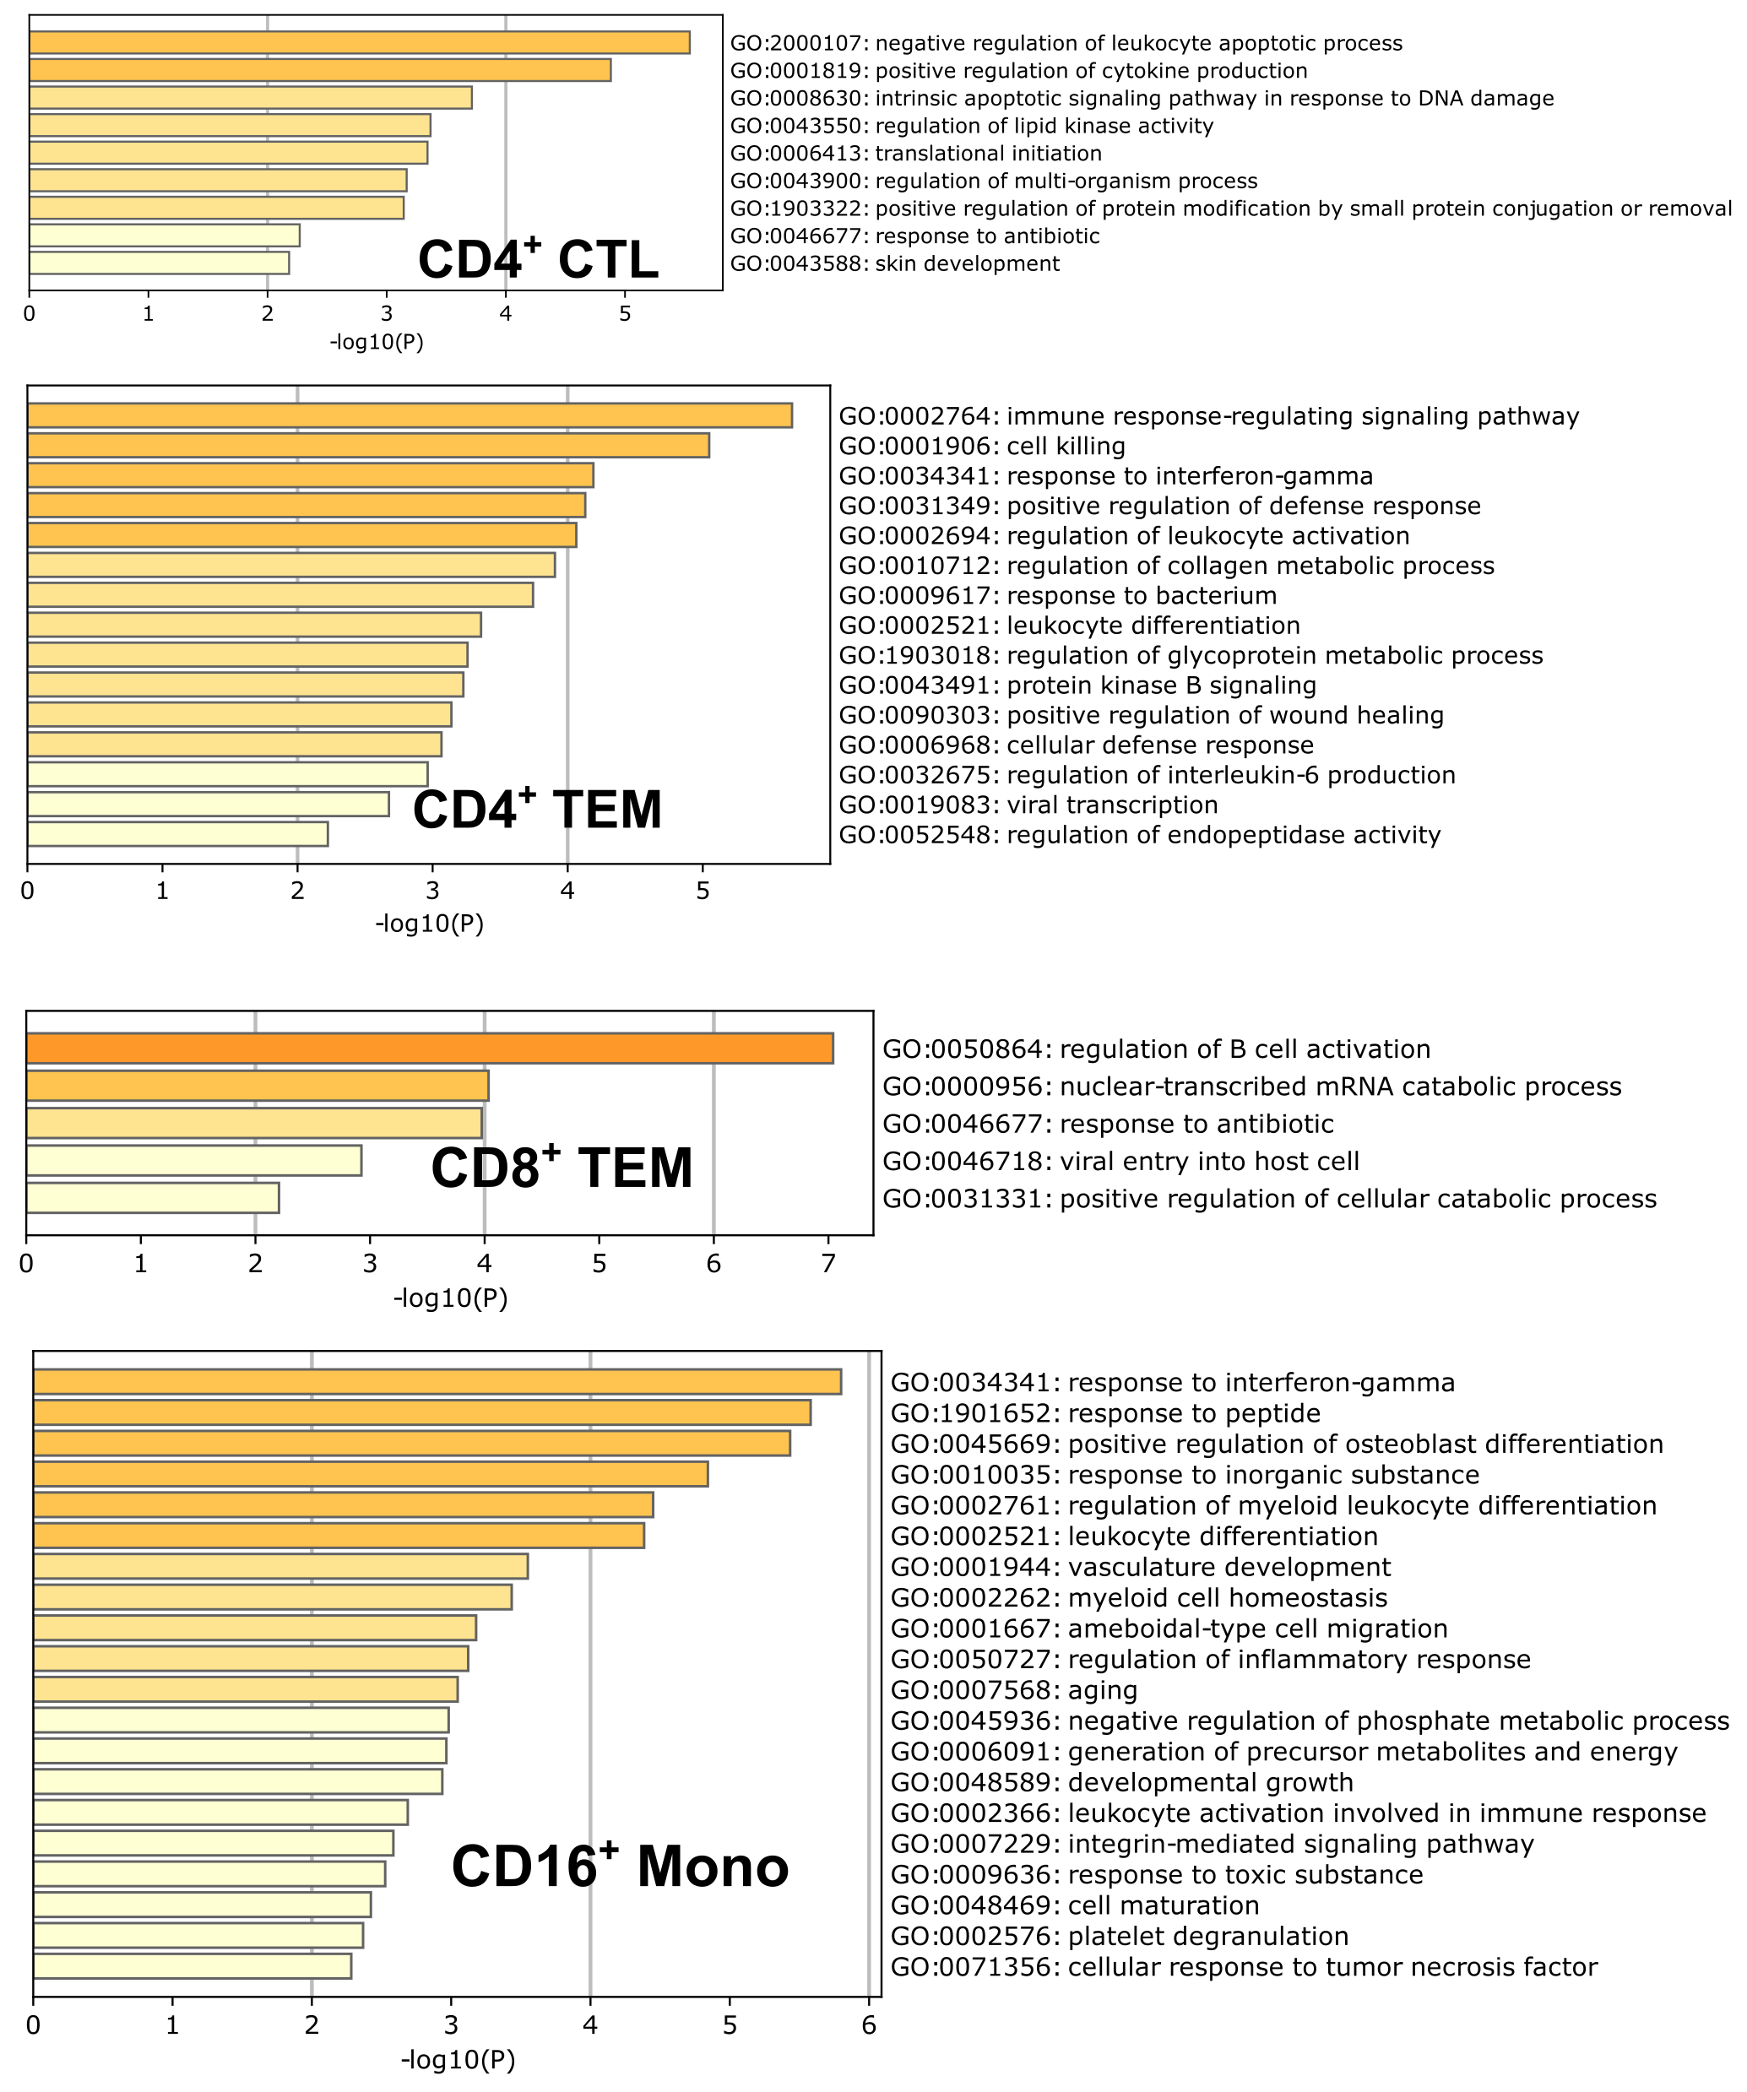
Figure 18: Pathway analysis of differentially expressed genes in CD4⁺ cytotoxic T cells (CTLs), CD4⁺ (effector memory T cell) TEM, CD8⁺ TEM and CD16⁺ monocytes.
Pathway analysis of differentially expressed genes of T cell subsets based on Gene Ontology terms.

Transcriptome analysis of neutrophils in GPP
Since neutrophils are major contributors to GPP, transcriptome analysis of three MPO-deficient GPP patients and four HDs were performed. GPP1 was completly MPO-deficient, while GPP2 (two variants) and GPP5 (one variant) were only partially MPO-deficient with different degrees. The principal component analysis (PCA) showed clustering of patients and HDs along PC1 (Figure 19a). Pathway analysis of DEGs revealed “complement activation, classical pathway” as most enriched pathway followed by “SRP-dependent cotranslational protein targeting to membrane” and “negative regulation of viral genome replication” (Figure 19b).
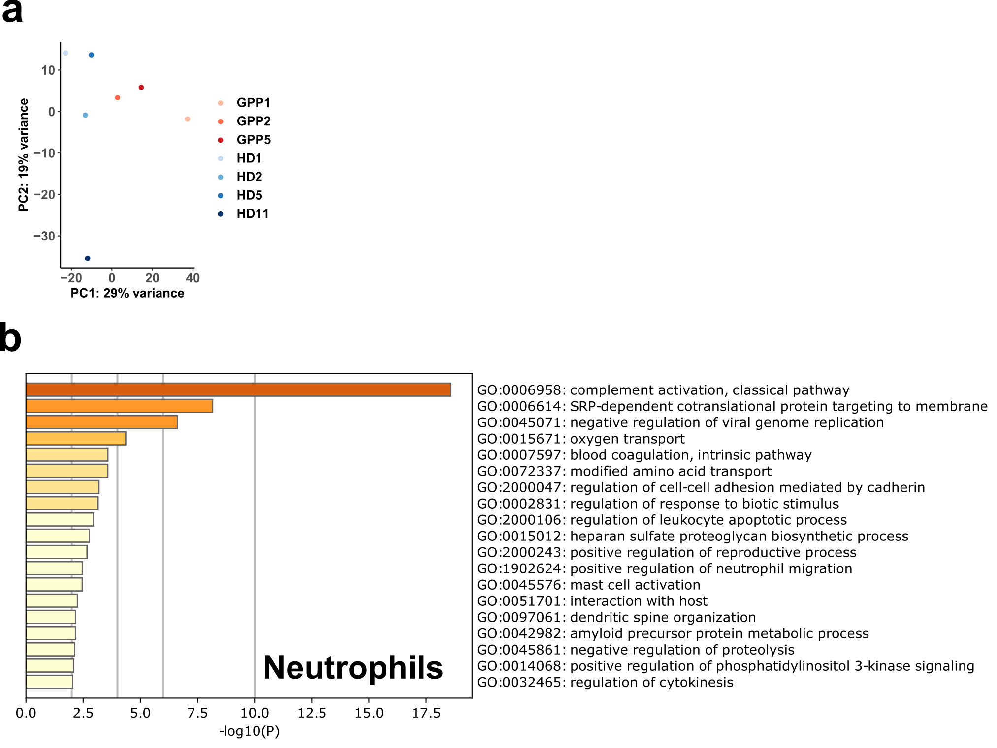
Figure 19: Transcriptome analysis of neutrophils of three MPO-deficient patients and four healthy donors.
a Principal component analysis of patients and controls. b Pathway analysis of differentially expressed genes in neutrophils based on Gene Ontology terms.

Cellular and molecular features in GPP patients of acute state
To investigate cellular and molecular features of GPP during an acute episode, the transcriptome of peripheral blood immune cells of one MPO-deficient (heterozygous for c.2031-2A>C) patient GPP3 was analyzed. The female patient was 58 years old and was diagnosed with generalized pustular psoriasis at 51 years of age. She also had a diagnosis of systemic lupus erythematodes with renal involvement. Within the first day of hospitalization, her health status improved slightly (declining C-reactive protein levels from 150 to 130 mg/l serum, no fever, leukocytosis, Figure 20). She was treated with oral prednisolone 60mg/ day, a local steroid (0.1% Mometasone) once daily, and compresses with 0.04% Lavasept (Polyhexanide) twice per day. At day 2, more than 100,000/ml E.coli colonies were detected in the urine, leading to the diagnosis of a urinary tract infection as potential cause for the inflammatory episode. After treatment with antibiotics (Fosfomycin 3g), colonies were not detected at day 8, but the CRP remained at 191mg/l and reached the maximum value on day 7 (242.5mg/l). The number of leukocytes per microliter blood stabilized between 16.4 to 18.4*10^3 from day 5 to 12 (Fig.3A), still exceeding the upper reference (10*10^3/µl given by laboratory of university hospital Erlangen). At day 16, therapy with infliximab was started. The patient had no fever during the hospitalization.
Peripheral immune cells for transcriptome analysis were collected on day 9, believing that the ongoing inflammation was largely driven by a GPP episode and not by the bacterial infection (Figure 20). The patient was dismissed from hospital at day 19. Further blood samples were obtained on day 15 and 47 - 4 weeks after the patient had left the hospital. Even at this time point, the number of leukocytes was still elevated at 14.2* 10^3/µl blood. To summarize, samples were collected at three different time points: one sample at the peak of GPP driven inflammation (GPP3.T0), one in improved condition (GPP3.T1) and one after recovery of the patient with slightly elevated numbers of leukocytes (GPP3.T2).
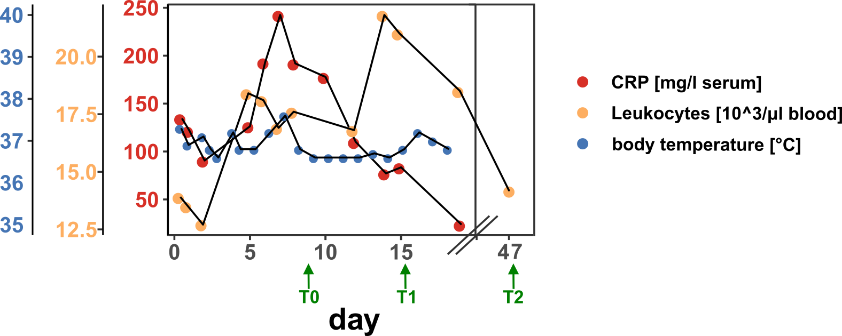
Figure 20: Levels of C-reactive protein (CRP), frequency of leukocytes and body temperature of one GPP patient during an acute episode.
Blood for transcriptome analyses was drawn on day 9 (T0), day 15 (T1) and day 47 (T2).

Cellular characterization of PBMCs of one GPP patient during an acute episode
Annotation via multimodal reference mapping resulted in 28 cell types, including all major cell types identified in the experiment with patients in stable disease state (Figure 12). Overall, CD8⁺ TEMs was the predominant cell type at all three time points of the acute episode, while naïve T cells and monocytes were reduced at the last time point (Figure 21a-b). 48.7% of total PBMCs were assigned to CD8⁺ TEMs, which was remarkably higher compared to the experiment with the stable patients (GPP:1 4.29% and HD: 7.96%, Table 14). However, the proportion of CD8⁺ TEMs did not change during the course of the episode (Figure 21c), and flow cytometry analysis of GPP3 in stable disease state revealed the highest percentage of GZMA⁺ or GZMK⁺ cells representing CD8⁺ TEMs in the group of GPP patients (92.5%, Figure 14).
Besides CD8⁺ T cells, proportions of CD4⁺ TCMs and CD4⁺ TEMs were higher, when the patient recovered (GPP3.T2) (Figure 21c). At the same time point, 95% of all CD4⁺ proliferating T cells were present. Compared to the study with the stable GPP patients, proportions of CD4⁺ and CD8⁺ proliferating T cells were approximately ten times higher in the combined data of the acute episode (Table 14).

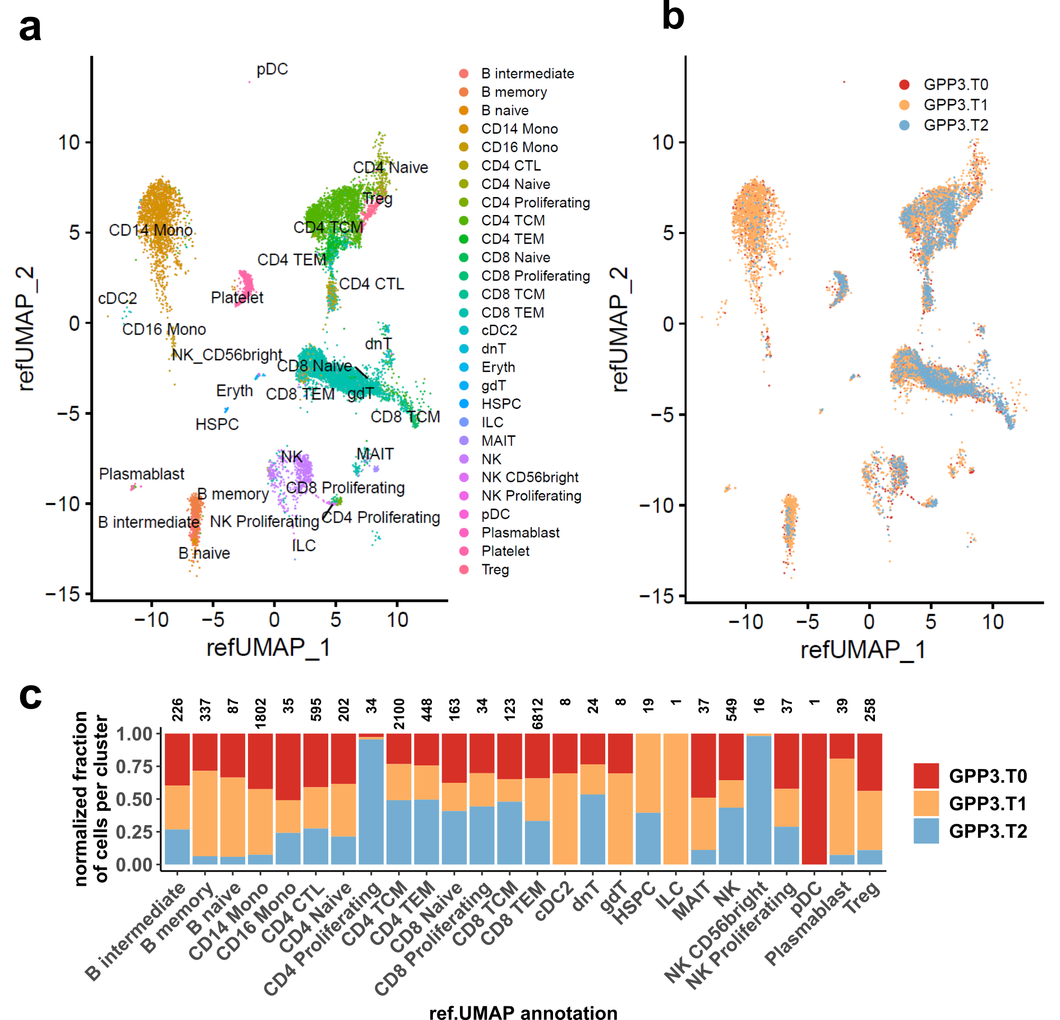
Figure 21: Single cell RNA sequencing analysis of peripheral mononuclear blood cells (PBMCs) of MPO-deficient patient during an acute episode.
a-b RefUMAP of PBMCs colored by cluster annotation (a) and three time points GPP3.T0 (day 9), GPP3.T1 (day 15), and GPP3.T2 (day 47) (b). c Proportions of cell type per donor normalized according to total number of cells per time point. Numbers at the top show total raw cell counts for each cell type. Descriptions of cell types are given in Table 14.
While the overall number of CD16⁺ monocytes in the patient at the acute episode was lower compared to HD and patients of stable state (0.25% - acute state versus 6.25% - GPP, 5.55% - HD, Table 14), the proportion of CD16⁺ monocytes was higher at the beginning of the episode (50%). The total number of CD14⁺ monocytes was only slightly lower, but the proportion declined dramatically after inflammation diminished (7.4% at T2, Figure 21). At the same time point, the proportions of naïve B cells and of memory B cells were decimated as well (6.3% and 5.9%, respectively, Figure 21). In total, naïve B cells were decreased (0.04%) compared to the study including patients at more stable disease state (HD: 2.37%, patients: 5.63%, Table 14).
Table 14: The frequency of selected cell types in peripheral mononuclear blood cells (PBMCs) of healthy donors (HD) and of GPP patients in stable and acute state.
Patients in stable state were GPP1 and GPP2 as described in chapter 4.4.1.
cell types | Frequency of PBMCs in percent (%)
 | HD | stable state | acute episode (mean)
CD14⁺ monocyte | 15.99 | 16.99 | 12.88
CD16⁺ monocyte | 5.55 | 6.25 | 0.25
CD8⁺ TEM | 7.96 | 14.29 | 48.67
CD4⁺ proliferating T cell | 0.01 | 0.04 | 0.24
CD8⁺ proliferating T cell | 0.03 | 0.02 | 0.24
CD4⁺ naïve T cell | 14.32 | 3.45 | 1.44
CD8⁺ naïve T cell | 4.55 | 1.12 | 1.16
naïve B cell | 2.37 | 5.63 | 0.04
intermediate B cell | 1.81 | 2.41 | 0.02
memory B cell | 2.62 | 4.40 | 0.03

T helper (Th) cells were annotated using SingleR which uses bulk RNAseq data of pure cell types for cluster annotation of scRNAseq data {Aran, 2019 #1803}. The proportions of IL-17A producing Th17 cells did not change during the flare (Figure 22b). Annotated cells expressed RORC, encoding the lineage-specific transcription factor isoforms RORγ and RORγt, a marker of Th17 cells {Castro, 2017 #1853} (Figure 22c). At the latest time point, the proportion of Th2 cells was reduced (Figure 22b).
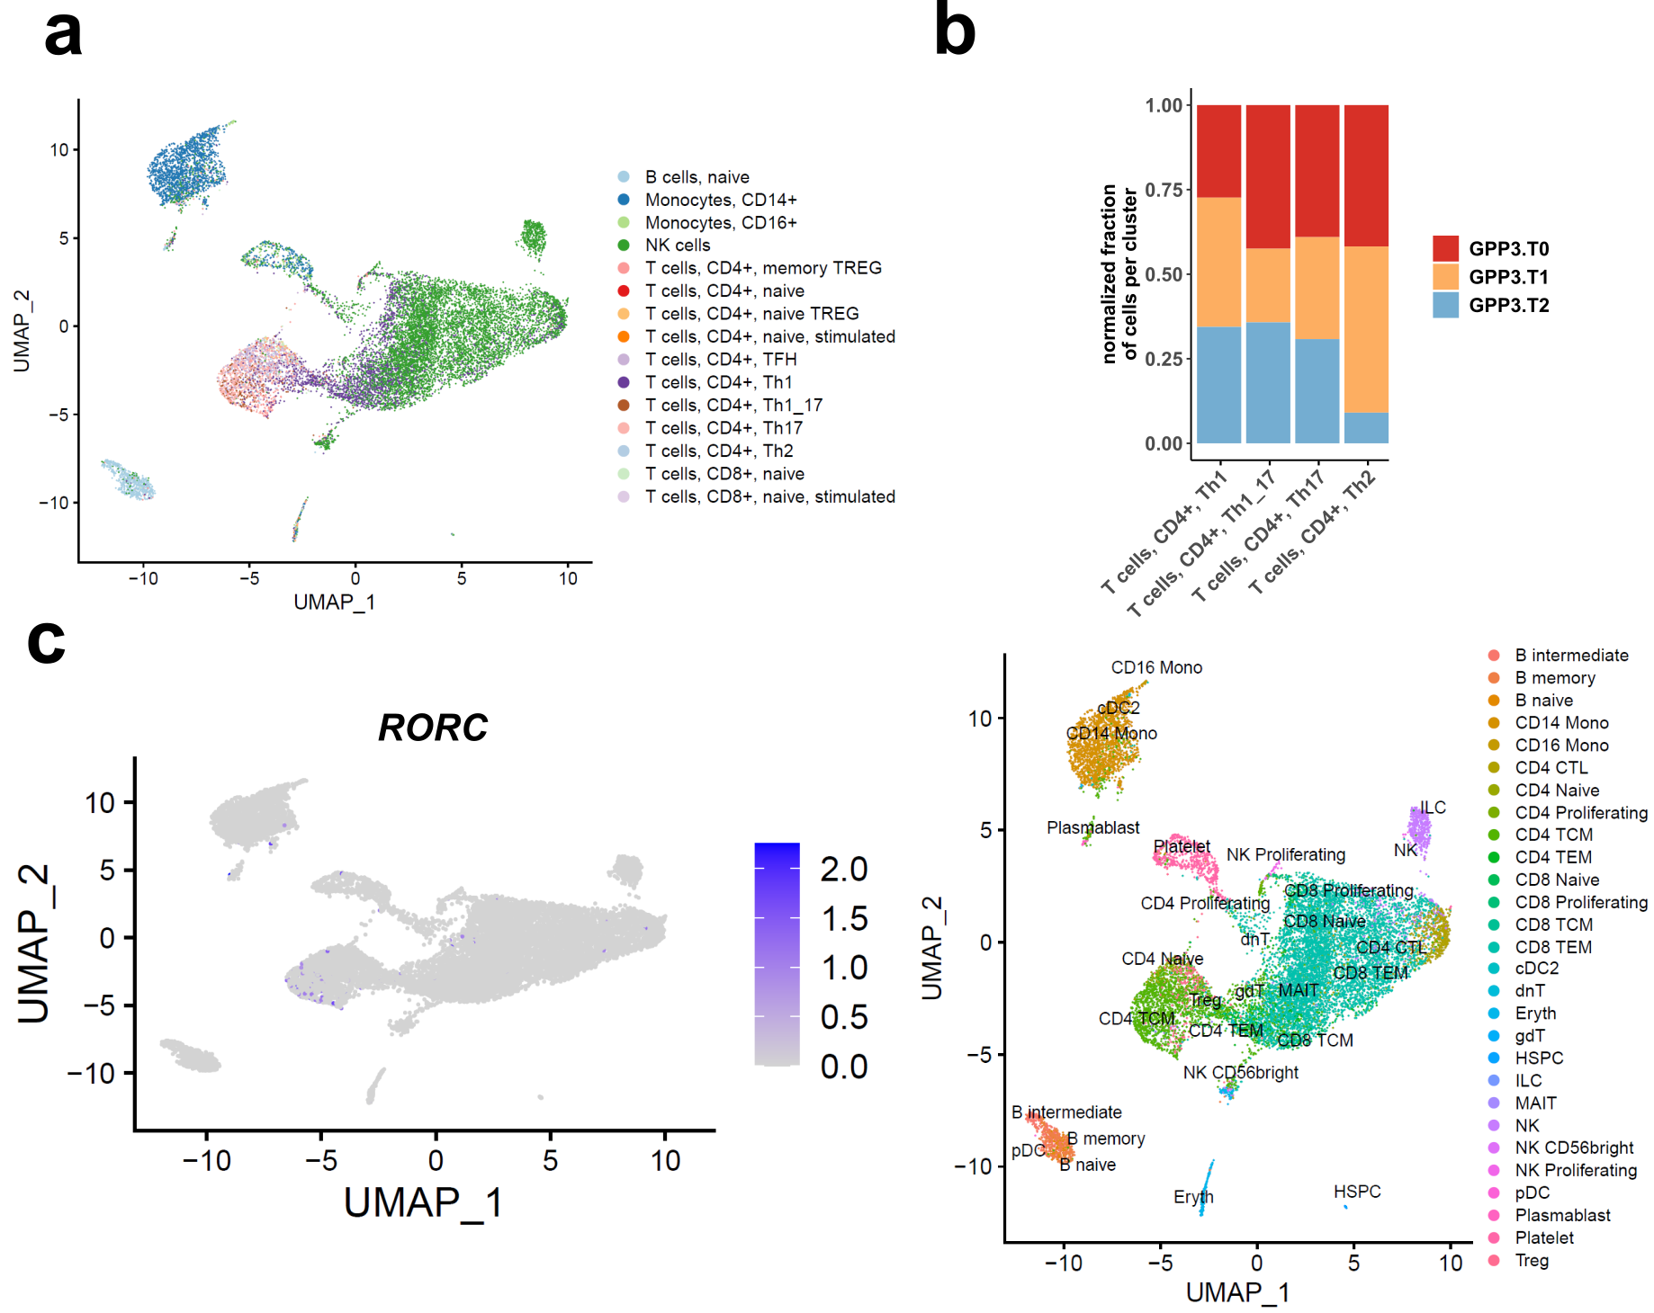
Figure 22: Proportion of T cell subsets in patient during an acute episode.
a UMAP colored by 15 clusters annotated by SingleR (Aran et al., 2019). b Normalized proportions of the T cell subsets Th1, Th2, Th17 per time point - GPP3.T0 (day 9), GPP3.T1 (day 15), and GPP3.T2 (day 47). Annotation based on SingleR . c UMAP colored by gene expression level of RORC, a known marker of Th17 cells (left) and by annotated clusters based on multimodal reference mapping (right).

Pathway analysis and prediction of ligand-receptor interaction of peripheral mononuclear blood cells (PBMCs) in an acute episode of GPP
When differential gene expression between the first and the last time point of the acute episode was investigated, the DEGs in CD4⁺ TCMs, CD8⁺ TEM, CD4⁺ CTLs and NK cells all shared “SRP-dependent cotranslational protein targeting to membrane” as most enriched pathway. The DEGs in NK cells, CD8⁺ TEMs and CD4⁺ CTLs were also enriched for “oxidative phosphorylation”. Of note, the pathway “cellular response to interferon-γ” was enriched in CD4⁺ TCMs. Pathway analysis of CD14⁺ monocytes indicated a role in “regulated exocytosis”, “SRP-dependent cotranslational protein targeting to membrane” and “phagocytosis”. The p-values of most enriched pathways were at least ten potencies lower compared to the ones of PBMCs of stable patients (Figure 23 & Figure 18). The pathway “SRP-dependent cotranslational protein targeting to membrane” is highly enriched in all investigated cells, suggesting a potential role in the acute disease state.
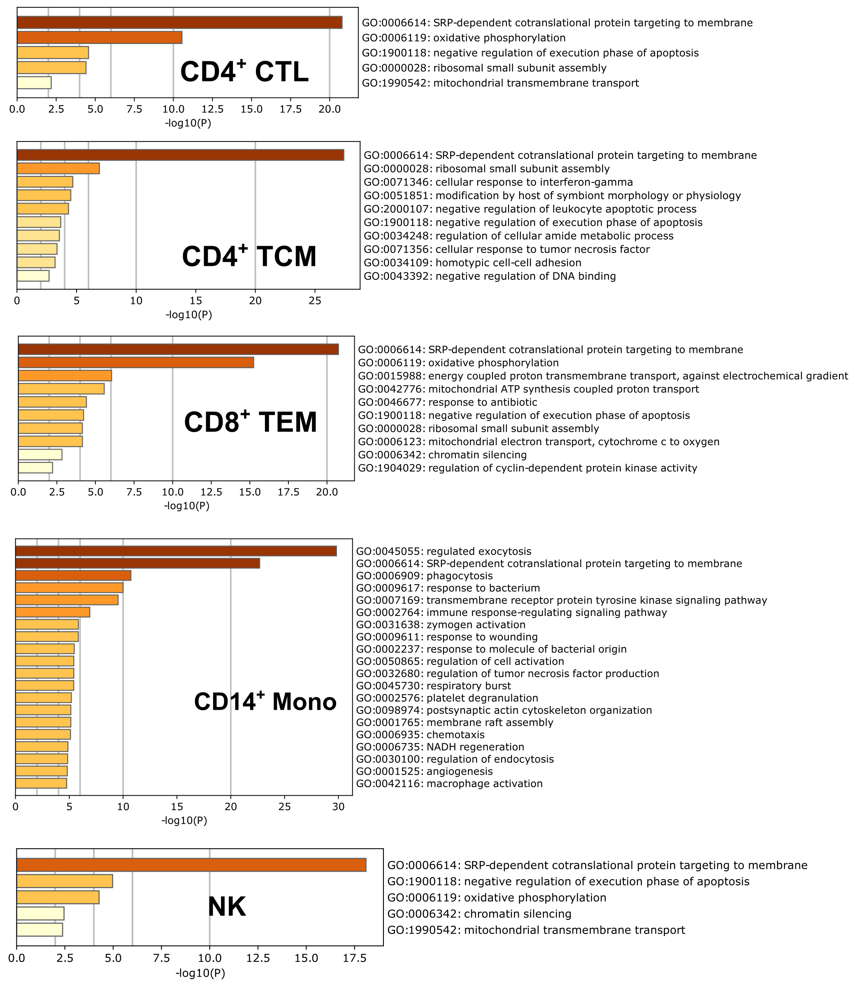
Figure 23: Pathway analysis of differentially expressed genes in three T cell subsets, NK cells and CD14⁺ monocytes based on Gene Ontology terms.
For the calculation of differentially expressed genes, the time points GPP3.T0/ day9 and GPP3.T2/ day47 were considered.

In order to unravel the complex communication of immune cell types, the scRNAseq data were analyzed based on the publicly available repository of known receptor-ligand pairs - CellphoneDB {Efremova, 2020 #1801}. Cell types of the early phase of the episode (T0) were more interactive compared to the ones of the late phase (T2) (Figure 24a-b). At T0, the majority of cell types including T cell subsets, B cells and NK cells were connected by numerous ligand-receptor interactions with each other, but later at T2, only intermediate B cells, CD16⁺ monocytes and double negative T cells (dnT) were communicating by multiple receptor-ligand pairs.
On the level of immune-relevant ligand-receptor interactions, high interaction numbers were observed in NK cells, non-naïve T cells and monocytes in the early phase of the episode. In consistence with a general decline in cell- cell interactions, the immune and cell type specific interactions of known interacting pairs were limited to the expression of CCL5_CCR1, CCL5_CCR5 and PF4_CXCR3 at later disease state (dashed lines, Figure 25a-b). These findings revealed the complexity of this network. For example, the ligand CCL5 was specifically expressed in NK cells, platelets, CD8⁺ T cell subtypes and CD4⁺ CTLs. The corresponding receptors, CCR1 and CCR5, were expressed in monocytes, dendritic cells (DC) and B cells (dashed lines, Figure 25a-b). Besides CCL5, multiple interacting pairs with the ligands CCL3 and CCL4 were cell type specific and highly expressed at T0, but these could not be detected, when the episode subsided at T2.
Pathway analysis of genes, which encode the cell type specific and expressed interacting pairs, revealed an enrichment of the innate and adaptive immune response at the early phase of the episode. Later at T2, the pathways “lymphocyte activation”, “response to tumor necrosis factor” and “cell activation involved in immune response” were most enriched (Figure 26a-b).
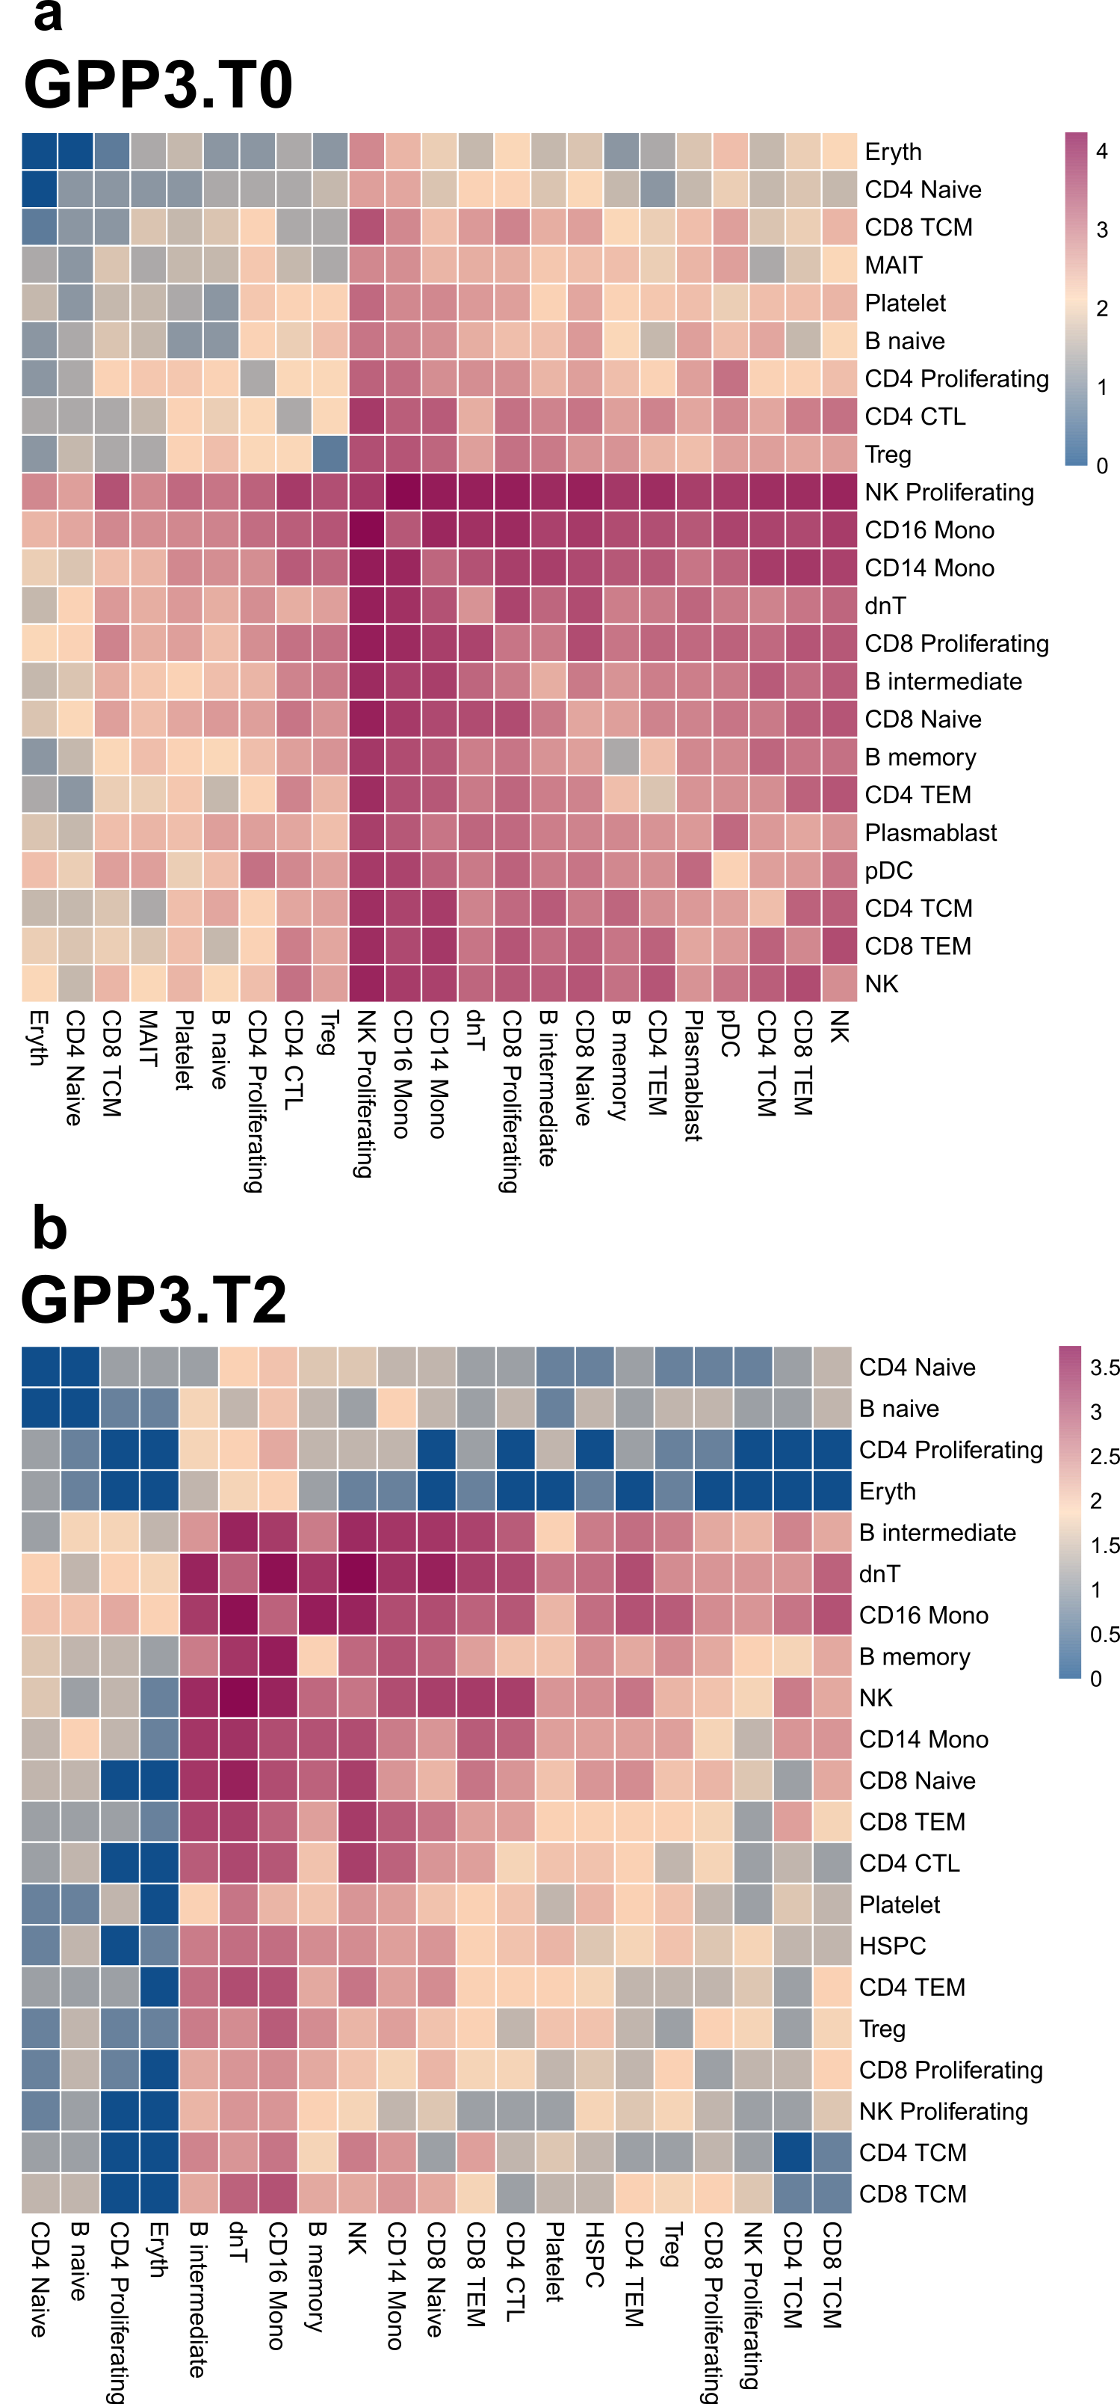
Figure 24: Prediction of receptor-ligand interactions based on single-cell RNA sequencing data of single patient during an acute episode.
a-b Logarithmic numbers of receptor-ligand-pairs per combination of cell type at time point GPP3.T0 day9 (a) and GPP3.T2 (day47) (b) displayed as heatmaps.

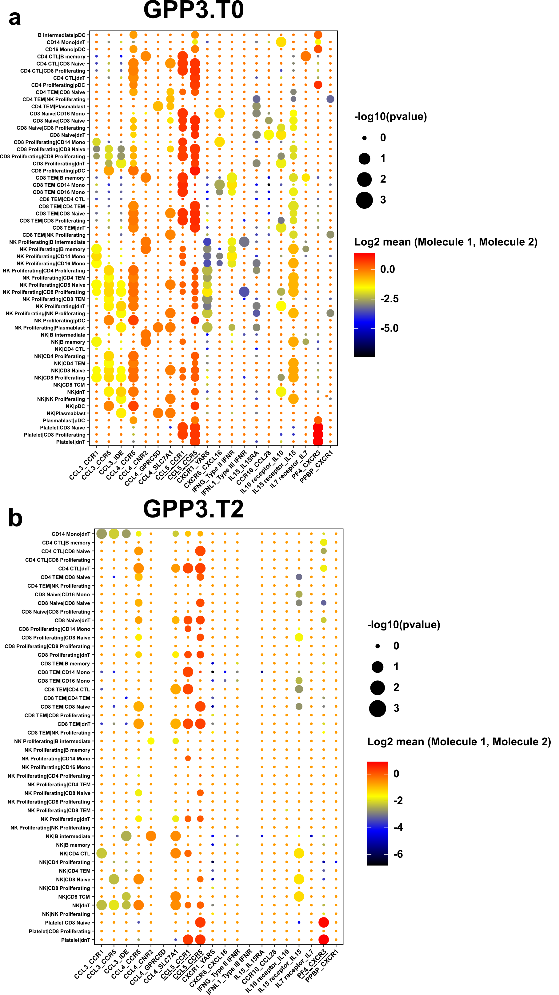
Figure 25: Cell type specific and immune-related receptor-ligand-pairs during acute episode.
a-b Dot plots of cell type specific and immune-related receptor-ligand-pairs at time point GPP3.T0/ day9 (c) and GPP3.T2/ day47 (d). The circle size corresponds to the p-value and the color gradient displays the mean expression of ligand and receptor, respectively. Underlined receptor-ligand pairs are described in the main text.

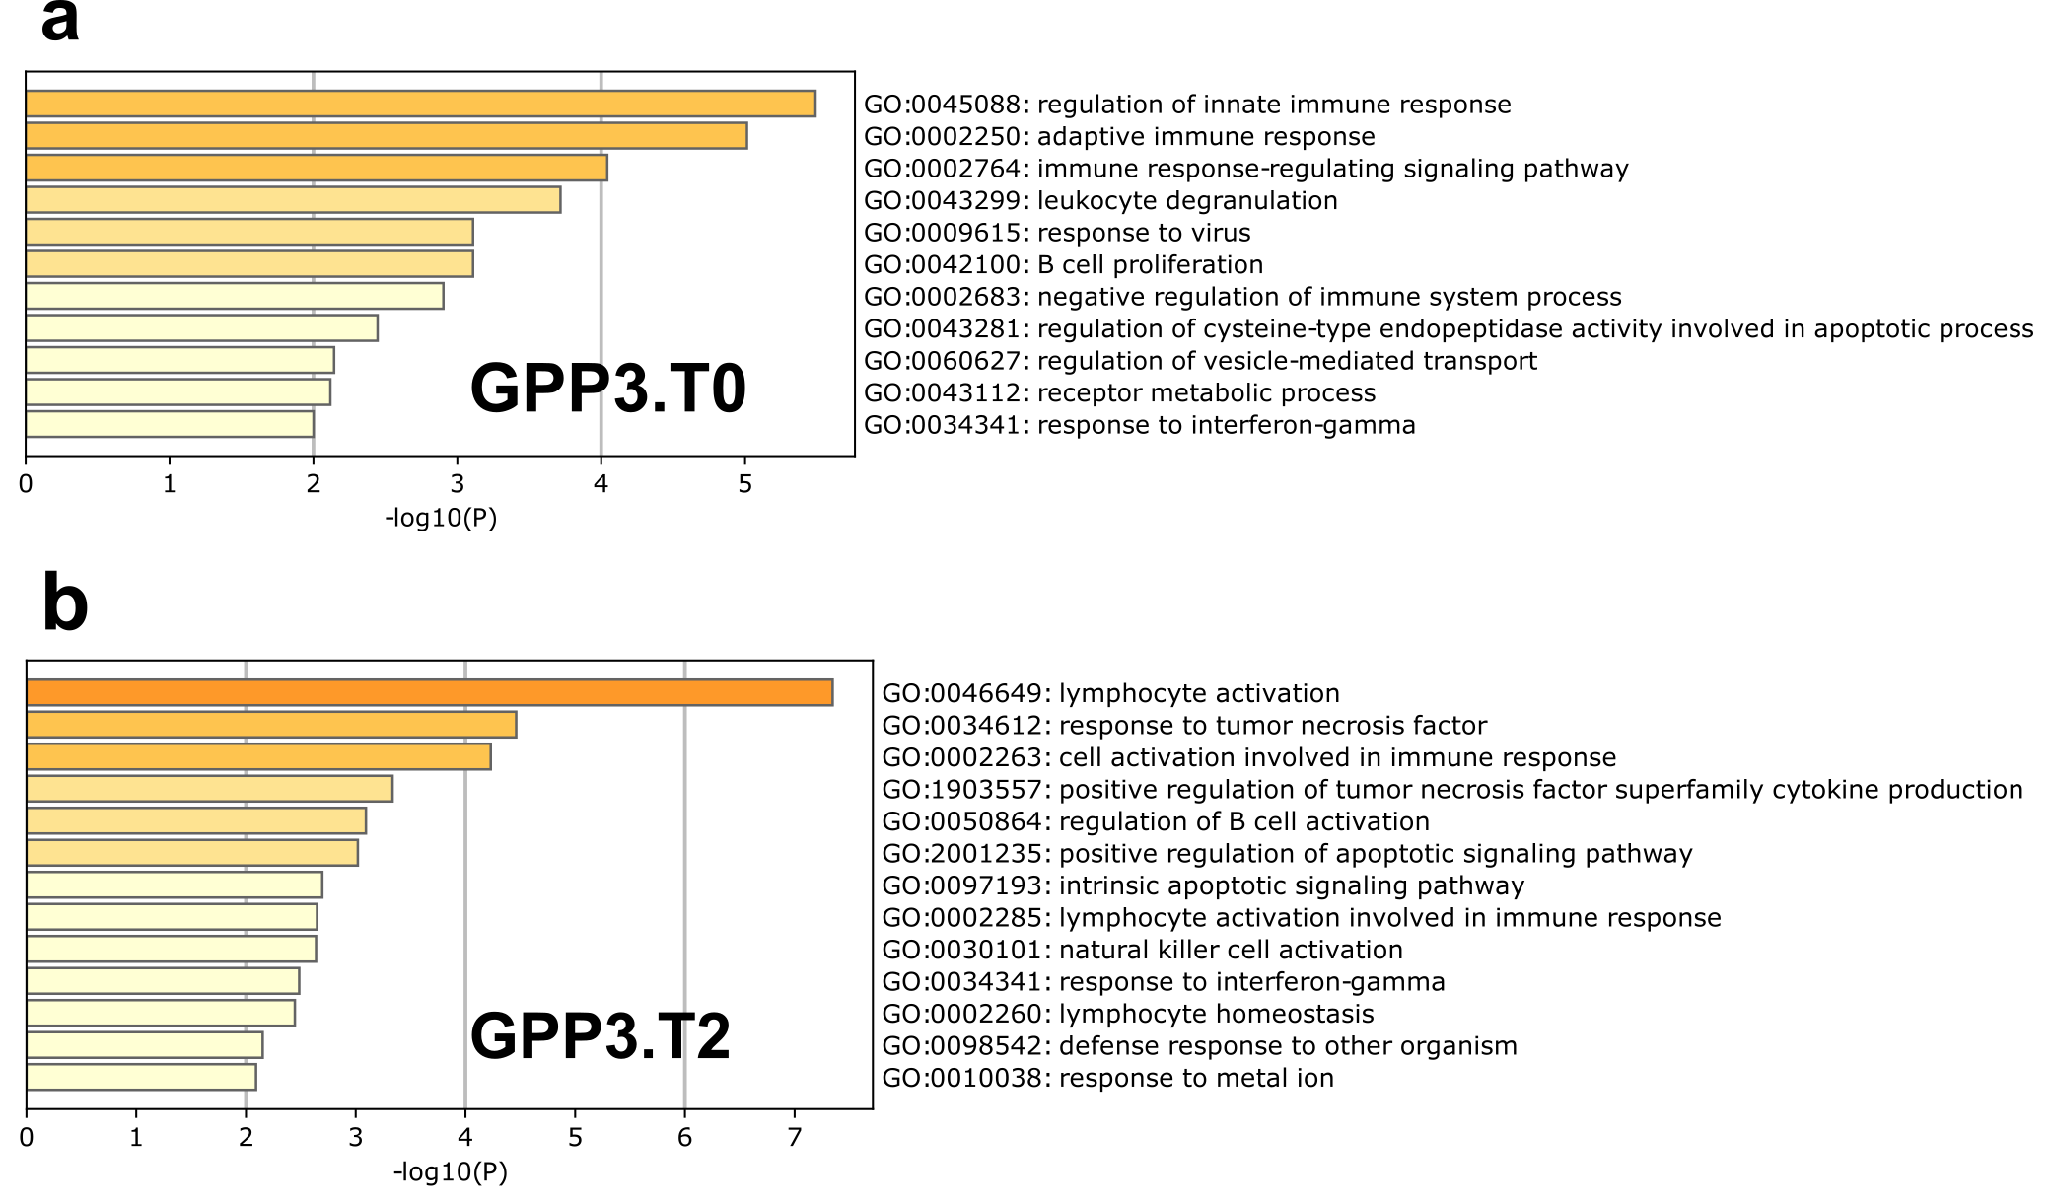
Figure 26: Pathway analysis of genes coding for cell type specifically expressed receptor-ligand pairs at time point GPP3.T0 (e) and GPP3.T2 (f).

Transcriptome analysis of neutrophils in acute episode
Principal component analysis of transcriptome of neutrophils indicated a strong difference of GPP3.T0 and GPP3.T2 compared to GPP3.T1 (Figure 27a), when considering that PC1 (x-axis) displays 66% of variance. Overall, 14,836 genes were expressed in neutrophils during the acute episode. A linear model for each gene revealed 53 genes, which showed a strongly decreased or increased expression over time. Pathway analysis of these genes showed “type I interferon signaling pathway” as the most enriched pathway (Figure 27b). The P value was more than six potencies lower compared to the second most enriched pathway.
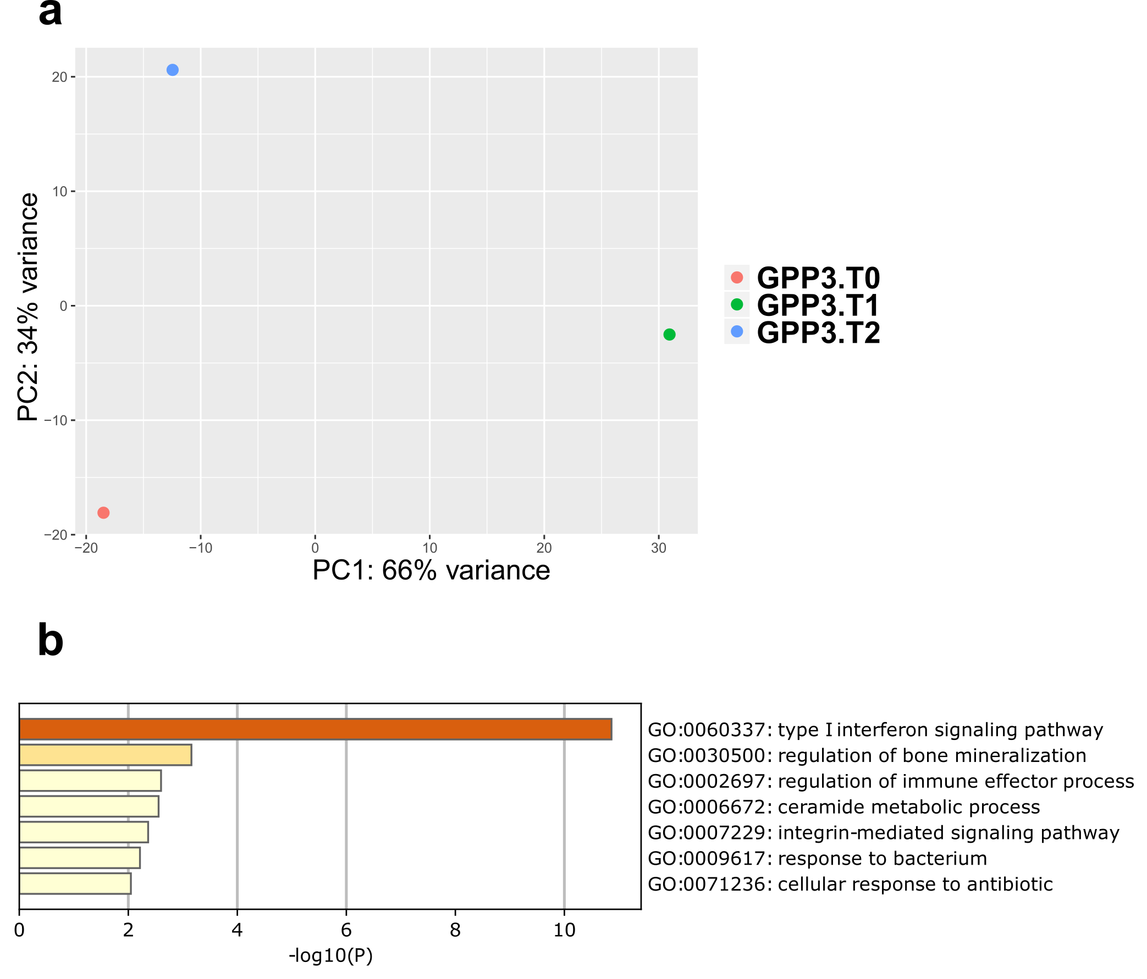
Figure 27: Transcriptome analysis neutrophils of GPP3 within an acute episode.
a Principal component analysis of transcriptomes in neutrophils of GPP3 at the three time points GPP3.T0/ day 9, GPP3.T1/ day 15 and GPP3.T2/ day 47. b pathway analysis of neutrophilic genes that changed during the acute episode.

Discussion

Pathogenic MPO variants in GPP
The genetic basis of the rare multi-systemic subtype of psoriasis GPP is unknown for the majority of GPP cases {Mossner, 2018 #1364}, although variants in IL36RN, CARD14, AP1S3 and SERPINA3 have been associated with this auto-inflammatory disease {Marrakchi, 2011 #779;Jordan, 2012 #602;Setta-Kaffetzi, 2014 #1070;Onoufriadis, 2011 #887;Frey, 2020 #1702;}. Via whole-exome sequencing and targeted sequencing of 82 patients, rare variants of the gene MPO encoding myeloperoxidase were identified and functionally analyzed.
MPO-deficiency has been described with GPP in several studies before {Stendahl, 1984 #1676;De Argila, 1996 #1678;Disdier, 1991 #1706}. In this thesis, eight pathogenic MPO variants were identified in one fifth of 82 patients and functionally characterized by several assays. The splice variant c.2031-2A>C leads preferentially to the inclusion of intron 11 (Figure 3b). In contrast, the study of Marchetti et al. demonstrate that this variant led to the use of an alternative splice acceptor site at -109 in intron 11 and thereby including 109nt of intron 11 {Marchetti, 2004 #1668}. The latter splice product was identified as a less abundant splice variant in this thesis. Marchetti et. al. used an eukaryotic mini-gene expression system and performed transient transfection into the Hep3B cell line followed by RT-PCR. For future studies of potential MPO splice variants, this artificial expression system should be avoided, if possible, as it models the splicing patterns of neutrophils incorrectly. The limited space in an artificial vector may prevent the complete modelling of this gene. The analysis of cumulative frequencies of mutant alleles in patients and controls revealed that only variants leading to complete deficiency were associated with GPP. Therefore, the MPO variants c.752T>C/ p.(Met251Thr) and c.995C>T/ p.(Ala332Val) leading to partial deficiency may represent variants with a small effect size or can only be pathogenic in combination with other variants.

GPP may be considered as a monogenic disease, since bi-allelic variants in IL36RN were described as disease-causing. In this thesis, the number of patients with two variants in IL36RN was twice as high as the number of patients with one variant (18.5% versus 8.3%). For MPO variants, the relation is reversed (4.9% versus 18.8%). Five of 17 GPP patients with variants in MPO also carried one or even two variants in IL36RN. Therefore, penetrance of IL36RN variants for GPP may be higher compared to the penetrance of MPO variants. Confirmatory, the prevalence of MPO-deficiency is approximately 0.025% (0.04%, complete deficiency 0.021% Pubmed 6267975; 0.05%, complete 0.005% PMID: 6260268) which is orders of magnitude higher compared to the prevalence of GPP (0.0001-0.0009%) {Augey, 2006 #48}. This is also in line with the number of control individuals from the 1,000 Genomes project ({Genomes Project, 2015 #1697}) and in-house exomes. In total, 0.2% of 4,937 controls carried two functional relevant MPO variants, while only xx% carried two IL36RN variants.
The association of GPP with the number of variants was higher when including heterozygous IL36RN variants compared to variants in MPO alone (Figure 4). These genetic data suggest that GPP is an oligogenic disease. This hypothesis has been discussed before, as GPP patients with IL36RN variants carried further variants in CARD14 and AP1S3 {Mossner, 2018 #1364;Twelves, 2019 #1733;Frey, 2020 #1702}.
Just recently, Vergnano et al. identified the MPO variant c.2031-2A>C in homozygous state in two individuals of a patient group composed of 14 European GPP and 109 acral pustular psoriasis patients (frequency 1.4%) {Vergnano, 2020 #1781}. In patients affected by acral pustular psoriasis, the formation of pustules locates at the nails and surrounding tissue at fingers and toes. The frequency of the variant c.2031-2A>C was slightly lower compared to the results presented in chapter 4.1.1 (two of 82 patients, 2.4%). In the same study, two of 96 patients with AGEP carried two variants in MPO (c.1705C>T/ p.(Arg569Trp), c.2031-2A>C and c.1555_1569del14/ p.(Met519Profs*21) in homozygous state) {Vergnano, 2020 #1781}. Overall, four patients with two variants were identified in 142 patients (2.8%), while in this thesis, four patients with two variants were identified in 82 patients (4.8%). The difference may be due to the different composition of the study group regarding ethnicity and diagnosis. Nevertheless, the study of Vergnano et. al. validated the association of GPP and other subtypes of pustular psoriasis with variants in MPO.
Only 40% of the patients carried variants in MPO and/ or IL36RN. To unravel the genetic basis of unsolved GPP cases, further strategies could be applied. The whole-exome sequencing analysis focuses on homozygous, nonsynonymous, rare variants, which affected one gene in at least two patients. Intragenic variants had not been taken into account. Also heterozygous and compound heterozygous variants were omitted by these filters. Filtering for heterozygous variants would have expanded the number of candidate genes massively and the impact or heterozygous variants are difficult to interpret. Compound heterozygous variants could not have been validated due to absent parental DNA and those filter criteria would have result in a very high number of variants. To focus on a limited number of variants, only those regions could be considered which are transcribed or within regions of open chromatin in GPP associated cell types. For example, this information could be provided by publicly available scRNAseq data sets of skin biopsies obtained from psoriasis patients which contain the transcriptome of keratinocytes expressing IL36G and IL36RN {Hughes, 2020 #1818}. Another option would be to focus on genes of certain pathways connected to GPP pathogenesis or to screen for variants by trio analysis (affected child, unaffected parents/ family).

MPO-deficiency may contribute to GPP by multiple mechanisms
MPO is the main neutrophilic enzyme and is also expressed in monocytes. How does MPO-deficiency contribute to GPP? The presented data suggest that MPO-deficiency promotes GPP by increased serine protease activities (Figure 28a). These enzymes have been described to activate the IL-36α, IL-36β and IL-36γ cytokines at different levels of specificity {Henry, 2016 #1598}. Although the specific role for each IL-36 cytokine is unclear, all RNA isoforms are highly expressed in GPP and PsV lesions compared to healthy control skin {Johnston, 2017 #1654} and each IL-36 cytokine can induce secretion of pro-inflammatory cytokines IL-6 and IL-8 in vitro {Towne, 2004 #1174; Henry, 2016 #1598}. While Henry et. al. demonstrated that the activities of IL-36β and cathepsin G, but not of IL-36α and IL-36γ are elevated in psoriatic skin {Henry, 2016 #1598}, Ainscough et al. claimed that the expression of IL-36γ and the activity of cathepsin S is increased in skin from patients with PsV {Ainscough, 2017 #1684}. However, in the latter study, the expression of IL-36α and IL-36γ were not investigated. Recent scRNAseq data only detected an increased expression of IL36G in keratinocytes of patients with psoriasis vulgaris {Hughes, 2020 #1818}. Overall, the lack of a systematic study including GPP and PsV skin biopsies is evident.
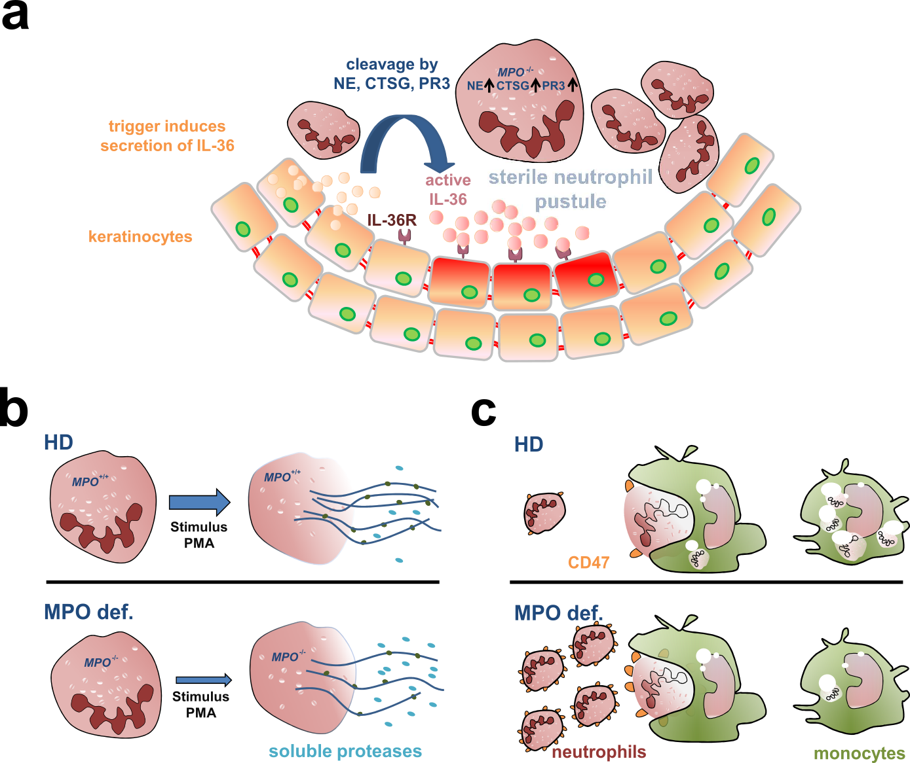
Figure 28: Proposed mechanisms of MPO-deficiency in GPP.
a Keratinocytes release IL-36 cytokines upon the activation of an unknown trigger. The cytokines are cleaved by serine proteases with increased activity in MPO-deficiency. Cleaved IL-36 cytokines bind to the IL-36R on keratinocytes followed by the release of further pro-inflammatory cytokines. b Upon stimulation with PMA, NET formation is impaired in neutrophils suggesting a more prominent role of soluble proteases instead of NET bound proteases. c Clearance of MPO-deficient neutrophils by MPO-deficient monocytes is reduced explaining the high abundance of neutrophils in pustules of GPP patients. CTSG: cathepsin G, IL-36R: interleukin-36 receptor, NE: neutrophil elastase, PR3: proteinase 3

In azurophilic granules of neutrophils, MPO catalyzes the generation of the highly reactive radicals hypohalous acids, which exhibit antimicrobial activity. Of note, MPO-deficient neutrophils are still able to eliminate microbes such as Staphylococcus aureus ex vitro, but more slowly compared to neutrophils from healthy donors {Hampton, 1996 #1887;Decleva, 2006 #1886}. Besides from clinical reports of mpo deficient patients with systemic candidiasis in the presence of diabetes mellitus{Lehrer, 1969 #1893}, no systematic study underlines a clinical impact of MPO-deficiency so far.
It is tempting to assume that the lack of hypohalous acids may be compensated by other antimicrobial molecules including serine proteases. These IL-36 activating enzymes also have antimicrobial activities and are located in the azurophilic granules {Schultz, 1962 #1894}. It has also been suggested that hypohalous acids catalyzed by MPO may inactivate neutrophil elastase directly in wild-type neutrophils {Hirche, 2005 #1599}. Overall, the proposed pathway also links neutrophils to keratinocytes, two well-known cellular players in GPP, and may explain why some patients without variants in IL36RN have been treated successfully with monoclonal antibodies against IL-36R {Bachelez, 2019 #1705}.
Neutrophilic proteases are either released as soluble enzymes after degranulation of neutrophils or bound to neutrophil extracellular traps (NETs) {Henry, 2016 #1598}. Formation of NETs via the PMA-induced pathway was impaired in MPO-deficient GPP patients in vitro as described previously (Figure 28b) {Bjornsdottir, 2015 #1674;Parker, 2012 #1690}. These findings might suggest that serine proteases are more frequent in their soluble form due to reduced formation of NETs in MPO-deficient patients, although other pathways of formation of NETs are not affected by MPO-deficiency. Formation of NETs has been shown to possess pro- and anti-inflammatory features {Schauer, 2014 #1734;Hahn, 2016 #1859}. Their influence on inflammatory processes in psoriasis may be investigated in MPO-deficient psoriasis mouse models in future studies, as the inflammatory environment including infiltrating immune cells, chemokines and cytokines present in psoriatic skin is difficult to model in ex vivo studies.
Besides being the source for NET formation and serine proteases, neutrophils are highly abundant in pustules of GPP patients. This observation raises the question of whether MPO-deficiency may influence the proportions of neutrophils. The evidence provided in chapter 4.2.3 showed a reduced clearance of neutrophils by monocytes (efferocytosis) in MPO-deficient patients and mice in vitro (Figure 28c). Confirmatory to that, Vergnano et al. showed in a group of 778 British individuals (UK Biobank {Sudlow, 2015 #1895}) that carriers of the MPO variants c.2031 2A>C, c.1705C>T/ p.(Arg569Trp), c.995C>T/ p.(Ala332Val) and c.752T>C/ p.(Met251Thr) did have a significantly higher percentage of neutrophils in peripheral blood {Vergnano, 2020 #1781}. Whether neutrophils are more abundant in pustules of GPP patients with variants in MPO compared to those without, has not been investigated so far. Efferocytosis has been described to promote inflammation in rheumatoid arthritis and further autoimmune disease {Kourtzelis, 2019 #1708}. Mice developed systemic lupus erythematosus (SLE)-type autoimmune diseases, when they were disturbed in the clearance of apoptotic lymphocytes induced by MFG-E8-deficiency {Hanayama, 2004 #1888}. This underlines the importance of efferocytosis which is tightly controlled by numerous signals, including “find-me” signals, “eat-me” signals and “don’t-eat-me” signals {Ravichandran, 2010 #1889}. One “don’t-eat-me” signal is the surface molecule CD47, which was nominally, but not significantly higher expressed on human neutrophils of three MPO-deficient patients compared to healthy donors. This molecule has been described to prevent phagocytosis of tumor cells in numerous malignancies {Jaiswal, 2009 #1862}. Considering recent studies about CD47 as a potential target for antibody therapies in oncology, this “don’t eat me signal” may be an appropriate target in GPP {Hayat, 2019 #1719}. However, further studies including more patients with and without disease-contributing variants are necessary to assess CD47 as potential target molecule.
Only recently, neutrophils incubated with PMA were less apoptotic, when the MPO inhibitor 4-Aminobenzoic acid hydrazide was added compared to PMA alone {Vergnano, 2020 #1781}. This raises the question whether neutrophils are more abundant in MPO-deficient individuals, because they are activated and thereby escape efferocytosis. However, the fact that no vehicle control was performed in that study is rather problematic. This experimental control is essential, because the solvent of the MPO inhibitor - DMSO - may also have an apoptotic impact on viable cells.
MPO-deficiency may promote inflammation in GPP via increased activities of IL-36 activating proteases, reduced clearance of neutrophils and impaired NET formation. These pathways offer several potential therapeutic targets. In the context of cardiovascular disease, MPO inhibitors should be applied with caution, especially in case of patients with psoriatic disease.

Variants in MPO in other psoriatic subtypes
Phenotypic analysis demonstrated that GPP patients with MPO variants were more frequently affected by PPP and also had a positive family history of psoriasis more often than those without MPO variants. This rised the question whether MPO variants were associated with other psoriatic subtypes. The segregation analysis of seven families of GPP patients with MPO variants was inconclusive. The frequency of individuals with MPO variants was slightly lower in family members affected by PsV than in healthy members. When the association of MPO variants with PsV, PsA, PPP and SAPHO syndrome was investigated only PPP was marginally associated with variants in MPO. The number of all patients with two variants in MPO was 50% higher compared to controls (not significant).
The present association study took seven MPO variants into account including the five most frequent ones. Those variants were selected, as they led to MPO-deficiency in 21 GPP patients before. In total, 54 MPO variants were characterized as functional relevant (Figure 4, Chapter 6.3). Nevertheless, it is unlikely to find additional significantly associated variants, when the number of patients is not increased by orders of magnitude. This is due to the low population frequency of variants not included in the study. 40 undetected pathogenic varinats had a population frequency below 0.01%, while only three variants had a frequency between 0.01% and 0.1% (NFE of gnomAD {Karczewski, 2020 #1771}). Theroretically, the genotypes of 5,000 individuals were required to identify one rare variant with an allel frequency of 0.01% in one individual.
Association studies of variants in the major GPP gene IL36RN led to similar results. While no association was detected with the common forms of psoriasis {Lohr, 2016 #1350;Berki, 2014 #88}, association studies with PPP patients were inconsistent {Mossner, 2018 #1364;Mossner, 2015 #1555;Setta-Kaffetzi, 2013 #1069; Twelves, 2019 #1733}. Both IL36RN and MPO are not located at one of the susceptibility loci identified by genome-wide association studies {Tsoi, 2017 #1338}. However, it is unclear, whether rare variants in these genomic regions were tested for association in this study.
Overall, the genetic basis of GPP is distinct from the common forms of psoriasis as well as other pustular forms including PPP. As the analysis concentrated on patients of German origin, variants in MPO may be associated with PPP in patients of other ethnic backgrounds.

Cellular and molecular players in GPP patients of stable and acute disease-state
The integrated analysis of circulating immune cells is promising to elucidate new pathogenic pathways and cell types in autoimmune disease, while the cluster annotation is essential and challenging {Luecken, 2019 #1898}. The inventors of the new method multimodal reference mapping state that the differentiation of CD4⁺ and CD8⁺ T cell subsets can be strikingly facilitated in comparison to annotation based on known markers in UMAP {Hao, 2021 #1856}. By validating cell type proportions such as CD4⁺ CTLs at protein level using flow cytometry, multimodal reference mapping was assessed as valid. In a second independent flow cytometry experiment, CD4⁺ effector T cells were also shown to be more abundant in GPP patients compared to healthy donors, while CD8⁺ effector T cells were not (Figure 15).
The findings in chapter 4.4.1 provided evidence, that CD4⁺ CTLs are more prominent in GPP patients with disease-associated variants. In principle, higher proportions of CD4⁺ T cells have been discovered before, although the authors interpreted the expanded cell type as Th17 cells due to the expression of IL-17 (IL17A) {Arakawa, 2018 #1810}. Therefore, the question arose whether the cluster of CD4⁺ CTLs may contain largely Th17 cells. Even though the expression of IL17A is not detected by the used technlogoy of single cell RNA sequencing, the Th17 marker RORC was not expressed in CD4⁺ CTLs suggesting correct annotation (Figure 22). Indeed, Th17 cells were only nominally, but not significantly increased in GPP patients using flow cytometry. The identification was not based on IL-17 expression, but on CD196⁺ (CCR6) and CD183⁻ (CXCR3) expression on CD4⁺ T cells {Donaubauer, 2019 #1814;Donaubauer, 2020 #1813}.
As IL-17 expression has also been detected in CD8⁺ CTLs in common forms of psoriasis {Hijnen, 2013 #1840;Ortega, 2009 #1830;Res, 2010 #1841}, CD4⁺ CTLs might be able to produce IL-17 as well. Future studies should investigate whether CD4⁺ CTLs may produce IL-17 and studies of Th17 cells should rely on the expression of IL-17, CD4 and RORC. Additionally, single-cell repertoire sequencing of PBMCs may elucidate which T cell clones expanded. Similarly, though less precise, sophisticated algorithms have been developed to reconstruct the T cell repertoires from scRNAseq data {Song, 2021 #1878}. Recent technologies in the field of antigen prediction based on the T cell receptor {Joglekar, 2020 #1863} may shed some light on the nature of the antigen targeted by T cell receptors of the expanded clones. These antigens might trigger the inflammatory reaction and their identities are valuable for diagnostics and therapy. The interplay between T cells, neutrophils, monocytes and further cellular players may be investigated in the future by psoriasis mouse models. After the induction of psoriasis, it would be interesting to see at which disease state which cell types migrates into the inflamed tissue.
Why are CD4⁺ CTLs only more abundant in GPP patients with variants in disease-associated genes? Previous studies showed that deficiencies in MPO and IL-36Ra can activate dendritic cells (DCs) {Vigne, 2011 #1796;Odobasic, 2013 #1607;Foster, 2014 #378}. Additionally, CD4⁺ T cells have been described to express the IL-36R. Either directly or indirectly via DCs, unopposed IL-36 signaling and deficiency of MPO might facilitate the differentiation and proliferation of effector T cells, presumably CD4⁺ CTLs (Figure 29). Activated CD4⁺ CTLs are known to produce pro-inflammatory cytokines, including TNF-α, TNF-β and IL-2 {Takeuchi, 2017 #1844}. In addition, these T cells mediate cytotoxicity against MHC-II expressing target cells in an antigen depending matter by secretion of perforin and granzyme B. While expression of MHC-II is limited to antigen-expressing cells (e.g. DCs), unusual expression was described on neutrophils and keratinocytes upon stimulation {Kambayashi, 2014 #1845;Ferreira-Duarte, 2017 #1864}. Usually, apoptotic target cell are cleared in a process of phagocytosis or efferocytosis. As we identified a reduced efferocytosis of MPO-deficient neutrophils by MPO-deficient monocytes (4.2.3), this process of MHC II positive cells, neutrophils and keratinocytes might also be impaired and act in favor of inflammation.

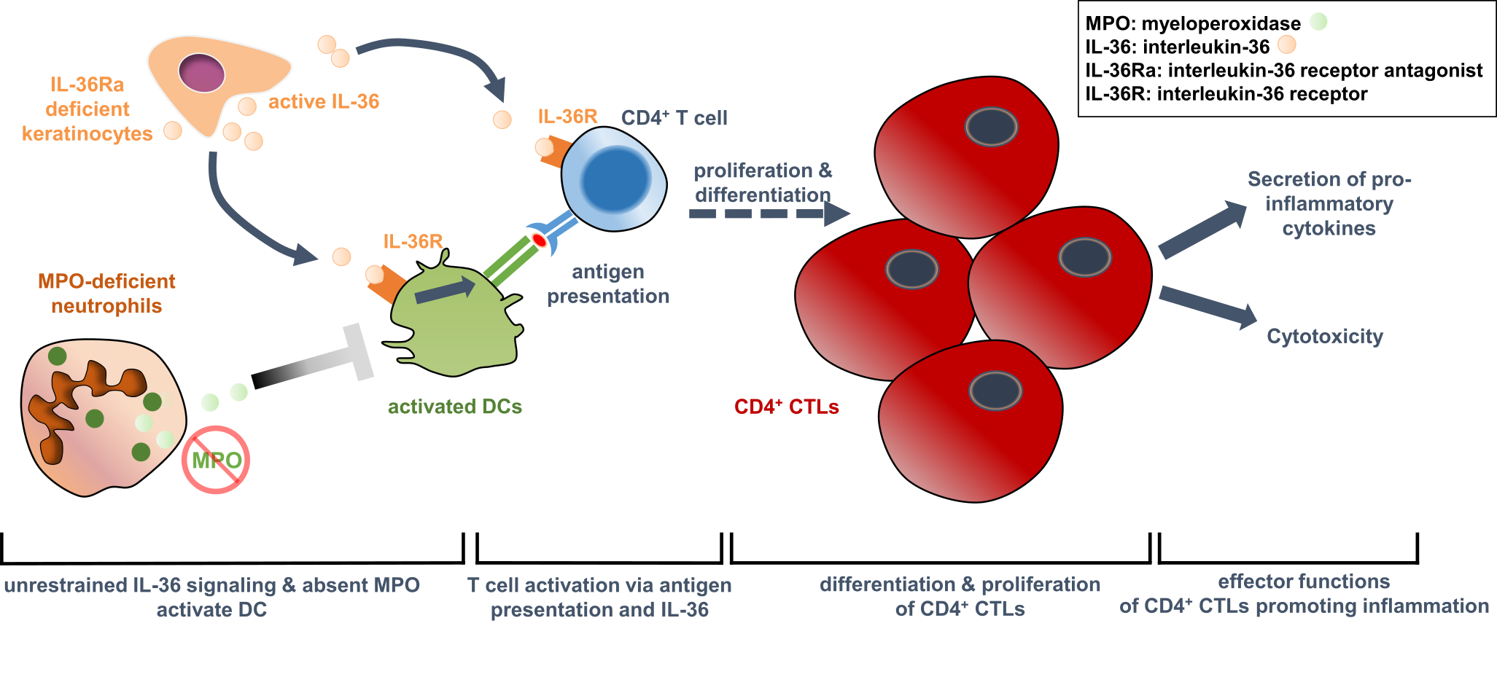
Figure 29: Model of clonal expansion of CD4⁺ CTLs in MPO- and IL-36a-deficiency
The deficiency of MPO and an abundance of IL-36 cytokines in loss of IL-36a might activate CD4⁺ T cells directly via the IL-36R or indirectly via dendritic cells (DCs). Activated CD4⁺ T cells proliferate and differentiate to CD4⁺ cytotoxic T cells (CTLs). These effector T cells might promote inflammation through the secretion of pro-inflammatory cytokines and mediation of cytotoxicity against MHC-II expressing target cells.

Most importantly, further studies need to validate that CD4⁺ CTLs are more frequent in patients with disease associated variants and that this cell type promoting inflammation in GPP.
Subsequently, expanded CD4⁺ CTLs might be considered as a therapeutic target. A recent study provided evidence that CD4⁺ CTLs were reduced in patients with angina pectoris after treatment with TNFα inhibitor infliximab {Rizzello, 2006 #1842}. GPP patients treated with infliximab had a nominally, though not significantly higher mean expression of the CD4⁺ CTLs marker FGFBP2 compared to patients treated otherwise. However, this analysis may be biased, as blood was drawn at different time points of individual treatment intervals. Also, the degree of MPO- and IL36Ra-deficiency was different depending on the (combination of) genetic variant(s). Additionally, functional evidence for IL36Ra-deficiency of each patient is missing in this thesis. The lowest expression in each treatment group belonged to GPP patients without any disease-associated variants. For this reason, it is tempting to assume that genetic variants may have a larger influence compared to current therapies.
Besides infliximab, further monoclonal antibodies aiming to reduce CD4⁺ CTLs have been developed {Chemin, 2019 #1846}. An antibody against the receptor natural killer group 2 member D (NKG2D) has been tested successfully in a phase-II clinical trial in patients with Crohn’s disease. NKG2D is expressed on NK cells and T cells including CD4⁺ CTLs. The expression of the corresponding gene (?)has been described as part of costimulatory signals, which are essential for mediating cytotoxicity {Allez, 2017 #1843}. Another therapeutic option to prevent activation of CD4⁺ CTLs is an anti-fractalkine monoclonal antibody, which has been successfully tested in patients with rheumatoid arthritis {Tanaka, 2021 #1850}. The chemokine fractalkine is increasingly expressed on inflamed endothelial cells. It is recognized by the receptor CX3CR1, which is expressed on monocytes and cytotoxic T cells {Nishimura, 2002 #1865}. Upon ligand-receptor binding, the immune cells recruit other cells by producing pro-inflammatory cytokines. Whether inhibition of TNFα, of NKG2D, the use of fractalkine or other molecules might suppress inflammation in GPP, needs to be evaluated in further studies after the pathogenic role of CD4⁺ CTLs was validated.
CD4⁺ CTLs have been described to produce interferon-γ (IFN-γ, type-II interferon) upon stimulation with PMA/ ionomycin in mouse models of infectious diseases {Takeuchi, 2017 #1844}. Just recently, IL-36 activity was shown to correlate with an IFN-α signature (type-I interferon) in GPP patients and individuals with severe PsV {Catapano, 2020 #1816}. This was discovered via pathway analysis based on DEGs of whole blood transcriptome analysis. RNA was isolated from blood and RNA encoding globin was depleted before sequencing. Whether the IFN-α signature was more enriched in patients with disease-associated variants compared to patients without has not been discussed by Catapano et al. In this thesis, pathway analysis showed an enrichment of “response to interferon” in CD4⁺ TEMs and CD16⁺ monocytes in stable patients and enrichment of the “type I interferon signaling pathway” in genes with changed expression in neutrophils over the course of an acute episode of one patient.
Concluding, evidence for the role of interferon signaling in GPP accumulates, although findings based on sequencing of RNA from whole blood and scRNAseq of PBMCs should be compared with caution. Whether type I or type II Interferon signalling are potential pathogenic parthways, is unclear. These pathways may contribute to extracutaneous inflammation in GPP patients as discussed before {Catapano, 2020 #1816}. According to the authors, IL-36 binded on the IL-36R on human plasmacytoid dendritic cells and thus promoted toll-like receptor (TLR)-9 activation and IFN-α production demonstrated in ex vivo experiments {Catapano, 2020 #1816}. In plasmacytoid dendritic cells, the protein PLSCR1 was shown to be upregulated mediating TLR-9 translocation {Catapano, 2020 #1816}.

The patient affected by an acute episode was noticeable, as the proportion of CD4⁺ CTLs indicated by FGFBP2 expression was the lowest compared to other patients with disease-associated variants as well as patients and healthy donors without variants (Figure 16). The increased proportion of CD8⁺ TEMs was unchanged along the course of the episode (Table 14 & Figure 21) and had been detected in an experiment taking place before the acute episode. In that experiment, the proportions of CD8⁺ TEMs were higher in this patient compared to the two other MPO-deficient GPP partients and four HDs (Figure 14). Nevertheless, the unbalanced T cell distribution might be a susceptibility factor for the onset of GPP or systemic lupus erythematosus (SLE), the patients’ older clinical diagnose. Of note, SLE has been connected to this T cell subtype before {Blanco, 2005 #1848}. At the molecular level, prediction of ligand-receptor interaction suggests that the cytokines CCL3, CCL4 and CCL5 (RANTES) might play an important role in the onset and resolution of the acute episode. All three cytokines have been associated with plaque psoriasis and/ or with GPP before {Pedrosa, 2011 #1804;Duarte, 2015 #1805;Chen, 2013 #1806;Fujisawa, 2012 #1879}: Serum levels of CCL4 and CCL4L polymorphisms correlated with severity of psoriasis vulgaris in 211 psoriatic patients {Pedrosa, 2011 #1804}. Serum levels of CCL5 were also shown to be significantly increased in 117 psoriasis patients compared to 26 healthy donors {Duarte, 2015 #1805}. In seven GPP patients, serum levels of CCL3 and CCL4 were significantly increased compared to 16 healthy donors {Fujisawa, 2012 #1879}.
The pathway “SRP-dependent cotranslational protein targeting to membrane” was the most enriched pathway of the patient during the acute flare, but also in neutrophils of stable patients. The pathway is essential for the targeting of secretory proteins to the membrane, e.g. Interleukine-6 {Verboogen, 2019 #1899;Ellgaard, 2016 #1900}. Therefore, this pathway might indicated activated immune cells, which are producing high amounts of secretory proteins, such as Interleukins and other immune-modulating proteins.
The role of monocytes in GPP is ambivalent. During the acute flare, the frequency of CD16⁺ monocytes was decreased in the patient compared to the dataset of stable patients and HDs (Table 14). The proportions of all monocytic subsets were reduced when the inflammation diminished. This is in good agreement with further studies demonstrating that GPP patients can be treated successfully using granulocyte and monocyte adsorption apheresis {Fujisawa, 2015 #1849;Fujisawa, 2012 #1879}. In contrast, Vergnano et al. showed that the percentage of monocytes was significantly decreased in individuals from the UK Biobank carrying the MPO c.2031-2A>C splice site variant {Vergnano, 2020 #1781}. However, individuals affected by an immunological disease, infection or immune-modulating therapeutics were not omitted as control individuals in this analysis. These circumstances may have affected the number of monocytes as well. A decreased proportion of monocytes may further reduce the efferocytosis of MPO-deficient neutrophils and thereby predispose carriers to GPP. Therefore, the role of monocytes should be studied in patients and mouse models focusing on apoptosis, the serine protease cathepsin S in conjunction with its inhibitor cystatin C and efferocytosis.
Overall, the data presented in this thesis focus on immune cells from peripheral blood instead of skin tissue of GPP patients. Other cells were not available for these studies. The second limitation of this thesis is the fact that the patients were in variable disease state. Peripheral blood cells of only one patient during an acute flare was investigated in detail. This is due to organizational reasons, as GPP patients are not hospitalized in Erlangen during an acute disease episode on a regular basis. Future studies may focus on the molecular and cellular characteristics of patients’ skin tissue. Until now, the skin of GPP patients during an acute flare were not investigated to the best of my knowledge. This could be achieved by scRNAseq in conjunction with flow cytometry.

Besides keratinocytes, neutrophils are the most important cell type in GPP. In a comparative bulk RNAseq MPO-deficient patients, the pathway “complement activation, classical pathway” was enriched in neutrophils. The complement system has been described in single cases of GPP since the late 1970s {Stendahl, 1984 #1676;Tagami, 1977 #1838}. It is a fundamental part of the innate immune system, and the classical pathway is activated via the binding of C1q to antibody-antigen complexes, cell debris, or acute phase proteins including C-reactive protein {Murphy, 2016 #1891}. It has been speculated that the complement system contributes to PsV in early disease state {Giang, 2018 #1828}. C3-deficient psoriasis mouse models showed reduced disease activity, less infiltrated neutrophils and reduced IL-17 cytokine levels suggesting a potential link between the complement system and the IL-23/ IL-17 axis of adaptive immunity {Schonthaler, 2013 #1866;Giacomassi, 2017 #1867}. Whether the complement system also contributes to the systemic inflammation in GPP, remains unknown. Considering that the complement system is known to promote inflammatory reactions immediately and ubiquitously, future studies should focus on this pathways.

Conclusions
Variants in MPO encoding myeloperoxidase were identified in 21% of patients with GPP. Notably, only MPO variants leading to complete enzyme deficiency were significantly associated with GPP. The number of MPO variants was significantly associated with GPP and association was even more significant, when carriers of single IL36RN variants were considered additionally. These findings suggest that GPP has an oligogenic basis. Further disease-associated genes are yet undefined, and the majority of cases is still unsolved. Ex vivo studies suggest that MPO-deficiency contributes to GPP via increased protease activities, impaired NET formation and reduced phagocytosis of neutrophils by monocytes. These underlying mechanisms should be validated in functional murine studies in vivo. If confirmed, they provide potential treatment targets.
Lack of evidence for association of MPO variants with more common psoriatic diseases (PsV, PsA) and SAPHO syndrome shows that the genetic basis of GPP differs from these disease subtypes. The nominally significant association of MPO variants and palmoplantar pustular psoriasis needs independent replication. If so, pathogenic pathways associated with MPO-deficiency should be investigated in these patients. If not, functional relevant variants of MPO may be considered as susceptibility factors with very low or no significance.
Annotation of single-cell RNA sequencing data by multimodal referencing mapping resulted in a precise distinction of CD4⁺ and CD8⁺ T cell subsets, which was validated at protein level by flow cytometry. The transcriptome analysis of patients’ PBMCs revealed an expansion of CD4⁺ CTLs dependent on disease-contributing variants. If this result can be validated in further studies, inactivation of this pro-inflammatory cell type could be a promising therapeutic approach. Transcriptome analysis of neutrophils provided evidence for an involvement of the complement system in patients with rather stable disease state and the type I interferon pathway during an acute episode. To what extent the complement system and the type I interferon pathway promote inflammation systemically or locally, is yet undetermined. Overall, variants in MPO and IL36RN contribute to GPP by pathways of innate and adaptive immunity.

Materials & Methods
A list of consumable materials, chemicals and enzymes, buffers and solutions, kits, devices, antibodies, oligonucleotides, plasmids, software and databases is available in chapter 6.25.

Recruitment of patients
The ethical committee of the Friedrich-Alexander-Universität of Erlangen-Nürnberg approved the studies presented in this thesis. Written informed consent was obtained from each affected and control individual before enrolment by the recruiting physicians. Investigations were performed according to the Declaration of Helsinki principles. Patients with GPP, ACH and PPP were diagnosed according to the ERASPEN consensus criteria {Navarini, 2017 #1724}. The diagnosis of patients affected by AGEP was according to the scoring system used by RegiSCAR study groups and modified by Paulmann and Mockenhaupt {Sidoroff, 2001 #1727;Paulmann, 2015 #1725}.
A summary of phenotypical characteristics of patients with GPP, ACH and AGEP is available in the results of this thesis (Table 5). Characteristics of patients with PsV, PsA, PPP and SAPHO syndrome are shown in Table 15.
Table 15: Phenotypical characteristics of patients affected by PsV, PsA, PPP and SAPHO syndrome.
41 of 206 patients (16.6%) were additionally affected by PsV, while 59 of 181 (24.6) had PsA.
 | PsV | PsA | PPP | SAPHO syndrome

Gender
female | 574 (42.4%) | 597 (45.5%) | 216 (83.1%) | 34 (65.4%)
male | 781 (57.6%) | 716 (54.5%) | 44 (16.9%) | 18 (34.6%)
Age at recruitment |  |  | 51.1 ± 12.9
0-20 | 806 (43.1%) | 13 (7.6%) |  | U
21-40 | 763 (40.8%) | 63 (36.6%) |  | U
>40 | 302 (16.1%) | 96 (55.8%) |  | U
Age of onset | 24.74 ± 13.83 | 29.49 ± 14.63 | 39.68 ± 16.64 | 37.73 ± 16.0

Family history of psoriasis
negativ | 665 (54.8%) | 631 (59.9%) | 126 (65.6%) | 23 (82.1%)
positive | 549 (45.2%) | 423 (40.1%) | 66 (34.4%) | 5 (17.9%)
U=unkown

The samples of the patient GPP3 during an acute phase of the disease were gained by Carola Berking and David Pauli from the Department of Dermatology at the university hospital Erlangen. A description of the patient is available in chapter 4.5.1.

The family members of seven GPP patients and one AGEP patients were contacted and recruited through the index patients. Diagnoses of those individuals were reported by themselves. Patients with PsV or PsA were diagnosed by board certified dermatologists and rheumatologists at university hospitals, but also at specialist practice as described previously {Huffmeier, 2005 #554}. The PsA- and PsV-patients were a subset of patients described previously {Lohr, 2019 #1699}. The study group of patients with SAPHO syndrome was similar to the one presented before {Assmann, 2020 #1884}. Patients affected by PPP were recruited as described previously {Mossner, 2015 #1555} PMID: 25989471.

Whole-exome sequencing analysis
To find new genetic factors, whole-exome sequencing was performed in 31 patients without functionally relevant variants in IL36RN. The enrichment was performed using SureSelect v4-6, the average coverage of the target was 142.3 ± 31.1 (standard deviation) and 87.4% ± 10.7 of the target was covered above 20x. Variants of interest had a coverage of ≥20x and were present in less than three control individuals (n=706). The latter were sequenced in-house and were not affected by an immunological disease.
The analysis was restricted to genes with homozygous variants in at least two patients. As the parents of patients were often not available for analysis, potentially compound heterozygous variants were ignored. A minor allele frequency (MAF) of 0.5% or lower was used, considering that the IL36RN variant c.338C>T/ (p.Ser113Leu) had a MAF of 0.44 in non-Finnish European individuals of the databank gnomAD {Karczewski, 2020 #1771}. Variants located in regions of segmental duplications (defined as regions of a minimum length of 1kb which occur more than once in the genome) with a similarity >90%) were omitted. The plausibility of the variants was assured by evaluating the NGS reads in the IGV browser. Four homozygous variants in the two genes MPO and MUC4 were identified (Table 22).
Table 16: Homozygous variants present in at least two of 31 GPP patients identified by whole-exome sequencing
For each variant, the affected gene, the location in the genome (hg19 reference) and the minor allele frequency in individuals of Non-Finnish European origin from gnomAD {Karczewski, 2020 #1771} is shown.
Gene | Variant at nucleotide/ protein level | Position in hg19 (dbSNP-ID) | Frequency in Non-Finnish European individuals of gnomAD (proportion of minor allele)
MPO | c.1768C>T/ p.Arg590Cys (NM_000250.2) | Chr17: 56,350,133 (rs142082076) | 0.004% (9/129,050)
MPO | c.265_275dup/ p.Ser94Alafs*24 (NM_000250.2) | Chr17: 56,357,348 (rs1188888247) | 0.0065% (1/15,406)
MUC4 | c.11698_11745del/ p.Arg3900_Thr3915del (NM_018406.7) | Chr3: 195,506,712-195,506,759 (rs1299856820) | 0% (0/48,894)
MUC4 | c.7792A>G/ p.Thr2598Ala (NM_018406.7) | Chr3: 195,510,659 (rs200280829) | 0.0071% (3/42,206)

Number of variants in MPO or MPO and IL36RN in GPP patients and control individuals
To evaluate whether the number of variants in MPO or MPO and IL36RN is a predictor for GPP, the number of functionally relevant variants in 82 GPP patients and 4,937 control individuals was determined. The group of control individuals consisted of 2,504 individuals from the 1,000 Genomes project (phase 3 {Genomes Project, 2015 #1697}) and 2,433 individuals, who were sequenced in-house using the same enrichment method as the GPP patients and did not have inflammatory disease. To identify all functionally relevant variants in MPO and IL36RN, all variants with an MAF of less than 2% were preselected. Of those, splice variants (splice acceptor sites (-1/-2), splice donor sites (+1/+2)) and truncating variants were considered functionally relevant. After a systematic literature search using NCBI’s Pubmed (“IL36RN AND mutat∗ AND deficien∗.” and “MPO AND mutat∗ AND deficien∗.”), the remaining ones were only considered relevant, if evidence was provided. A list of all functionally relevant variants is given in the supplements (Table S 1, page 126). In total, eight and 16 different functional variants in MPO were found in all patients and control individuals, respectively. Six different functional IL36RN variants were identified in control individuals, while four of them were found in patients.

Polymerase chain reaction (PCR)
Polymerase chain reaction (PCR) was performed in order to amplify DNA. Concentration and quality of DNA was measured photometrically using the Infinite 200 NanoQuant (Tecan). The working solution of a DNA had a concentration of 20ng/µl. A standard approach was used, if not indicated otherwise (Table 16).
Table 17: PCR reaction
Reagent | Volume [µl]
dNTPS | 0.3
Reaction Buffer | 1.5
ddH2O | 4,7
Taq Polymerase | 0.07
MgCl2 | 0.45
Betaine | 3
DNA | 4 (20ng)
forward primer | 0.5
reverse primer | 0.5

Incubation took place in a thermocycler using the program Cx32 (Table 17).
Table 18: Thermocycler program Cx32
Temperature | Time | Cycles
94°C | 3 min
94°C | 20 sec | 9 Cycles
65°C – 1°C/Cycle | 60 sec
68°C | 60 sec
94°C | 20 sec | 29 Cycles
55°C | 60 sec
68°C | 60 sec
68°C | 10 min
15°C | 5 min

For longer fragments (>1kbp), the elongation temperature was adjusted (1min per 1kb). All primers used (Table 32) were purchased from Thermo Fisher Scientific and stock solutions (100ng/µl) were generated by dissolving the oligonucleotides in ddH₂O (double-distilled water). For working solutions, a concentration of 20ng/µl was used. The primers were designed with the tool Primer3web and tested with the in-silico PCR tool from the UCSC genome browser.

Agarose gel electrophoresis
To test whether PCR fragments have the expected size, agarose gel electrophoresis was performed. The agarose content of gels was 1.5%. peqGREEN DNA/RNA binding dye (Peqlab) was added and the gel was stored at 65 °C until use. Before loading, 3µl loading dye was added to 3µl of PCR product. Gels were performed in TBE-filled electrophoresis chambers and a picture was taken on a ChemiDoc™ Touch Imaging System (Bio-Rad).

Sanger sequencing
Sanger sequencing was used to determine the sequence of base pairs on specific DNA fragments, as introduced by Sanger et al. {, 1977 #1030}.
PCR products were purified with the Agencourt® AMPure® kit (Beckman Coulter) using the pipetting robot Biomek® NXP (Beckman Coulter). The sequencing reaction was performed using the BigDye® Terminator v3.1 cycle sequencing kit (Thermo Fisher Scientific, Table 18).
Table 19: Sequencing reaction
Reagent | Volume [µl]
Sequencing Buffer | 2
Premix | 0.25
H2O | 2
DMSO | 0.25
forward or reverse primer | 0.5
purified PCR product | 5

The reaction was performed using the thermocycler program BigDye55 (Table 19). For longer transcripts (>750bp), the step at 60°C were prolonged to four minutes. The sequencing product was purified using the Agencourt® CleanSEQ® kit (Beckman Coulter) and analyzed on an ABI 3730 DNA Analyzer (Thermo Fisher Scientific).
Table 20: thermocycler program BigDye55
Temperature | Time | Cycles
96°C | 10 sec | 25 Cycles
55°C | 10 sec
60°C | 2 min
15°C | 10 min

Synthesis of cDNA
SuperScript III™ reverse transcriptase (Thermo Fisher Scientific) and oligo dT primers (Life Technologies (Thermo Fisher Scientific)) were utilized to synthesize cDNA from RNA following the manufacturer’s instruction. For cDNA synthesis of neutrophils, we used 100 ng of RNA and the product was diluted to a total volume of 200 µl. Otherwise, we used 1µl of RNA per sample.

Site-directed mutagenesis
In order to investigate missense variants in MPO, site-directed mutagenesis was performed to generate plasmids with specific variants. Primers were designed using a publicly available tool (http://bioinformatics.org/primerx/cgi-bin/DNA_1.cgi, access date: 23.02.2018). The vector was amplified with these specific primers using PfuUltra II Fusion High-Fidelity DNA polymerase (Agilent) (Table 20). The PCR program was identical to Cx32 (Table 17) with an adjusted elongation time of 6 minutes.
Table 21: Reaction of site-directed mutagenesis
Reagent | Volume [µl]
H2O | 17.5
10× PfuUltra buffer | 2.5
dNTP(2,5mM) | 2.5
cDNA(100ng) | 2
primer F | 0.5
primer R | 0.5
PfuUltra polymerase | 0.5
total | 26

Transformation of bacteria and plasmid preparation
In order to amplify the plasmids with MPO variants, One Shot™ TOP10 Chemically competent E. coli (Thermo fisher scientific) were used according to the manufacturer’s protocol. 1µl of PCR product was used. After an overnight incubation, clones were selected and used directly for colony PCR (reaction as in Table 16) and transferred to a 5ml falcon containing 5ml LB (lysogeny broth) medium and 50µg/ml ampicillin for an incubation phase of 12 hours. The QIAprep Spin Miniprep Kit (Qiagen) was used for isolation of plasmid DNA following the manufacturer’s instructions. Concentration and quality of DNAs were measured photometrically using the Infinite 200 NanoQuant (Tecan). All positive clones were sequenced a second time for verification purposes.

Transfection of Human Embryonic Kidney (HEK)-293T cells
Human Embryonic Kidney (HEK)-293T cells were transfected with MPO mutant constructs in order to assess the impact of missense MPO variants. Originally, HEK cells derived from a human embryonic kidney of an embryo. The exposition to sheared DNA obtained from an adenovirus type 5 led to immortalization of those cells. The “T” indicates the stable transfection of a plamid encoding temperature-sensitive mutant of the SV40 large T antigen {Graham, 1977 #1852}. This cell line was kindly provided by the group of Christaine Zweier.
Cells were cultured in DMEM (Dulbecco's modified Eagle's medium) ham’s F-12 (Thermo Fisher Scientific or Sigma Aldrich) growth medium containing 10% FCS (Fetal calf serum) and 1% Penicillin-Streptomycin-Glutamine under sterile conditions at 5% CO₂, 37 °C and 91% humidity. The passage of these cells took place every 3-4 days. The media was removed and 1xPBS (Phosphate-buffered saline) was used for washing. Next, the cells were detached from the flask by incubation with 0.05% Trypsin-EDTA (Ethylenediaminetetraacetic acid) for 5 min at 37°C. Subsequently, the cells were rinsed with fresh medium, until clumps of cells were dissolved. 90% of the suspension was discarded, while 10% remained in the bottle, and new media was added.
For transfection purposes, HEK-293T cells were grown to 80-90% confluency in a 6-well plate. In one 1.5ml Eppendorf tube, 100µl Opti-MEM (Thermo Fischer), 1µg of expression vector and 3.75µl of Reagent Plus (Thermo Fischer) was mixed and incubated for 15 minutes. In a second tube, 100µl of Opti-MEM and 2.5µl of Lipofectamin 2000 were mixed, added to the first Eppendorf tube and incubated for 15 minutes. In the meantime, cells were washed with 1ml of Opti-MEM. After the incubation phase of 15 minutes, 800µl of Opti-MEM was added to the mix without mingling. The total volume of 1ml was added carefully to the cells. After 4 hours, the media was replaced by DMEM with 20% FCS. The supernatant was harvested for enzyme activity tests after three days. For control purposes, we used 0.5µg of MPO expression plasmid and 0.5µl of an OFP-expression plasmid and checked for fluorescent cells under the microscope before harvesting.

Isolation of immune cells from peripheral blood

Isolation peripheral blood mononuclear cells (PBMCs) and neutrophils based on Ficoll
For isolation of PBMCs and neutrophils, 20ml of EDTA blood was mixed with 10ml of PBS. 15ml of ficoll (Lymphoflot, Bio-Rad, Feldkirchen, Germany) were layered carefully over the blood without mixing. After centrifuging at 600g for 30min with the lowest acceleration and without brakes, the ring below the plasma containing PBMCs was transferred to a new falcon and washed twice with FACS buffer. The neutrophils located between the erythrocytes at the bottom and the ficoll phase in the middle were transferred (6-8ml) to a new 50ml falcon. Depletion of erythrocytes was performed by 30-second incubation with 36ml of chilled H₂O. To stop the lysis, 4ml of 10x PBS was added. The lysis step was performed twice, and centrifuging took place at 350g for 10min. Neutrophils and PBMC were counted using Neubauer chambers, and purity was assessed by flow cytometry (antibodies are given in chapter 6.25.6). Neutrophils isolated via ficoll method were used for the analysis of NET formation, efferocytosis and enzyme activity. The purity of isolated living neutrophils (>85%) was assessed by Madelaine Hahn (Department of Internal Medicine 3 – Rheumatology and Immunology, university hospital Erlangen) using flow cytometry. PBMCs were used for isolation of CD14⁺ monocytes,

Isolation of CD14⁺ monocytes from PBMCs
Isolation of CD14⁺ monocytes was performed with EasySep™ Human CD14 Positive Selection Kit II (Stemcell, Vancouver, BC, Canada) according to the manufacturer’s protocol. PBMCs isolated by ficoll were used as a source (see previous chapter 1.1). The purity of isolated cells (>85%) was assessed by Madelaine Hahn (Department of Internal Medicine 3 – Rheumatology and Immunology) using flow cytometry.

Isolation of neutrophils from whole blood
Isolation of neutrophils from EDTA blood was performed with MACSxpress Whole Blood Neutrophil Isolation Kit followed by depletion of erythrocytes with the MACSxpress Erythrocyte Depletion Kit (Miltenyi Biotec, Bergisch Gladbach, Germany) according to the manufacturer’s protocols. Neutrophils were only used isolation of RNA.

Enzyme activity assays
The neutrophils used to determine the activities of the following enzymes were isolated based on Ficoll as described in chapter 1.1.

Myeloperoxidase based on ELISA
To determine MPO activity, an ELISA kit (HK324-02, HycultBiotech, Uden, Netherlands) was used according to the manufacturer’s protocol. Either 100µl of the supernatant of transfected HEK-293T cells or the supernatant of 2*10^6 neutrophils, incubated in 100µl PBS for 1.5 h at 37°C and 5% CO₂, was added to the 96-well plates. After 1h of incubation, wells were washed three times. 50µl of 0.03% H₂O₂ solution and 50µL of 1:1,000 diluted 200mM ADHP (10-Acetyl-3,7-dihydroxyphenoxazine; AAT Bioquest) were added as substrates. Upon oxidation, the fluorescence intensity of ADHP changes proportional to the reaction velocity. This velocity is proportional to the enzyme activity, as the substrate is present in excess. The fluorescence intensity was measured at excitation/emission (Ex/Em) 535/590 every minute for 30min using a fluorescence plate reader SpectraMax M3 (Molecular Devices, San Jose, CA, USA).
For quantification, standards were measured for each experiment. In a linear phase of at least five time points (>5min), the values of the samples were extracted from values of the control well (only media) at the corresponding time points. Next, the slope of the linear regression was determined within the time frame for each sample. By applying the linear regression of the standard curve (slope of fluorescence intensities versus concentration of MPO), the MPO activity of each sample was calculated.
In case of the activity measurements of mutant MPO constructs, I did not establish a standard curve. Instead, the slope of each sample was divided by the slope of the sample obtained from the wildtype construct. Activities were provided as percentage of activity from the wildtype construct.

Myeloperoxidase based on differential blood count
To test the MPO activity directly from EDTA blood samples, a differential blood count on an Advia 120 (Siemens Healthineers) was performed by members of the lab of Stephan von Hörsten (Department of Experimental Therapy, UK Erlangen). 4Chloro-Naphtol and H₂O₂ were added to the cells as substrates. The fluorescence intensity of these cells measured by flow cytometry was proportional to their corresponding MPO activity resulting in a MPXI (‘‘Mittlerer [German: average] PeroXidase Index’’). Higher values than 10 indicated MPO-deficiency according to the manufacturer.

Cathepsin G
To investigate the Cathepsin G activity in neutrophils, a commercially available kit (ab126780, Abcam, Cambridge, UK) was used. Tests were performed in triplicates and 1x10^6 neutrophils were lysed in 100µl of cold assay buffer, incubated for 10 minutes on ice and centrifuged at 16,000g for 5 minutes This lysate was also used for determining the activity of proteinase 3 and neutrophil elastase. The test was performed according to the manufacturer’s protocol.

Proteinase 3
Adam Lesner (Faculty of Chemistry, University of Gdansk) provided the highly specific and sensitive substrate ABZ-Tyr-Tyr-Abu-Asn-Glu-Pro-Tyr(3-NO2)-NH2 for determining the activity of proteinase 3 as described previously {Popow-Stellmaszyk, 2013 #1693}. Lysate was generated as described for cathepsin G activity test. Tests were performed in triplicates. In one well of a black 96-well plate, 20µl of supernatant was added to 80µl of PBS. For the standard curve, 10µl of proteinase 3 (BML-SE498-0025, enzolifesciences, Lörrach, Germany) was diluted with 190µl of PBS as a stock solution. In a serial dilution with seven steps, 100µl were added to 100µl of PBS. The lowest standard was 100µl of PBS only. 20µL of 15µM substrate was added to each well and the fluorescence intensity was measured at Ex/Em 360/485 every minute for 30 min using a fluorescence plate reader SpectraMax M3. Data analysis was performed as described for MPO activity test based on ELISA. Only values within the time frame of a linear course were considered (at least 5 time points).

Neutrophil elastase
To determine the activity of neutrophil elastase, the commercially available Neutrophil Elastase Activity Assay Kit (ab204730, Cayman chemical, Ann Arbor, MI, USA) was used according to the manufacturer’s protocol. Lysate was generated as described for cathepsin G activity test. The experiment was performed in triplicates. Data analysis was performed as described for MPO activity test based on ELISA. Only values within the time frame of a linear course were considered (at least 5 time points).

Cathepsin S
To investigate cathepsin S activity, we used a commercially available assay (K144, Biovision, Milpitas, CA, USA) according to the manufacturer’s protocol. 1.5x10^6 monocytes were lysed in 50µl of chilled lysis buffer. The monocytes were obtained as described in chapter 1.1. The experiment was performed in triplicates. Data analysis was performed as described for MPO activity test based on ELISA. Only values within the time frame of a linear course were considered (at least 5 time points).

Analysis of neutrophil extracellular traps (NETs)
The analysis of neutrophil extracellular traps (NETs) was performed by Jonas Hahn, Maximilien Euler and Markus Hoffmann from the Department of Internal Medicine 3 – Rheumatology and Immunology, university hospital Erlangen.
Neutrophils were isolated as described in chapter 1.1. For one condition per sample, 2.5*10^5 isolated human neutrophils were suspended in 200ml RPMI medium 1640 (GIBCO, Carlsbad, CA, USA). The cell suspension was then added into one well of a 96-well flat bottom plate (Cellstar, Greiner Bio-one). Subsequently, 5mM Sytox Green (Thermo Fisher Scientific) along with either phorbol myristate acetate (PMA) (100ng/mL; Sigma), A23187 (5mM, Sigma Aldrich (St. Louis, MO, USA)), or vehicle (RPMI medium) were pipetted. After sealing of the plate, the samples were analyzed using an Infinite 200 Pro plate reader (Tecan, Männedorf, Schweiz) for 240 min at 37°C and 5% CO₂. For data analysis, relative fluorescence intensities were subtracted by the values detected at the beginning and normalized to the vehicle control.

Efferocytosis assay
The efferocytosis assay was based on flow cytometry and performed by Heiko Bruns from the Department of Internal Medicine 5 – Haematology and Oncology, university hospital Erlangen. Neutrophils were labeled with CPD (ebioscience (Thermo Fisher Scientific)) following the manufacturer’s protocol and co-cultured with monocytes (ratio of neutrophils to monocytes 5:1) in sterile FACS tubes for 24h in RPMI and 10%FCS at 37°C and 5% CO₂. Then, the cell suspension was incubated with anti-CD11b-FITC antibody and flow cytometry analysis was performed. Non-phagocytosed neutrophils were CPD positive and CD11b negative. For quantification of the absolute number of remaining neutrophils, 123count eBeads (ebioscience) were added (Figure S1). Flow cytometry experiments were analyzed with FACS Canto II (BD Bioscience).
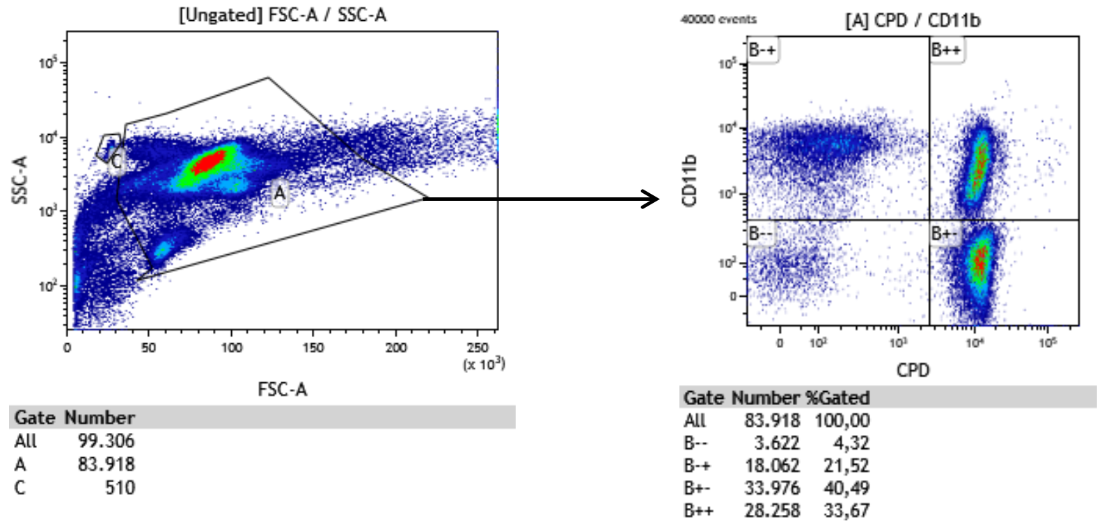
Figure 30: Flow cytometry strategy to analyse residual neutrophils.
The absolute number of viable, non-phagocytosed neutrophils were quantified by adding 123count eBeads (ebioscience). Those cells were CD11b positive and CPD negative as depicted in the upper left panel (B-+) of the right FACS plot.

Flow cytometry analysis of CD47 on neutrophils
The staining for CD47 was performed by Heiko Bruns (Department of Internal Medicine 5 – Haematology and Oncology, university hospital Erlangen). 1*10^5 neutrophils were incubated with a monoclonal anti-CD47 antibody (1:300, BD Bioscience) for 30 min at 4°C. The cell suspension was then washed twice with PBS and analyzed using flow cytometry.

Genotyping of MPO variants
The work in the wet lab was performed by Joseph Simon Horowitz under the supervision of Sabine Löhr. In order to genotype 3,663 individuals (1,105 PsV, 1,313 PsA, 271 PPP, 52 SAPHO syndrome and 922 control individuals) for seven functionally relevant MPO variants, the methods of single SNP genotyping assays based on TaqMan technology, SNP genotyping microarrays (NAME DES ARRAYS) and Sanger sequencing were used.
Four variants (c.752T>C/p.(Met251Thr), c.995C>T/p.(Ala332Val), c.1555_1568del/p.(Met519Profs*21), c.2031-2A>C/r.[2030_2031ins[2031-109_2031-1],2030_2031ins[2030+1_2031-1]) were genotyped by using predesigned TaqMan assays (n=3) or a self-designed assay (Table 21) Table 24(Life Technologies (Thermo Fisher Scientific), Carlsbad, CA, USA) with 20ng of genomic DNA as a template in a 5µl Taqman reaction. For detection, the 7900HT sequence detection system (Applied Biosystems (Thermo Fisher Scientific), Foster City, California, USA) was used. DNA of four GPP patients with the corresponding variant in MPO were used as positive controls. Genotypes that defy interpretation were sequenced by Sanger sequencing. Consequently, the genotyping rate was 100%.
Table 22: Description of three predesigned and one self-designed Taqman genotyping assay
rsID | Variant at nucleotide/ protein level | Taqman assay ID / Probes & Primers
rs56378716 | c.752T>C/ p.(Met251Thr) | C__27531740_20
rs28730837 | c.995C>T/ p.(Ala332Val) | C__25922741_20
rs963955387 | c.1555_1568del/ p.(Met519Profs*21) | Probes:  AGCCCATGGAACC for wildtype (VIC-labeled)  CAGCCCCCGTGTC for deletion (FAM-labeled)  Primers:  forward GTCTTCACCAATGCCTTCCG  reverse CTGGCCTAGGTCCTGCTTAC
rs35897051 | c.2031-2A>C/ | C__60526215_10

Four MPO variants were genotyped on global screening arrays (GSA; gsamd-24v1-0_20011747_a1, Illumina, San Diego, CA, USA) in 2,725 individuals (1,328 PsV, 1,344 PsA, 6 PPP, 47 SAPHO syndrome). Probands with a microarray-wide genotyping rate of <98% were omitted, and the distributions of SNPs were in concordance with Hardy-Weinberg equilibrium (threshold of 0.001). The variant c.1642C>T/p.(Arg548Trp) was excluded from this analysis, since the genotyping plots did not allow for reliable clustering in contrast to the other three variants (c.752T>C/p.Met251Thr), c.1705C>T/p.(Arg569Trp) and c.2031-2A>C) (Figure 31Figure 32).
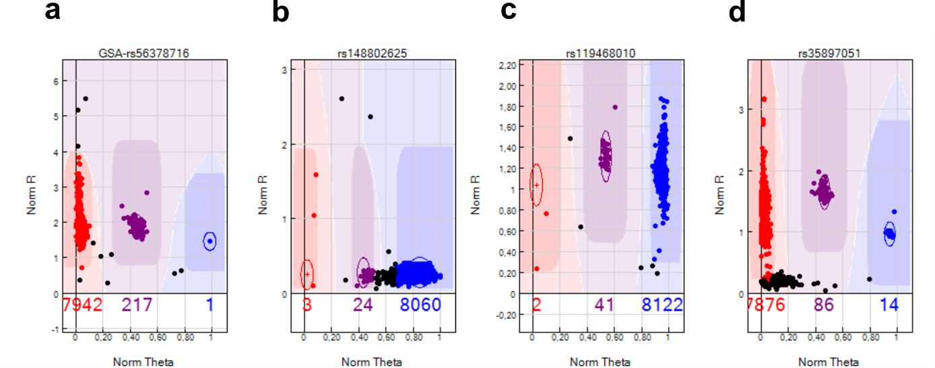
Figure 31: Genotyping plots of the four variants in MPO analyzed by GSA
The genotyping plot of a c.752T>C/ p.(Met251Thr) (rs56378716), b c.1642C>T/ p.(Arg548Trp) (rs148802625), c c.1705C>T/ p.(Arg569Trp) (rs119468010) and d c.2031-2A>C (rs35897051) generated by microarray analysis. Plots display genotyping signals in polar coordinates with the radius on the x-axis and the polar angle in radians on the y-axis. The color of the clusters indicates homozygosity (blue or red) or heterozygosity (purple), while circles around dots demonstrate genotype calls of high confidence. Unassigned genotypes are represented as black dots.
All rare genotypes detected by these methods were verified by Sanger sequencing. 7,338 genotypes (3 SNPs in 2,446 DNAs (1,073 PsV, 1,321 PsA, 4 PPP, 48 SAPHO syndrome)) were detected by both methods and served as quality control. In total, the genotypes of the two variants c.752T>C/p.(Met251Thr) and c.1705C>T/p.(Arg569Trp) were in complete concordance, while in case of c.2031-2A>C, six probands were homozygous for the rare allele (99.81% concordance) according to microarray, but heterozygous according to Sanger sequencing. Sanger sequencing also indicated an additional heterozygous variant (c.2031-6A>G) four bases upstream of c.2031-2A>C in all six probands, which probably led to a false-positive result. We supposed that a reduced binding of the microarray probes in case of the mismatch lead to false homozygous genotypes. In general, these concordance rates indicated reliable genotypes in case of these three SNPs.
Three SNPs c.1642C>T/p.(Arg548Trp), c.1705C>T/p.(Arg569Trp) and c.1768C>T/p.(Arg590Cys) were positioned in exon 10 and sequenced by Sanger in all patient groups.
In total, the genotyping rate of the seven variants detected by the three genotyping methods in 3,663 individuals was 100%Table 25 (Table 22). Additionally, 441 patients were genotyped for less than seven SNPs. These results were included for determining the association per variant, but not for the cumulative frequencies. All rare genotypes were verified by Sanger sequencing.
Table 23: Overview of SNPs and their corresponding genotyping methods
Variant at nucleotide/ protein level | Method
c.752T>C/p.(Met251Thr) | global screening array, TaqMan assay
c.995C>T/p.(Ala332Val) | TaqMan assay
c.1555_1568del/ p.(Met519Profs*21) | TaqMan assay
c.1642C>T/p.(Arg548Trp) | Sanger sequencing
c.1705C>T/p.(Arg569Trp) | Sanger sequencing, global screening array
c.1768C>T/p.(Arg590Cys) | Sanger sequencing
c.2031-2A>C | global screening array, TaqMan assay

Analysis of individuals with two variants for compound heterozygosity
In chapter 4.3.1, a segregation analysis of MPO and IL36RN variants in family members of MPO-deficient GPP patients was described. Two individuals in family VII of the segregation analysis carried two different IL36RN variants. To test whether these were in a compound heterozygous state, the region of interest was amplified, cloned into a vector and transformed in E.coli. Targeted sequencing of DNA purified from E.coli colonies was performed. These purified DNAs of both individuals were positive for only one of the two variants suggesting compound heterozygosity.

Single-cell RNA sequencing (scRNAseq) analysis of PBMCs
The scRNAseq experiments were performed by the NGS core unit (Andre´ Reis) of the Institute of Human Genetics, Erlangen. The generation of the cell-gene matrix was performed by Philipp Kirchner. In total, two experiments were performed. The first one included the two patients GPP1 and GPP2 and three healthy donors. GPP1 was analyzed at a second additional time point due to the low number of cells obtained from the first part of the experiment. PBMCs were isolated from EDTA whole blood using BD Vacutainers (BD, Franklin Lakes, NJ, USA) according to the manufacturer’s instructions. 6,000 cells were aimed to be sequenced. Libraries was generated by the Chromium controller (10X Genomics, Pleasanton, CA, USA) in conjunction with the single-cell 30 v2 kit (in case of GPP1_1, GPP2, HD1, HD2) or with the single-cell 30 v3 kit (GPP1_2, HD3) according to the manufacturer’s protocol. The sequencing of the libraries were performed by Illumina HiSeq 2500 sequencer to a depth of 160 million reads per sample. We used the Genome Reference Consortium Human Build 37 (GRCh37/hg19) obtained from ENSEMBL. The primary analysis was performed using bcl2fastq 2.17 (Illumina) and cellranger 1.3.1 (10X Genomics). The cellranger aggr command was used to normalize all samples to the same count of reads. QC filtering was performed using Seurat (Version3) with numerous criteria (Table 23) {Stuart, 2019 #1695}.
Table 24: Filtering criteria of scRNAseq experiments of HDs and patients in stable state
kit/ experiment | filtering criteria
 | No. of genes per cell | threshold of percentage of mitochondrial genes | threshold of percentage of ribosomal genes
v2/1 | 200-2,500 | <10% | >5%
v3/2 | 200-4,000 | <22% | >5%

To correct for batch effects, the data were integrated using the functions sctransform (batch_var= sample) and IntegrateData with 30 dimensions. To annotate each cell, multimodal referencing was applied according to the authors’ vignette (https://satijalab.org/seurat/articles/multimodal_reference_mapping.html, 19.11.2020) {Hao, 2021 #1856}. As recommended, the analyzed data (query) were merged with the reference data resulting in a UMAP. All major clusters were occupied by the cells of the reference data indicating that the reference data contained all cell types also found in the query data set (Figure 32a). The calculated prediction score per cell indicating how well the annotated cell matched with the reference data set is shown in Figure 32b.
The proportions of each annotated cell type were normalized by the number of filtered cells per sample (excluding platelets and erythrocytes). In order to annotate subsets of T helper cells including Th1, Th2 and Th17, the R packages SingleR in conjunction with the database of immune cell expression was used {Aran, 2019 #1803;Schmiedel, 2018 #1802}.
Differentially expressed genes (DEGs) were calculated with the function FindMarkers. All cells except erythrocytes with more than 1% of hemoglobin genes were omitted. The default settings of FindMarkers limit the analysis to genes with a log fold change of >0.25 and a minimal expression in 10% of all cells per cluster. If at least 10% of genes of that list were significant (adjusted p-value <0.01 and log fold change > 1.5), pathway analysis based on Gene Ontololgy terms of biological processes (“Biological Process (GO)”) was performed using metascape with default settings (Min Overlap: 3; P Value Cutoff: 0.001; Min Enrichment: 1.5) {Zhou, 2019 #1821}. A background gene list was defined as the top 90% of all expressed genes per cluster.
In a second experiment, PBMCs of patient GPP3 during an acute episode were sequenced. These cells were filtered concerning the number of features (lower limit of 200; the number of upper limit of 3,000) and the percentage of mitochondrial RNA (<20).
For the prediction of ligand-receptor interactions, the python package CellPhoneDB 2.1.5 {Efremova, 2020 #1801} was used with the following parameters: all samples were randomly subsampled to 1,000 cells and the number of iterations was 1,000. Considered genes were expressed in at least 10% of cells per cluster. For the dot plot of immune relevant interactions, only cell type specific (p<0.05) interactions and those with at least one gene name starting with IL, CCL, CXC, GZ, IF or KLRD were selected.

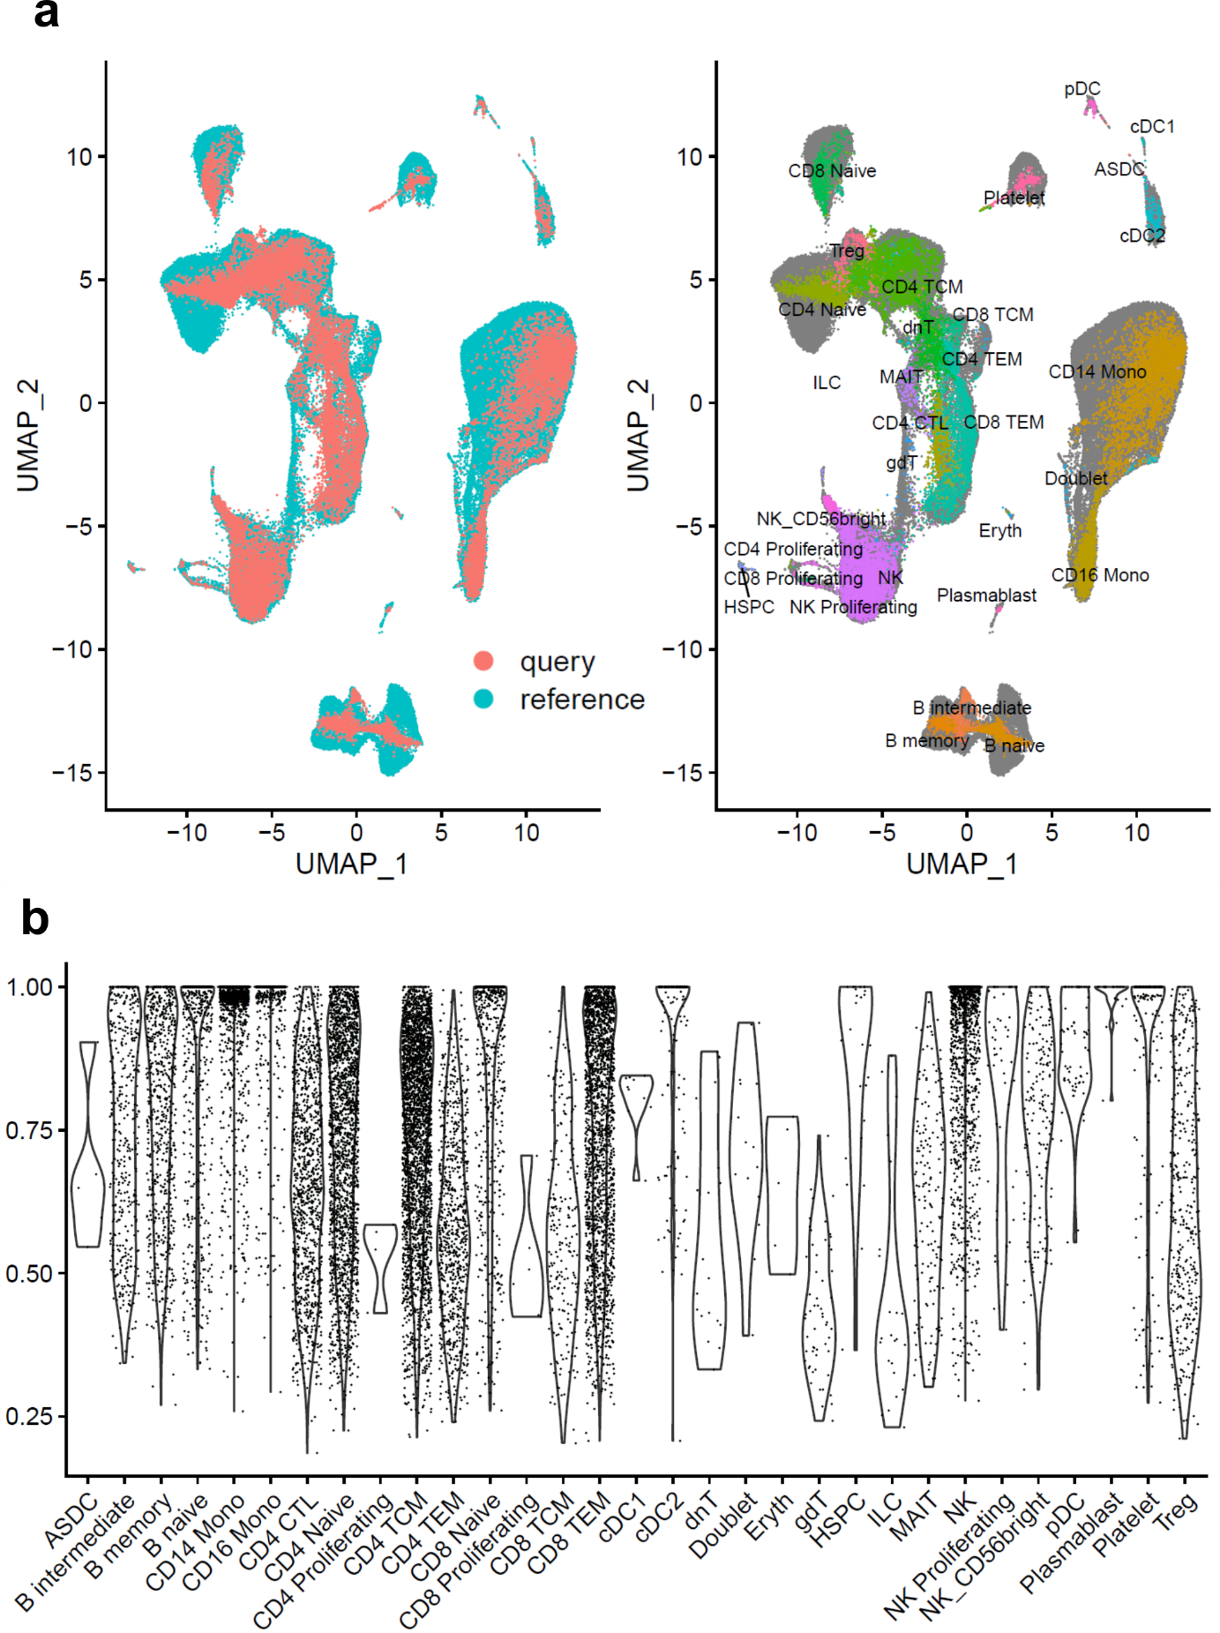
Figure 32: Quality assessment of multimodal reference mapping.
a: UMAP of the reference dataset merged with the dataset of the patients in stable state (query). All cell types of the query were also present in the reference data set, since no cluster was unique to the query data set. b: Violin plot indicating the calculated prediction score per cell grouped by annotated cell type. Descriptions of cell types are given in Table 12 (Page 48).

Isolation of RNA
For RNA isolation, we used the commercially available kit RNeasy Mini Kit. (Qiagen). In order to lyse neutrophils, beta-mercaptoethanol was added to the RLT-buffer according to the manufacturer’s protocol (Qiagen).

Targeted gene expression analysis
Targeted gene expression analysis, also called quantitative real-time PCR (qPCR), is a method to determine the abundance of a specific PCR product compared to a reference gene. Taqman gene expression assays (Thermo Fisher Scientific) were utilized and all probe IDs are shown in Table 19. The gene expression of FBFBP2 was analysed in 20 individuals in order to test, if CD4⁺ cytotoxic T cells and to a lesser degree CD8⁺ effector memory T cells are more frequent in GPP patients carrying disease-contributing variants compared to affected and healthy non-carriers.
Table 25: Taqman gene expression assays obtained from Thermo Fisher Scientific
Gene | Taqman probe
FGFBP2 | Hs00230605_m1
ACTB | Hs99999903_m1
B2M | Hs99999907_m1
PGK1 | Hs9999906_m1

Reactions were performed in quadruplicates in 384-well plates on the QuantStudio™ 12K Flex System (Life Technologies (Thermo Fisher Scientific)) (Table 20) and evaluated using die ExpressionSuite Software v1.0.3 (Life Technologies (Thermo Fisher Scientific)).
Table 26: qPCR reaction
Reagent | Volume [µl]
TaqMan Gene Expression MM (2x) | 7.5
TaqMan Gene Expression Assay (20x) | 0.75
H2O | 1.75
cDNA (1:5) | 5

In general, three housekeeping genes were used (ACTB, PGK1, B2M). To quantify relative gene expression levels, the ΔΔC_{T} method was used. The CT values were obtained from the software and normalized by the housekeeping genes (ΔC_{T} = C_{T,target} – C_{T,housekeeping genes}). Consequently, the fold change between the reference and the sample was determined (ΔΔC_{T} = ΔC_{T,sample} - ΔC_{T,control}). In order to determine the relative expression values (RQ values), the following formula was used: RQ = 2^{-ΔΔC}_{T}. The Wilcoxon T-test was used to determine, if the difference was significant as a normal distribution was not assumed.

Immunophenotyping by multicolor ﬂow cytometry
The frequency of multiple immune cell types were analysed in GPP patients and healthy donors as presented in chapter 4.4.1. (Figure 15). The analysis was performed by Benjamin Frey and Ina Becker (Department of Radiation Oncology, university hospital Erlangen). Fresh whole blood was used as sample and analysed by multicolor ﬂow cytometry as described previously {Donaubauer, 2020 #1813;Donaubauer, 2019 #1814;Ruhle, 2016 #1882}. Cells were then measured with Gallios flow cytometer (Beckman Coulter) and analyzed with the Kaluza software package (Beckman Coulter).

Flow Cytometry analysis of Granzyme A, Granzyme K and KSP37
The analysis was performed by Benjamin Frey and Ina Becker (Department of Radiation Oncology, Erlangen). 5*10^5 PBMCs were incubated with CD4-PerCP-CyC5.5, CD8-FITC, CD3- V450 and CD56-PerCP-CyC5.5 (all from Beckman Coulter) for 30min without light exposure followed by multiple wash cycles. Next, the cell suspension was stained with Granzyme A (Alexafluor 700), Granzyme K (PE-Cy7) and KSP37 (PE) (BioLegend, San Diego, CA, USA) using the Cyto-Fast™ Fix/ Perm Buffer Set (BioLegend) according to the manufacturer’s instructions. Cells were then measured with Gallios flow cytometer (Beckman Coulter) and analyzed with the Kaluza software package (Beckman Coulter). To account for batch effects, intracellular markers were analyzed in separate runs and the following cell populations were evaluated as described before {Bade, 2005 #1815}: CD3posCD4posCD8neg or CD3posCD4negCD8pos T cells and CD3negCD56pos NK cells.

RNA sequencing analysis
Sequencing of neutrophilic RNA was performed in three patients (GPP1, GPP2, GPP5) and four HDs. Additionally, this method was applied to study the transcriptome of neutrophils obtained from a patient at three different time points within an acute episode. Library preparation, sequencing and primary data analysis of both experiments were performed by the NGS core facility of the institute. Both experiments were performed as follows: The isolation of RNA from neutrophils was performed using the RNAeasy Mini kit from Qiagen. The RLT buffer was supplemented with ßeta-mercaptoethanol as described in the manufacturer’s protocol. The quality of RNA was assessed by the Agilent 2100 Bioanalyzer (Agilent, Santa Clara, CA, USA). Only RNA samples with a RNA integrity number (RIN) of >8.0 were considered. Libraries were obtained by using 200ng of neutrophilic RNA and the TruSeq Stranded mRNA Kit according to the manufacturer’s instructions (Illumina, San Diego, USA). Libraries were sequenced on a HiSeq-2500 platform (Illumina) as 100 bp single-end reads to a depth of at least 40 million reads. Obtained reads were converted in the FASTQ format and the Illumina adapter sequences of reads were masked by bcl2fastq v2.17.1.14 (Illumina). Reads which contained more than 50% of masked bases were removed using fqtrim v0.9.5.
For the first experiment, mapping of reads to the Homo sapiens reference transcriptome based on GRCh37/ hg19 and the ENSEMBL gene annotation 99 was performed using Salmon v1.1.0.
For the second experiment, the reads were additionally filtered using BWA 0.7.14-r1136 (https://github.com/lh3/bwa) with the aim to exclude unwanted RNA subtypes (tRNA, rRNA) {Li, 2010 #1912}. Next, the reads were mapped to the GRCh37 reference genome (Ensembl gene annotation 99) using STAR (version 2.6.1c, https://github.com/alexdobin/STAR) {Dobin, 2013 #1406}. The mapped ones were quantified as reads per gene. The reads of exons shared between multiple genes were omitted using subread featureCounts v1.6.1. Subsequently, DEGs were calculated using a negative binomial model executed in DESeq2 v1.30.1 (https://bioconductor.org/packages/release/bioc/html/DESeq2.html) under R v4.0.4 {Love, 2014 #1404;R-Core-Team, 2013 #963}. To account for multiple comparisons, the p-values of the significance tests were corrected (Benjamini-Hochberg).
For the second experiment, the genes with alterations of expression throughout the acute episode were calculated by a linear model for each gene. Those genes with an absolute slope above 0.7 were considered significant (Figure 33). Pathway analysis was performed as indicated for scRNAseq analysis.
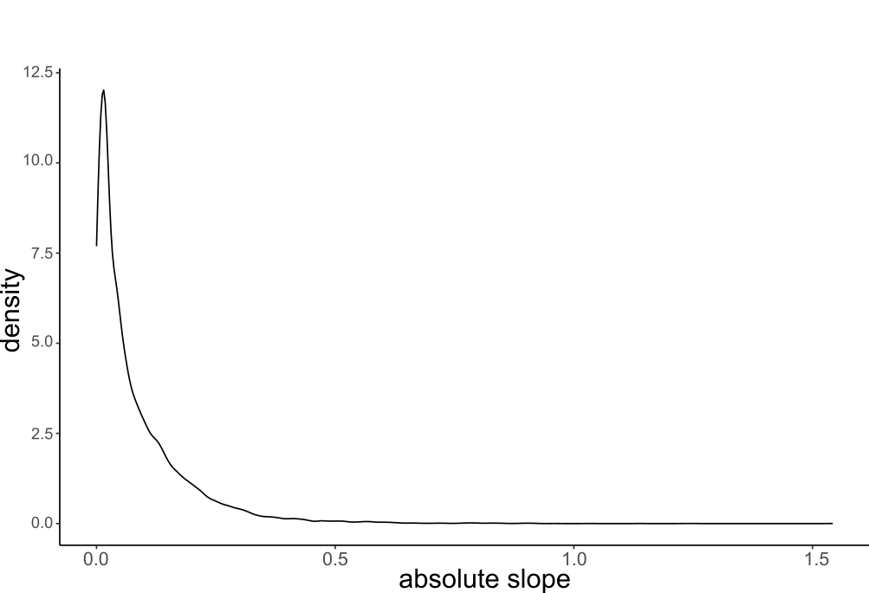
Figure 33: Distribution of the absolute slope of the gene-wise fitted linear models.

Statistical analysis
R version 3.6.1 was used for statistical analysis {R-Core-Team, 2013 #963}. The applied statistical test is described in the corresponding figure or table legend. A non-paragmetic test (Wilcoxon test) was used to assessed differences in gene expression of FGFBP2 and all genes detected by scRNAseq, since normal distribution was not assumed. The Welch Two Sample t-test was selected in case of NET formation, efferocytosis and FACS-staining experiments to assess differences between patients and controls.
The correlation of the MPXI and the age of onset with the number of variants was assessed by ANOVA of a linear model.
To assess the correlation of MPO activity with serine proteases activities, Spearman’s correlation coefficient R and a p value according to Pearson’s correlation was determined.
Firth’s logistic regression (R package logistf, {Puhr, 2017 #1868}) was performed to test if variants in MPO or MPO in conjunction with heterozygous variants of IL36RN predicts the health and affection status.
To test whether the differences in the cumulative allele frequency in patients (PsV, PsA, PPP, SAPHO syndrome) and controls is significant, the Fisher’s exact test was choosen. The p-values were not corrected for multiple testing. Fisher’s exact test was also applied for the association of psoriatic subtypes with single SNPs.
To assess the correlation of number of variants and psoriatic diseases, a logistic regression analysis and a p-value by ANOVA was determined. The correlation of MPO genotype (wildtype vs. mutant) and the severity of disease was assessed the same way.

{Puhr, 2017 #1868}

Reagents and materials

Consumable materials
Table 27: Consumable materials
Material | Company
Adhesive tape, double-sided | Tesa
Aluminium foil | Alio, Roth
Autoclaving bag | Roth
BD Vacutainer | Becton Dickinson
Cannula | BD Biosciences
Cell culture flask 25 cm2 | TPP Techno Plastic Products
Cover slip | Thermo Fisher Scientific
Disinfecting agent | Apesin
Falcons 15 ml, 50 ml | Greiner
Filter, Ø 125 mm pleated | A. Hartenstein
Filter, pleated | Schleicher & Schüll
Filter, sterilizing grade | VWR
Gloves Safeskin Satin Plus | Kimberly-Clark
Gloves Sempercare Nitrile | Sempermed
Marker tape | Costar
Microscope slide | Thermo Fisher Scientific
Microscope slide, Poly-L-Lysine-coated | Neuvitro
Monovette EDTA KE/4.9ml | Sarstedt
Monovette EDTA KE/9ml | Sarstedt
neoTape labelling tape | neoLab
Optical adhesive covers | Life Technologies (Thermo Fisher Scientific)
Para film | Pechiney Plastic Packaging
Pasteur pipettes | Roth
PAXgene Blood RNA tubes | Becton Dickinson
Petri dish | Peske
Petri dish | Greiner
Pipette tip 10 µl | Biozym
Pipette tip 200 µl, 1000 µl | Sarstedt
Pipette tip 5 ml, 10 ml, 20 ml | TPP Techno Plastic Products
Pipette tip dispenser 25 ml | Brand
Pipette tip PP 10 µl, short, with filter | Nerbe plus
Pipette tip, with filter 10 µl, 20 µl, 200 µl, 1000 µl | Biozym, nerbe plus
Pipette tips Combitips plus 0.1 ml, 0.5 ml | Eppendorf
Pistils | Roth
Plates: 384 Well optical reaction plate (qPCR) | Life Technologies (Thermo Fisher Scientific)
Plates: 96 Well PCR plates | Corning
Plates: 96 Well sequencing plates | Greiner
Reaction tube 0.2 ml | Peqlab, VWR
Reaction tube 0.5 ml | Peske
Reaction tube 1.5 ml with/without cover | Eppendorf, Peske
Reaction tube 2 ml | Eppendorf, Peske
Safety-Multifly-Needle | Sarstedt
Saran wrap | Saran
Scalpel, single-use | Feather
Syringe 1 ml, 2 ml | Braun
Thermowell sealing mats | Corning
Toothpick | Fackelmann
Well plates, glass | Hampton Research

Chemicals and enzymes
Table 28: Chemicals and enzymes
Chemicals and Enzymes | Company
Agar-Agar Kobe I | Roth
Agarose | Biozym
Ampicillin | Roth
Antarctic Phosphatase I (5 U/µl) | NEB
Antarctic Phosphatase Reaction Buffer (10x) | NEB
Betaine (5 M) | Sigma Aldrich
Beta-mercaptoethanol | Merck
Bovine serum albumin (BSA) | Sigma Aldrich
Bromophenol blue | Sigma Aldrich
Calcium chloride (CaCl) | Merck
DAPI | Serva
Deoxy nucleotide-Triphosphate (dNTPs) | Life Technologies (Thermo Fisher Scientific)
Dimethyl sulfoxide (DMSO) | Roth
Disodium hydrogen phosphate (Na2HPO4) | Roth
Dithiotreitol (DTT) | Roth, Life Technologies (Thermo Fisher Scientific)
DMEM/Ham’s F12 medium | Thermo Fisher Scientific, Sigma Aldrich
DNase I, RNase-free (10 U/µl) | Qiagen
Ethanol 96%, 99% | Roth
Ethidium bromide (10 mg/ml) | Roth
Ethylene diamine tetra acetate (EDTA) | Fluka
Exonuclease I (20 U/µl) | NEB
Fetal Calf Serum (FCS) | Gibco
Glycerine | Roth
Glycine | Roth
HEPES | Roth
HPLC water /ddH2O | Merck
Isopropanol | Roth
Lipofectamine™ 2000 Transfection Reagent | Thermo Fisher Scientific
Lithium chloride | Merck
Loading buffer (6X) | PeqLab
MagicMark™ XP Western Protein Standard | Thermo Fisher Scientific
Magnesium chloride (MgCl2) | Life Technologies (Thermo Fisher Scientific), VWR
Magnesium sulphate (MgSO4) | Merck
Oligo(dT)12-18 Primer | Thermo Fisher Scientific
Paraformaldehyde | Merck, Sigma Aldrich, Santa Cruz Biotechnology
pegGREEN DNA/RNA dye | VWR
Penicillin-Streptomycin (10000 U/10000 µg/ml) | Biochrom, Fluka
PfuUltra II Fusion HS DNA polymerase | Stratagene
PfuUltra II Reaction Buffer (10x) | Stratagene
Potassium chloride (KCl) | Merck, Roth
Potassium dihydrogen phosphate (KH2PO4) | Merck
Potassium hydrogen carbonate (KHCO3) | Merck
Proteinase K | Qiagen
Random primer | Life Technologies (Thermo Fisher Scientific)
RNaseOUT Ribonuclease Inhibitor (40 U/µl) | Thermo Fisher Scientific
RPMI 1640 Medium | Gibco
SOC culture medium | Life Technologies (Thermo Fisher Scientific)
Sodium bicarbonate (NAHCO3) | Merck
Sodium chloride (NaCl) | Merck, VWR
Sodium citrate | Roth
Sodium deoxycholate (DOC) | Merck
Sodium dodecylsulfat (SDS) | Fluka, Sigma, Merck
Sodium hydroxide cookies (NaOH) | Merck
Standard: 1 kb DNA ladder | NEB
Standard: 100 bp DNA ladder | NEB
Standard: SeeBlue® Plus2 Protein Standard | Thermo Fisher Scientific
Sugar, Sucrose | K-Classic, Südzucker
SuperScript II Reverse Transcriptase | Life Technologies (Thermo Fisher Scientific)
T7 Endonuclease I | NEB
Taq DNA Polymerase | Life Technologies (Thermo Fisher Scientific)
Taq reaction buffer (10x) | Life Technologies (Thermo Fisher Scientific)
TOP10 E. coli | Life Technologies (Thermo Fisher Scientific)
Trypsin-EDTA | Sigma
Tween 20 | Sigma, VWR
X-Gal | Roth
Yeast extract | Merck
Yeast powder | Sigma Aldrich

Buffers and solutions
Table 29: Buffer and solutions
Agarose gel (0.8 – 3.0 %) | 0.8 – 3.0 g Agarose per 100 ml 1x TBE
 | dissolve by heating in microwave
 | let cool down and add 0.06 μl / ml peqGREEN
Agar plates | 3.5 g Agar
 | 250 ml LB medium
 | autoclave, let cool down to 60 °C
 | add 250 µl Ampicillin and pour
 | store at 4 °C
Ampicillin stock (50 mg / ml) | 0.5 g Ampicillin
 | 10 ml ddH2O
 | sterile filtrate
 | store at -20 °C
LB (lysogeny broth) medium | 10 g Peptone
 | 5 g Yeast Extract
 | 10 g NaCl
 | 0.2 g NaOH cookies
 | fill to 1 l with ddH2O
 | adjust pH to 7.5
 | autoclave
1x PBS | 100 ml 10x PBS
 | 900 ml ddH2O
10x PBS | 80 g NaCl
 | 2 g KCl
 | 14.4 g Na2HPO4O
 | 2.4 g KH2PO4O
 | fill to 1 l with ddH2O
 | adjust pH to 7.2
 | autoclave

Kits
Table 30: Kits
Kits | Company
Agencourt AMPure Kit | Beckman Coulter
Agencourt CleanSEQ Kit | Agencourt
BigDye Terminator v3.1 Cycle Sequencing Kit | Applied Biosystems (Thermo Fisher Scientific)
DNeasy Blood & Tissue Kit | Qiagen
EasySep™ Human CD14 Positive Selection Kit II | Stemcell Technologies
EasySep™ Mouse Monocyte Isolation Kit | Stemcell Technologies
EasySep™ Mouse Neutrophil Enrichment Kit | Stemcell Technologies
MACSxpress Whole Blood Neutrophil Isolation Kit, human | Miltenyi Biotec
One Shot™ TOP10 Chemically Competent E. coli | Thermo Fisher Scientific
PAXgene Blood RNA Kit | Becton Dickinson
Plasmid Midi Kit | Qiagen
QIAprep Spin Miniprep Kit | Qiagen
QIAquick Gel Extraction Kit | Qiagen
QIAquick PCR Purification Kit | Qiagen
Quick Ligation Kit | NEB
RNase-Free DNase Set | Qiagen
RNeasy Mini Kit | Qiagen
Taqman Gene Expression Mastermix | Thermo Fisher Scientific
TOPO™ TA Cloning™ Kit for Subcloning | Thermo Fisher Scientific

Devices
Table 31: Devices
Device | Company
ABI 3730 Genetic Analyzer | Applied Biosystems (Thermo Fisher Scientific)
Biomek® NXP | Beckman Coulter
Bioruptor | diagenode
Centrifuge 5415 | Eppendorf
Centrifuge 5804 | Eppendorf
Centrifuge 5810 | Eppendorf
Centrifuge Biofuge 22 R | Heraeus
Centrifuge Biofuge pico | Heraeus
Centrifuge miniSpin | Eppendorf
Centrifuge Omnifuge 2.ORS | Heraeus, Sepatech
ChemiDoc™ Touch Imaging System | Bio-Rad
ChemiDoc™ Touch Imaging System | Bio-Rad
Digital pH-Meter 646 | Knick
Fireboy Bunsen burner | Tecnomara
Fridges and freezers | Siemens, Liebherr, Revco
Gel combs | PeqLab
Heating block | Eppendorf
Ice machine | Ziegra
Incubator B 6060 | Heraeus
Incubator for cell culture BBD 6220 | Thermo Fisher Scientific
Incubator Innova 4300 | New Brunswick Scientific
Incubator MIR-154 | Sanyo
Incubator MLL-352H | Panasonic
Lab scale MC1 | Sartorius
Magnetic stirrers IKAMAG RH and KMO2 | Janke&Kunkel
Micro scales CP225D | Sartorius
Microwaves | Panasonic, Siemens
Multipette pro | Eppendorf
Nanoquant Infinite 200 | Tecan
Pipette 8-Kanal 5-50 µl | Capp, Dunn
Pipette Pipetman P2, P20, P100, P200, P1000 | Gilson
QuantStudio™ 12K Flex System | Thermo Fisher Scientific
Rotator mixer | Heidolph
Rotator Unimax 1010, horizontal | Heidolph
Safety cabinet and work bench Gelaire BSB6A | Flow Laboratories
Safety cabinet and work bench Lamin Air | Heraeus
Stereoscopic microscope 2000C | Zeiss
Sterilizer (autoclave) | Melag, Webeco, HMC
Thermocycler | Eppendorf
Tweezers, various sizes | FST
UV protection screen UV-Star | Biometra
Vacuum-cleaner, hand-held | Black&Decker
Vortex stirrer | Janke&Kunkel
Washing machine | Gorenje
Water incubator | Memmert, Julabo, Lauda ecoline
Water-processing unit Purelab plus | USF-Elga
Microplate reader SpectraMax M3 | Molecular Devices

Antibodies
Table 32: Antibodies
Antibodies | Company | Application
Alexa Fluor® 647 anti-human Granzyme K Antibody | Biolegend | T cell marker, Figure 14
PE anti-human Ksp37 (FGFBP2) Antibody | Biolegend | T cell marker, Figure 14
PE anti-human Granzyme A Antibody | Biolegend | T cell marker, Figure 14
PE anti-human CD8a Antibody | Biolegend | Determination of the purity of isolated CD8 T cells
PE/Cyanine5 anti-human CD3 Antibody | Biolegend | Determination of the purity of isolated T cells
FITC anti-human CD56 (NCAM) Antibody | Biolegend | Determination of the purity of isolated NK cells
FITC anti-human CD14 Antibody | Biolegend | Determination of the purity of isolated monocytes
Pacific Blue™ anti-human CD4 Antibody | Biolegend | Determination of the purity of isolated T cells

Oligonucleotides
Table 33: Description of oligonucleotides
Name | Sequence
Oligonucleotides for sequencing
MPO_Ex1_F | CTTCCTCTACCTCACCCCAC
MPO_Ex1_R | CTATCAGGCCCCAGAGCTAG
MPO_Ex2_F | TTCCTAGCTCTGGGGCCT
MPO_Ex2_R | CCTCTCCCACCTTCAAGCT
MPO_Ex3_F | CAAAGCCTTGCCTCTGTCTG
MPO_Ex3_R | TGGAGGAAGAAGTTGAGGGG
MPO_Ex4-5_F | CCCCTCAACTTCTTCCTCCA
MPO_Ex4-5_R | TCAGCTGATCAGTGGGGAAG
MPO_Ex6_F | GCCAGCTGATCTCCGTGT
MPO_Ex6_R | CAGCGTCTGGGAAAGGAAAC
MPO_Ex7_F | CTGCTCATTAACCCTGCACC
MPO_Ex7_R | CCACAAGCTGCTCACAAACA
MPO_Ex8_F | GGGGTTTCAGTGGAGCAAAT
MPO_Ex8_R | TCAACCCTCCCAACACCAAT
MPO_Ex9_F | CCAAGAGCAGGCAGAGACT
MPO_Ex9_R | AGGCTAGAGAGTCAGACCAGA
MPO_Ex10_F | CTTGTGCCCAGCCCTCTT
MPO_Ex10_R | TATGCTTTGGAGAGGGCAGG
MPO_Ex11_F | TCTCCAGTGACCTCCCCA
MPO_Ex11_R | AGGAGGAAATTTGGGCTCCA
MPO_Ex12a_F | ATATCCTGGGAGCAGCACAA
MPO_Ex12a_R | CATTTTCTCAGCTGCACCCA
MPO_Ex12b_F | GCATTGAACCTGGCTTCCTG
MPO_Ex12b_R | GCCCTCCAAGAAACCATGAC
MPO_Ex12c_F | GACCTTGAGCAAATTACCCTCC
MPO_Ex12c_R | CTCAGAGCCCAGAGTAAGCC
IL36RN_E1F | TACCGGAGCTCTCTCCTGAC
IL36RN_E2F | GGAGACAAGGCTGTGCTGTT
IL36RN_E3F | ATGTGCTTCCATGCCTTGAT
IL36RN_E4F | CTGTGGGACACCCTAGCAG
Oligonucleotides for MPO splicing analysis
MPO_Ex12Splice_1F | GAGCCTCTGAAGCGCAAAG
MPO_Ex12Splice_1R | CCGGGGATATGAGTTGGACA
Oligonucleotides for MPO mutagenesis assay
MPO_Mut_M251T_1_F | GAGCGCTCACTCACGTTCATGCAATGG
MPO_Mut_M251T_1_R | CCATTGCATGAACGTGAGTGAGCGCTC
MPO_Mut_A332V_1_F | CAACCAGATCAACGTGCTCACTTCCTTCG
MPO_Mut_A332V_1_R | CGAAGGAAGTGAGCACGTTGATCTGGTTG
MPO_Mut_R569W_3_F | CAGTGGATGAGATCTGGGAGCGATTGTTTG
MPO_Mut_R569W_3_R | CAAACAATCGCTCCCAGATCTCATCCACTG
MPO_Mut_R548W_1_F | GACCCCATCCTCTGGGGCCTCATGG
MPO_Mut_R548W_1_R | CCATGAGGCCCCAGAGGATGGGGTC
MPO_Mut_R590C_1_F | CTGAACATGCAGTGCAGCAGGGACC
MPO_Mut_R590C_1_R | GGTCCCTGCTGCACTGCATGTTCAG

Plasmids
Table 34: Plasmids
Plasmid | company
Myeloperoxidase/MPO cDNA ORF Clone, Human, untagged | Sino Biological
pCMV3-C-OFPSpark Control Vector (C-terminal OFPSpark-tagged) | Sino Biological

Software and databases
Table 35: Software and databases
Name | Company/ source
(Fiji is just ImageJ) Version 1.51n | https://fiji.sc/
1000 Genomes Project | https://www.internationalgenome.org/
Adobe Acrobat XI Pro Version 11.0.23 | Adobe
Anaconda (miniconda) | https://anaconda.org/
brewer color palettes | http://applied-r.com/rcolorbrewer-palettes/#the-palettes
CellphoneDB | https://www.cellphonedb.org/
Chromas Version 2.23 | Technelysium
EndNote X8 | Clarivate Analytics
Ensembl | https://www.ensembl.org/index.html
ExpressionSuite Software v1.0.3 | Life Technologies (Thermo Fisher Scientific)
Firefox Quantum Version 66.0.2 | Mozilla
Gene Ontology | http://geneontology.org/
gnomAD | http://gnomad.broadinstitute.org/
Image Lab Version 6.0.0 | Bio-Rad
Ingenuity Pathway Analysis | Qiagen
Linux proton 4.15.0-140-generic #144-Ubuntu SMP Fri Mar 19 14:12:35 UTC 2021 x86_64 x86_64 x86_64 GNU/Linux | Linux based operating system
Microsoft Office 2010 | Microsoft
Multimodal reference mapping | https://satijalab.org/seurat/articles/multimodal_reference_mapping.html
NCBI | http://www.ncbi.nlm.nih.gov/
OMIM | https://www.omim.org/
panglaodb | https://panglaodb.se/
PANTHER (Mi et al. 2019) Version 14.0 | http://www.pantherdb.org/
Plink 1.9 | https://www.cog-genomics.org/plink/
Primer design for mutagenesis assay | http://bioinformatics.org/primerx/cgi-bin/DNA_1.cgi
Primer tool | https://primer3.ut.ee/
Primer-BLAST | https://www.ncbi.nlm.nih.gov/tools/primer-blast/
R Version 3.3.3 | https://www.r-project.org/
R-Studio Version 1.0.136 | https://www.rstudio.com/
Sequencing Analysis Software Version 5.1 | Applied Biosystems (Thermo Fisher Scientific)
Seurat Version 3 | https://satijalab.org/seurat/articles/get_started.html
UCSC Genome Browser | http://genome.ucsc.edu/
Windows 7 Enterprise | Microsoft

Mpo^{-/-} mice
To analyze efferocytosis, 8- to 10-week-old female and male wild-type mice (C57BL/6J) and Mpo^{-/-} mice (B6.129X1-Mpotm1Lus/J) were sacrificed. The study was approved by the ethics committees of the veterinary office of Erlangen (Germany, Genehmigung Az: 55.2-2532.2-1084-28). Mice were purchased from Jackson Laboratory and were harbored in a specific pathogen-free facility and the environment was identical between wild-type and knock-out (temperature, light/dark cycle, food and water supply).

References

Acknowledgements

Publications
Parts of the chapters 4.1 and 4.2 are published in the following publication:
Haskamp S, Bruns H, Hahn M, Hoffmann M, Gregor A, Löhr S, Hahn J, Schauer C, Ringer M, Flamann C, Frey B, Lesner A, Thiel CT, Ekici AB, von Hörsten S, Aßmann G, Riepe C, Euler M, Schäkel K, Philipp S, Prinz JC, Mößner R, Kersting F, Sticherling M, Sefiani A, Lyahyai J, Sondermann W, Oji V, Schulz P, Wilsmann-Theis D, Sticht H, Schett G, Reis A, Uebe S, Frey S, Hüffmeier U. Myeloperoxidase Modulates Inflammation in Generalized Pustular Psoriasis and Additional Rare Pustular Skin Diseases. Am J Hum Genet. 2020 Sep 3;107(3):527-538. doi: 10.1016/j.ajhg.2020.07.001.
Parts of the chapter 4.3 are published in the following publication:
Haskamp S, Horowitz JS, Oji V, Philipp S, Sticherling M, Schäkel K, Schuhmann S, Prinz JC, Burkhardt H, Behrens F, Böhm B, Köhm M, Rech J, Simon D, Schett G, Morrison K, Gerdes S, Assmann G, Nimeh A, Schuster V, Jacobi A, Weyergraf A, Reis A, Uebe S, Wilsmann-Theis D, Mößner R, Hüffmeier U. Genetic Analysis of MPO Variants in Four Psoriasis Subtypes in Patients from Germany. J Invest Dermatol. 2021 Aug;141(8):2079-2083. doi: 10.1016/j.jid.2021.01.017.
Parts of the chapter 4.4 are published in the following publication:
Haskamp S, Frey B, Becker I, Schulz-Kuhnt A, Atreya I, Berking C, Pauli D, Ekici AB, Berges J, Mößner R, Wilsmann-Theis D, Sticherling M, Uebe S, Kirchner P, Hüffmeier U. Transcriptomes of MPO-deficient patients with generalized pustular psoriasis reveals expansion of CD4+ cytotoxic T cells and an involvement of the complement system. J Invest Dermatol. 2021 Dec 29:S0022-202X(21)02639-7. doi: 10.1016/j.jid.2021.12.021. Epub ahead of print.

Supplements

List of abbreviations
Abbreviation | Description
aa | amino acid
ACH | Acrodermatitis continua of Hallopeau
AGEP | Acute generalized exanthematous pustulosis
ANOVA | analysis of variation
B intermediate | intermediate B cells
B memory | memory B cells
B naive | naive B cells
bp | base pair
CADD | Combined Annotation Dependent Depletion
CD14 Mono | CD14⁺ monocytes
CD16 Mono | CD16⁺ monocytes
CD4 CTL | CD4⁺ cytotoxic T lymphocyte
CD4 Naive | CD4⁺ naive T cell
CD4 Proliferating | CD4⁺ proliferating T cell
CD4 TCM | CD4⁺ central memory T cell
CD4 TEM | CD4⁺ effector memory T cell
CD8 Naive | CD8⁺ naive T cell
CD8 Proliferating | CD8⁺ proliferating T cell
CD8 TCM | CD8⁺ central memory T cell
CD8 TEM | CD8⁺ effector memory T cell
cDC1 | CD141⁺ conventional dendritic cell
cDC2 | CD1C⁺ conventional dendritic cell
CI | confidence interval
CRP | c-reactive protein
CTSG | cathepsin G
CTSS | cathepsin S
DMEM | Dulbecco’s Modified Eagle’s Medium
DMSO | dimethyl sulfoxide
DNA | deoyribonucleic acid
dnT | double negative (CD4, CD8) T cell
dNTP | deoxynucleoside triphosphate
Doublet | CD16⁺ CD14⁺ monocytes
ds | double stranded
EDTA | ethylenediaminetetraacetic acid
ERASPEN | the European Rare and Severe Psoriasis Expert Network
FACS | fluorescence-activated cell sorting
FCS | fetal calf serum
gdT | gamma/delta T cell
GO | Gene Ontology
GPP | generalized pustular psoriasis
HD | healthy donor
HSPC | hematopoietic stem cell progenitor cell
IFN | interferon
IHddd | Impetigo herpetiformis
IL | interleukin
IL-36R | interleukin (IL)-36 receptor
IL-36Ra | interleukin (IL)-36 receptor-antagonist
ILC | innate lymphoid cell
KO | knockout
LB | lysogeny broth
MAF | minor allele frequency
MAIT | mucosal associated invariant T cell
MPO | Myeloperoxidase
MPO-def | MPO-deficiency/ MPO-deficient
MPXI | Mittlerer (German: mean) Peroxidase Index
mRNA | messenger RNA
n.s. | not significant
NE | neutrophil elastase
NET | neutrophil extracellular traps
NFE | non-Finnish European individuals of gnomAD
NFκB | nuclear factor-κB
NK | natural killer cell
NK Proliferating | proliferating natural killer cell
NK_CD56bright | natural killer cell with high expression of CD56
OR | odds ratio
PBMC | peripheral mononuclear blood cells
PBS | phosphate buffered saline
PCA | principal component analysis
PCR | polymerase chain reaction
pDC | plasmacytoid dendritic cells
Plasmablast | Plasmablast
PMA | phorbol myristate acetate
PP | pustular psoriasis
PPP | palmoplantar pustular psoriasis
PR3 | proteinase 3
PsA | psoriasis arthitis
PsV | psoriasis vulgaris
qPCR | quantitative real-time PCR
refUMAP | reference uniform manifold approximation and projection
RNA | ribonucleic acid
RNA-seq | RNA sequencing
RT-PCR | reverse transcription polymerase chain reaction
SAPHO sydrome | Synovitis-acne-pustulosis-hyperostosis-osteitis
scRNAseq | single-cell RNA sequencing
SLE | systemic lupus erythematosus
Th | T helper cells
Treg | regulatory T cell
w/o | without

List of figures
Figure 1: Model of IL36RN-deficient keratinocytes promoting inflammation in GPP. 16
Figure 2: Structural models of MPO affected by the variants p.Arg590Cys and p.Arg548Trp 23
Figure 3: Functional tests of variants in MPO. 25
Figure 4: Number of disease-associated variants in IL36RN and MPO in patients with GPP and controls and relation to age of onset. 28
Figure 5: Correlation of the enzyme activity of MPO and the activities of four serine proteases in patients and healthy donors. 33
Figure 6: Analysis of the formation of neutrophil extracellular traps in three MPO-deficient patients and four healthy donors (HDs). 34
Figure 7: Phagocytosis of neutrophils by monocytes in mice and human with MPO-deficiency. 35
Figure 8: Staining of CD47 on neutrophils and transcriptional analysis of monocytes of MPO-deficient patients and healthy donors. 36
Figure 9: Segregation analysis of MPO and IL36RN variants in eight families of MPO-deficient GPP and AGEP patients. 38
Figure 10: The correlation of age of onset and variants in MPO in patients affected with PsV (n= 1,003), PsA (n= 1,145), PPP(n= 201) and SAPHO syndrome (n= 48). 44
Figure 11: Single-cell RNA transcriptomics of peripheral mononuclear blood cells (PBMCs) obtained from two MPO-deficient patients and three healthy donors. 47
Figure 12: Proportions of cell types of PBMCs based on single-cell RNA transcriptomics. 49
Figure 13: Analysis of single-cell RNA sequencing data using an unsupervised clustering algorithm. 50
Figure 14: Markers of effector T cell subsets and their protein expression analyzed by flow cytometry. 52
Figure 15: The proportions of T cell subsets analyzed by flow cytometry 53
Figure 16: Targeted gene expression analysis of FGFBP2 of five healthy donors and 15 patients labeled by variants in MPO and IL36RN. 55
Figure 17: Flow cytometry analysis of innate lymphoid cells (ILCs) in four GPP patients and four healthy donors. 55
Figure 18: Pathway analysis of differentially expressed genes in CD4⁺ cytotoxic T cells (CTLs), CD4⁺ (effector memory T cell) TEM, CD8⁺ TEM and CD16⁺ monocytes. 57
Figure 19: Transcriptome analysis of neutrophils of three MPO-deficient patients and four healthy donors. 58
Figure 20: Levels of C-reactive protein (CRP), frequency of leukocytes and body temperature of one GPP patient during an acute episode. 59
Figure 21: Single cell RNA sequencing analysis of peripheral mononuclear blood cells (PBMCs) of MPO-deficient patient during an acute episode. 61
Figure 22: Proportion of T cell subsets in patient during an acute episode. 63
Figure 23: Pathway analysis of differentially expressed genes in three T cell subsets, NK cells and CD14⁺ monocytes based on Gene Ontology terms. 64
Figure 24: Prediction of receptor-ligand interactions based on single-cell RNA sequencing data of single patient during an acute episode. 66
Figure 25: Cell type specific and immune-related receptor-ligand-pairs during acute episode. 67
Figure 26: Pathway analysis of genes coding for cell type specifically expressed receptor-ligand pairs at time point GPP3.T0 (e) and GPP3.T2 (f). 68
Figure 27: Transcriptome analysis neutrophils of GPP3 within an acute episode. 69
Figure 28: Proposed mechanisms of MPO-deficiency in GPP. 73
Figure 29: Model of clonal expansion of CD4⁺ CTLs in MPO- and IL-36a-deficiency 79
Figure 30: Flow cytometry strategy to analyse residual neutrophils. 96
Figure 31: Genotyping plots of the four variants in MPO analyzed by GSA 98
Figure 32: Quality assessment of multimodal reference mapping. 102
Figure 33: Distribution of the absolute slope of the gene-wise fitted linear models. 106

List of tables
Table 1: Characteristics of homozygous variants in MPO and MUC4 detected by WES in at least two patients. 20
Table 2: Characteristics of variants in MPO found in 82 Patients 21
Table 3: Cumulative frequencies of MPO variants resulting in different degrees of MPO-deficiency. 26
Table 4: Statistical analyses of different modes of inheritance based on 82 patients and 4,937 controls (1000 Genome Project, in-house exomes). 27
Table 5: Clinical and phenotypic data of 82 patients summarized in total or grouped by variants in MPO and further sub-grouped by variants in IL36RN and by number of variants in MPO. 30
Table 6: Allele numbers and frequencies of pathogenic variants in MPO in patients affected with PsV (n= 1,105), PsA (n= 1,313), PPP (n= 271) and SAPHO syndrome (n= 52) compared to 922 German control individuals and 64,591 Non-Finnish European individuals (NFE) of gnomAD {Karczewski, 2020 #1771}. 40
Table 7: Numbers and frequencies of MPO variants in patients affected with PsV (n= 1,105), PsA (n= 1,313), PPP (n= 271) and SAPHO syndrome (n= 52) compared to control individuals (922 German control individuals, 404 of Non-Finnish European individuals from the 1000 Genomes Project, 2,433 in-house exomes). 41
Table 8: Numbers and frequencies of MPO and IL36RN variants in patients affected with PsV (n= 1,105), PsA (n= 1,313), PPP (n= 271) and SAPHO syndrome (n= 52) compared to control individuals (922 German control individuals, 404 of Non-Finnish European individuals from the 1000 Genomes Project, 2,433 in-house exomes). 41
Table 9: Phenotypical characteristics of eleven patients and ten controls with two MPO variants. 42
Table 10: Numbers and frequencies of the number of MPO variants and the severity of PsV in 580 patients. Severity was assessed by dermatologists considering the PASI score and general symptoms. 44
Table 11: Family history of psoriasis in patients (PsV: n=1,214 with, PsA: n=1,054, PPP: n=192, SAPHO syndrome: n=28) with and without variants in MPO. 45
Table 12: Description of cell types annotated by multimodal reference mapping as described previously {Hao, 2021 #1856}. 48
Table 13: Combination of protein markers for T cell subsets used for flow cytometry. 52
Table 14: The frequency of selected cell types in peripheral mononuclear blood cells (PBMCs) of healthy donors (HD) and of GPP patients in stable and acute state. 62
Table 15: Homozygous variants present in at least two of 31 GPP patients identified by whole-exome sequencing 86
Table 16: PCR reaction 87
Table 17: Thermocycler program Cx32 88
Table 18: Sequencing reaction 89
Table 19: thermocycler program BigDye55 89
Table 20: Reaction of site-directed mutagenesis 90
Table 21: Description of three predesigned and one self-designed Taqman genotyping assay 97
Table 22: Overview of SNPs and their corresponding genotyping methods 99
Table 23: Filtering criteria of scRNAseq experiments of HDs and patients in stable state 100
Table 24: Taqman gene expression assays obtained from Thermo Fisher Scientific 103
Table 25: qPCR reaction 103
Table 26: Consumable materials 107
Table 27: Chemicals and enzymes 108
Table 28: Buffer and solutions 110
Table 29: Kits 110
Table 30: Devices 111
Table 31: Antibodies 112
Table 32: Description of oligonucleotides 113
Table 33: Plasmids 114
Table 34: Software and databases 114

Supplemental data
In this chapter the following supplemental tables are present.
Table | Description
Table S 1 | A description of all functionally relevant MPO variants
Table S 2 | Detailed characteristics and genetic data of 15 patients analysed in chapter 4.4 and 4.5

NGS-Datasets (scRNAseq and RNA-seq) are available at the Gene Expression Omnibus (https://www.ncbi.nlm.nih.gov/geo/) (GSE182244 – transcriptomes of PBMCs; GSE181994 - neutrophil transcriptomes).

Table S 1: Functional relevant MPO variants in 82 patients, Non-Finnish European individuals of gnomAD (Karczewski et al. 2020) as well as in control individuals of the 1000 Genomes project (Genomes Project 2015) and in-house WES.
Variant at nucleotide/ protein level | Position on Chr. 17 in hg19 (dbSNP-ID) | Reported previously in | evidence for MPO-deficiency from this study | Frequency in 82 cases(proportion of rare allele) | Frequency in NFE of gnomAD (proportion of rare allele)ª | Frequency in 1000 Genomes and in-house exomes (proportion of rare allele)
c.130C>T/ p.(Gln44Ter) | 56,357,990 (rs770449231) |  |  |  | 0.001% (1/112,836)
c.249-2A>G | 56,357,377 (rs762526880) |  |  |  | 0.017% (22/127,860)
c.265_275dup/ p.(Ser94AlafsTer24) | 56,357,348 (rs1188888247) |  | prediction, blood smear | 1.22% (2/164) | 0.006% (1/15,406)
c.325del/ p.(A108fs5) | 56,357,299 (rs761553889) | Marchetti et al. 2004 |  |  | 0.001% (1/113,488) | 0.061% (6/9,874)
c.406_407del/ p.(Arg136AlafsTer6) | 56,357,216 (rs774294175) |  |  |  | 0.002% (2/128,926) | 0.010% (1/9,874)
c.493del/ p.(Val165Ter) | 56,356,938 (rs769915235) |  |  |  | 0.002% (2/128,842)
c.493dup/ p.(Val165GlyfsTer40) | 56,356,938 (rs769915235) |  |  |  | 0.001% (1/113,436)
c.518A>G/ p.(Y173C) | 56,356,914 (rs78950939) | DeLeo et al. 1989 |  |  | 0.093% (120/128,796) | 0.030% (3/9,874)
c.534del/ p.(Met179CysfsTer64) | 56,356,897 (rs983441275) |  |  |  | 0.001% (1/113,270)
c.604G>T/ p.(Glu202Ter) | 56,356,732 (rs778013714) |  |  |  | 0.028% (31/110,052) | 0.030% (3/9,874)
c.625_626del/ p.(Leu209SerfsTer31) | 56,356,709 (rs768929197) |  |  |  | 0.001% (1/83,950)
c.677del/ p.(Leu226ArgfsTer17) | 56,356,658 (NA) |  |  |  | 0.002% (1/65,896)
c.679-1_683del | 56,356,570 (rs140406162) |  |  |  | 0.003% (3/112,300)
c.700_703dup/ p.(Val235AspfsTer7) | 56,356,550 (rs755583875) |  |  |  | 0.002% (2/122,188)
c.687_708del/ p.(Val230SerfsTer6) | 56,356,545 (rs1284512613) |  |  |  | 0.001% (1/108,234)
c.721del/ p.(Gln241SerfsTer2) | 56,356,532 (rs752305386) |  |  |  | 0.001% (1/110,194)
c.736del/ p.(Gln246ArgfsTer188) | 56,356,517 (rs1421375324) |  |  |  | 0.001% (1/111,138)
c.752T>C/ p.(Met251Thr) | 56,356,502 (rs56378716) | Romano et al. 1997 | MPXI, fluorometric assay, HEK cells^{b,c} | 1.22% (2/164) | 1.365% (1735/127,130) | 0.800% (79/9,874)
c.885+1G>C | 56,356,368 (rs150667367) |  |  |  | 0.002% (2/122,224)
c.886-2A>G | 56,355,508 (rs761687700) |  |  |  | 0.001% (1/112,196)
c.932del/ p.(Pro311ArgfsTer123) | 56,355,459 (rs748478973) |  |  |  | 0.001% (1/113,522)
c.995C>T/ p.(Ala332Val) | 56,355,397 (rs28730837) | Reumaux et al.2003 | MPXI, fluorometric assay, HEK cells^{b,c} | 1.83% (3/164) | 1.791% (2314/129,174) | 0.922% (91/9,874)
c.1176del/ p.(Ser393GlnfsTer41) | 56,355,215 (NA) |  |  |  | 0.001% (1/113,200)
c.1280_1281insTGTT/ p.(Thr428ValfsTer10) | 56,352,987 (rs766138040) |  |  |  | 0.001% (1/113,742)
c.1281del/ p.(Thr428GlnfsTer6) | 56,352,986 (rs762933005) |  |  |  | 0.003% (3/113,738)
c.1283_1286del/ p.(Thr428SerfsTer5) | 56,352,981 (rs750310166) |  |  |  | 0.001% (1/113,740)
c.1363C>T/ p.(Gln455Ter) | 56,352,905 (rs1157468668) |  |  |  | 0.002% (2/113,712)
c.1394del/ p.(Leu465ArgfsTer8) | 56,351,001 (rs1266756225) |  |  |  | 0.001% (1/113,746)
c.1495C>T/ p.(Arg499Cys) | 56,350,901 (rs119469014) | Persad et al. 2006 |  |  | 0.002% (3/129,196) | 0.010% (1/9,874)
c.1501G>A/ p.(G501S) | 56,350,895 (rs119469013) | Ohashi et al. 2004 |  |  | 0.006% (1/15,424)
c.1554del/ p.(Met519TrpfsTer39) | 56,350,841 (rs763911422) |  |  |  | 0.001% (1/113,766)
c.1555_1568del/ p.(Met519ProfsTer21) | 56,350,827 (rs963955387) | Romano et al. 1997 | MPXI, fluorometric assay ^{b} | 1.22% (2/164) | 0.146% (189/129,180) | 0.071% (7/9,874)
c.1555_1568dup/ p.(Met519ProfsTer21) | 56,350,827 (rs536522394) |  |  |  |  | 0.041% (4/9,874)
c.1596del/ p.(Phe532LeufsTer26) | 56,350,799 (rs1310078520) |  |  |  | 0.001% (1/113,692)
c.1618G>T/ p.(Glu540Ter) | 56,350,778 (rs753633290) |  |  |  | 0.001% (1/113,592)
c.1642C>T/ p.(Arg548Trp) | 56,350,259 (rs148802625) |  | Structural modeling, MPXI, HEK cells^{b} | 0.61% (1/164) | 0.052% (67/129,140) | 0.091% (9/9,874)
c.1705C>T/ p.(Arg569Trp) | 56,350,196 (rs119468010) | Nauseef et al. 1994 | MPXI, fluorometric assay, HEK cells^{b} | 1.83% (3/164) | 0.286% (370/129,182) | 0.152% (15/9,874)
c.1708G>T/ p.(Glu570Ter) | 56,350,193 (rs1451203960) |  |  |  | 0.001% (1/113,760)
c.1711C>T/ p.(Arg571Ter) | 56,350,190 (rs773478778) |  |  |  | 0.001% (1/113,758)
c.1715T>G/ p.(L572W) | 56,350,186 (rs119469012) | Marchetti et al. 2004 |  |  | 0.006% (1/15,432)
c.1768C>T/ p.(Arg590Cys) | 56,350,133 (rs142082076) |  | Structural modeling, HEK cells^{b} | 1.22% (2/164) | 0.007% (9/129,050)
c.1792G>T/ p.(Gly598Ter) | 56,350,109 (rs529845670) |  |  |  |  | 0.010% (1/9,874)
c.1793-2A>G | 56,349,255 (rs1209338486) |  |  |  | 0.006% (1/15,426)
c.1805G>A/ p.(Trp602Ter) | 56,349,241 (rs555739612) | Wang et al. 2013 |  |  |  | 0.010% (1/9,874)
c.1823del/ p.(Leu608ProfsTer14) | 56,349,222 (rs569034063) |  |  |  | 0.002% (2/113,668)
c.1907C>T / p.(Thr636Met) | 56,349,139 (rs148277574) | Reumaux et al.2003 |  |  | 0.01% (13/129,100) | 0.041% (4/9,874)
c.1927T>C/ p.(W643R) | 56,349,119 (rs748784444) | Marchetti et al. 2004 |  |  | 0.001% (1/113,558) | 0.010% (1/9,874)
c.1939dup/ p.(Val647GlyfsTer30) | 56,349,106 (rs760957433) |  |  |  | 0.001% (1/113,320)
c.2020dup/ p.(Asp674GlyfsTer3) | 56,349,025 (rs888091966) |  |  |  | 0.001% (1/112,788)
c.2031-2A>C/ p.(Phe678*) | 56,348,226 (rs35897051) | Reumaux et al.2003 | MPXI^{d}, fluorometric assay^{b} | 3.65% (6/164) | 0.726% (936/128,900) | 0.314% (31/9,874)
c.2031-1G>A | 56,348,225 (rs753251694) |  |  |  | 0.001% (1/113,488)
c.2057_2060del/ p.(Phe686SerfsTer50) | 56,348,194 (rs1344409883) |  |  |  | 0.006% (1/15,420)
c.2062_2063del/ p.(Met688AlafsTer26) | 56,348,191 (rs1186684185) |  |  |  | 0.006% (1/15,418)
c.2098_2102del/ p.(Pro700AspfsTer13) | 56,348,152 (rs1466446519) |  |  |  | 0.006% (1/15,420)
a NFE= Non-Finnish European individuals of gnomAD 4; b MPXI= index of fluorometric assay indicating the degree of MPO-deficiency, fluorometric assay= MPO activity in neutrophil lysates, HEK cells = mpo activity of lysat from HEK cells transiently transfected with MPO mutant constructs; c variants resulting in partial MPO-deficiency in homozygous state; d MPXI= due to complete deficiency in the homozygous individual, no MPXI was measured, but LUCs (large unstained cells) were detected instead of neutrophils; an MPXI of 50 was estimated. Another fluorometric assay on neutrophil lysates validated complete deficiency.

Table S 2: Detailed clinical characteristics and genetic data of 13 GPP patients, one AGEP patients and one ACH patients.
ID according to chapter 4.4- 4.5 | recruiter | IL36RN variant(s) | MPO variant(s) | medication scRNAseq samples (PBMC) | medication RNA samples (whole blood) | medication RNA samples (neutrophils) | concomitant disease | sample included for
GPP1_1 & GPP1_2 | Bonn Dermatologie | het. c.115+6C>T | hom. c.2031-2A>C | GPP1_1: Secukinumab ( IL-17A inhib.), Methotrexate; GPP1_2 Ixekizumab ( IL-17A inhib.), Methotrexate | Secukinumab (IL-17A inhib.) | Secukinumab (IL-17A inhib.), Methotrexate | geographic tongue, PsA, Hypertension, polyarthritis | scRNAseq, RNASeq, RT-qPCR, FACS, ILCs
GPP2_1 & GPP2_2 | Dermatologie Bad Bentheim, Dr. Schulz | none | c.het. c.995C>T/(p.Ala332Val), c.2031-2A>C | Infliximab (TNFα inhib.) | for both samples: Infliximab (TNFα inhib.) | Infliximab (TNFα inhib.) | PPP, nail dystrophy | scRNAseq, RNAseq, RT-qPCR, FACS, ILCs
GPP3 | Hautklinik Erlangen | none | het. c.2031-2A>C | - | Prednisolon (steroid medication), Azathioprin (inhibitor of purine synthesis) | - | none | scRNAseq acute patient, RT-qPCR, FACS, ILCs without subclustering
GPP4 | Hautklinik Erlangen, Renner | c.het. c.280G>T/(p.E94X), c.338>C>T/(p.S113L) | none | - | Infliximab (TNFα inhib.) | - | PPP, scrotal tongue | RT-qPCR, FACS, ILCs
GPP5_1 & GPP5_2 | Dermatologie Berlin | c.het. c.130G>A/(p.V44M), c.338C>T/( p.S113L) | het. c.1705C>T/(p.Arg569Trp) | - | GPP5_1: no immunsuppressive therapy; GPP5_2: Ixekizumab (IL-17A inhib.) | Ixekizumab (IL-17) | PsV, nail dystrophy | RNAseq, RT-qPCR
GPP6_1 & GPP6_2 | Hautklinik Göttingen, Mößner | none | het. c.2031-2A>C | - | GPP6_1: Golimumab (TNFα inhib.); GPP6_2: Ixekizumab (IL-17A inhib.) | - | PsV | RT-qPCR
GPP7 (AGEP) | Münster | none | het. c.1555_1568del/(p.Met519Profs*21) | - | no immunsuppressive therapy | - | PPP, geographic tongue | RT-qPCR
GPP8 | Klinikum Universität München, Prinz | none | het. c.T752C/(p.Met251Thr) | - | Ustekinumab (IL-12/IL-23 blocker) | - | PsV, geographic tongue, PsA, polyarthritis | RT-qPCR
GPP9 (ACH) | Hautklinik Göttingen, Mößner | het. c.142C>T/(p.R48W) | none | - | Adalimumab (TNFα inhib.), Methotrexate | - | PsA | RT-qPCR
GPP10 | Hautklinik Bonn, Wilsmann-Theis | none | none | - | Mycophenolat Mofetil (inhibits activated lymphocytes) | - | none | RT-qPCR
GPP11 | Hautklinik Göttingen | none | none | - | Immunosporin, Secukinumab (IL-17A inhib.) | - | recurrent Herpes, M. Basedow, renal insufficiency, hypertension, drug allergy, nail dystrophy | RT-qPCR
GPP12 | Hautklinik Göttingen, Mößner | none | none | - | Ixekizumab (IL-17A inhib.) | - | U | RT-qPCR
GPP13 | Heidelberg Hautklinik Schäkel | c.het. c.142C>T/(p.R48W), c.338C>T/(p.S113L) | none | - | Secukinumab (IL-17A inhib.) | - | PsV, PsA, polyarthritis | RT-qPCR
GPP14 | Göttingen Hautklinik Mössner | none | none | - | no immunsuppressive therapy | - | PsV, PPP | RT-qPCR
GPP15 | Göttingen Hautklinik Prof. Mössner | none | none | - | Infliximab (TNFα inhib.) | - | U | RT-qPCR
c.het.= compound heterozygous; GPP= generalized pustular psoriasis; het.= heterozygous; hom.= homozygous; U= unkown; PsV= psoriasis vulgaris; PsA= psoriasis arthritis; PPP= palmoplantar pustular psoriasis

